Sonar Car 3 – SELECT CASE Command and Rotate Sonar Car
Cornerstone Electronics Technology and Robotics II

- Administration:
  - Prayer
- PicBasic Pro Programs Used in This Lesson:
  - General PicBasic Pro Program Listing: http://www.cornerstonerobotics.org/picbasic.php
- Environment for Sonar Car:
  - It is assumed that the robot is placed on flat ground, 2-dimensional plane.
  - The surface is a hard substance such as wood floor or tile.
  - The planar surface is inside a corridor formed by two straight parallel walls.
  - The field of motion is populated by static obstacles.
- Obstacle Avoidance:
  - Obstacle avoidance is one of the most important aspects of mobile robotics. Your sonar car is equipped with an ultra-sonic range finder for this purpose.
  - The goal is for the sonar car to take 7 ultra-sonic distance readings, choose the longest distance reading of the seven, and then rotate the car in the direction of the longest distance reading before traveling forward. For example in Figure 1below, the sonar car should determine that direction 4 is the longest distance reading at its current position and it should rotate in that direction and then move forward.

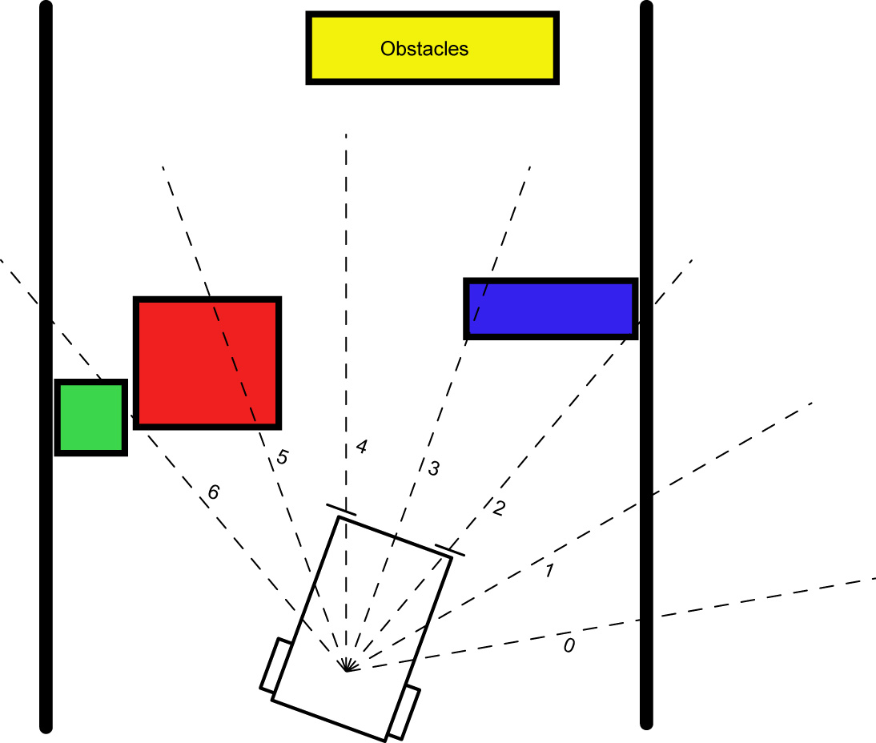

Figure 1

- Timing in Rotation:
  - Correct Alignment of Ultrasonic Range Finder and Car Rotation:
    - The time to rotate the car in the direction of Position 0 must match the alignment of Ultrasonic Range Finder Position 0. In the same manner, the rotation to Position 6 must correspond to the orientation of Ultrasonic Range Finder Position 6.
    - The rotation time is set in the program through series of trial and error.
    - Once the outer positions are aligned properly, the in-between alignments will automatically be adjusted by the program.
    - Note that in Position 3 the car will not have to turn, but may travel forward.

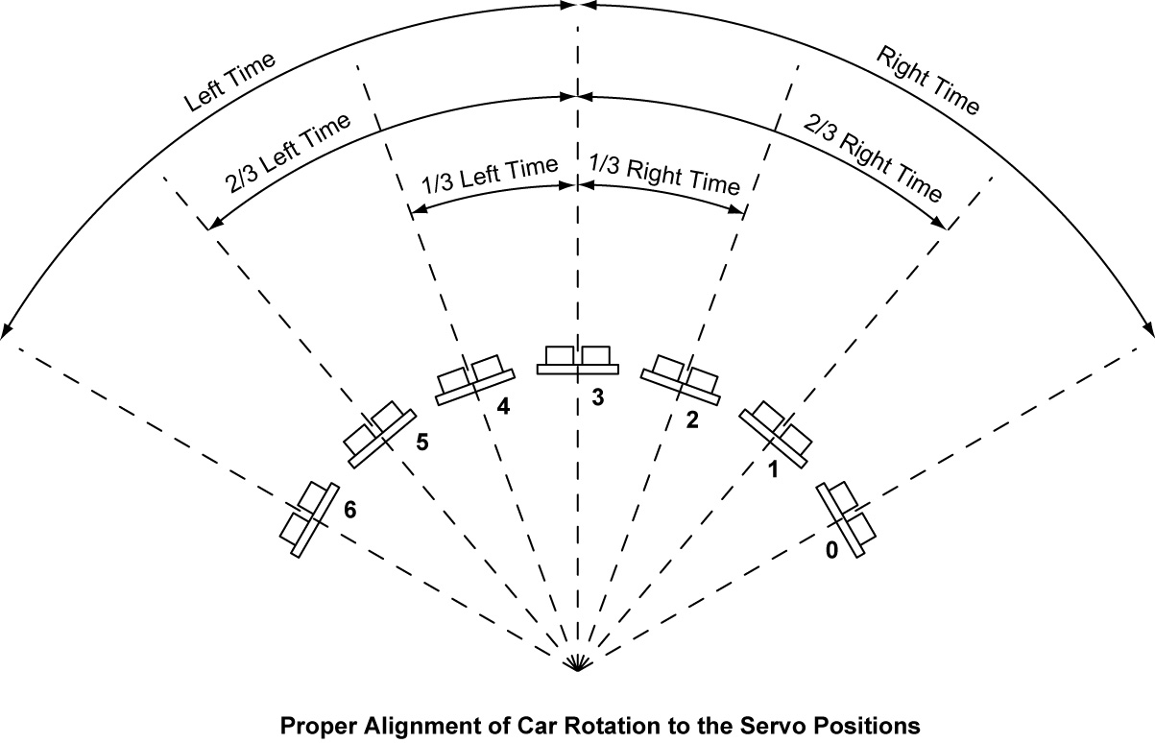

  - Improper Alignment, Time Settings Too Long:
    - If the time settings are too high, the car will over rotate and be misaligned with the ultrasonic range finder positions.

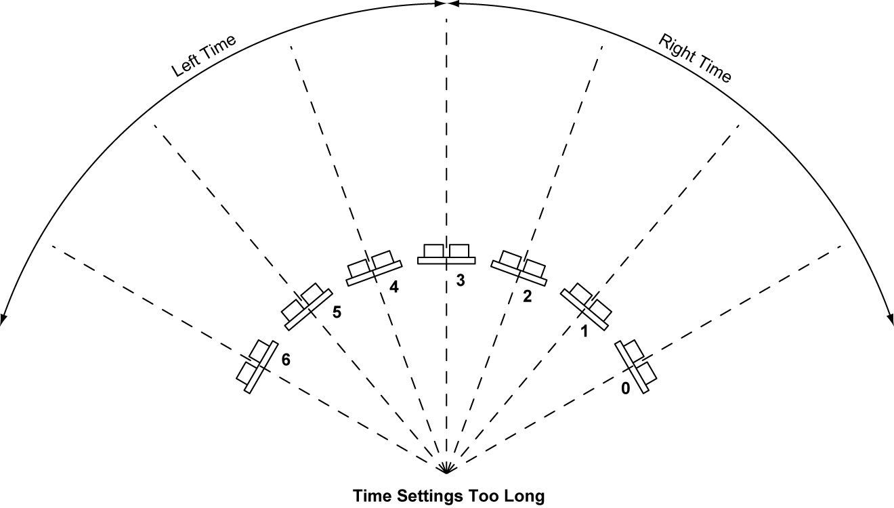

  - Improper Alignment, Time Settings Too Short
    - Setting the rotation time too short will also lead to misalignment.

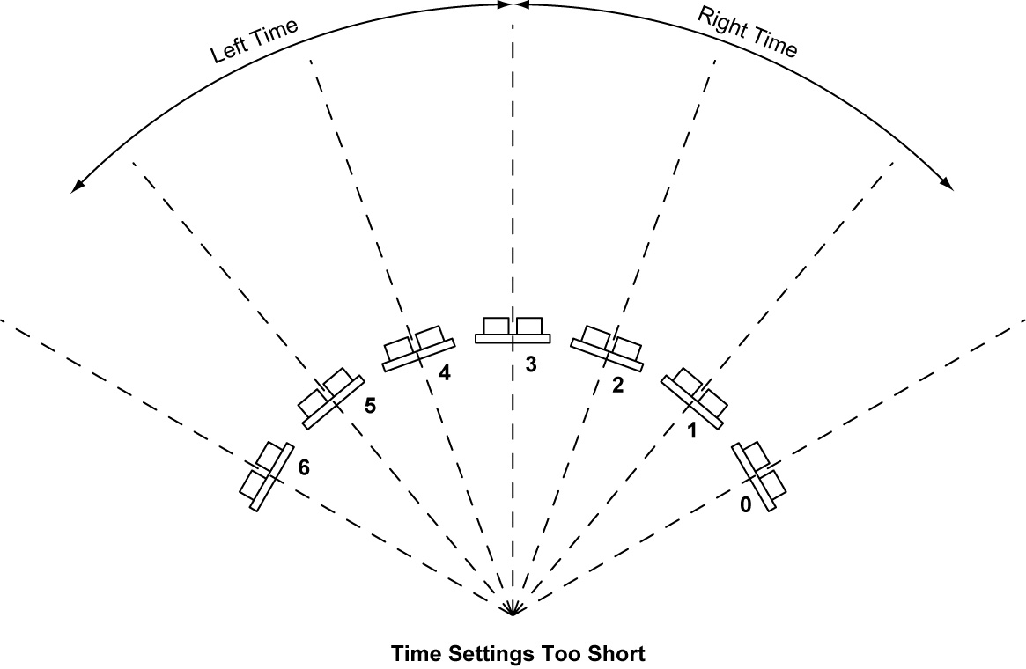

- New PicBasic Pro Command:
  - SELECT CASE: SELECT CASE statements are easier to use than multiple IF...THEN statements. SELECT CASE statements compare a Variable with different CASEs which represent different values or range of values. If the CASE expression is true, the statement(s) below that CASE are executed.

Format:

SELECT CASE Variable
CASE Expression 1 {, Expr...}
Statement...
Statement
CASE Expression 2 {, Expr...}
Statement...
Statement
{CASE ELSE
Statement...}
Statement
END SELECT

Explanation:

SELECT CASE declares the Variable that is used in all of the CASE comparisons. Each CASE is followed by the Statements to be executed if the CASE is true. IS may be used to specify a comparison other than equal to. If none of the CASEs are true, the Statements under the optional CASE ELSE statement are executed. An END SELECT closes the SELECT CASE.

Example:

SELECT CASE x
CASE 1 ‘ Case if x = 1, then y = 10
y = 10
CASE 2, 3 ‘ Case if x = 2 or 3, then y = 20
y = 20
CASE IS > 5 ‘ Case if x > 5, then y = 100
y = 100
CASE ELSE ‘ If none of the Cases are true, then
‘ y = 0.
y = 0
END SELECT ‘ Close SELECT CASE

Sonar Car 3 – Select Case Command and Rotate Sonar Car
LAB 1 – SELECT CASE Command
Cornerstone Electronics Technology and Robotics II

- Purpose: The purpose of this lab is to acquaint the student with the use of SELECT CASE in a PicBasic Pro programming.

- Apparatus and Materials:

  - 1 – Breadboard w/ +5V Power Supply
  - PIC16F88 Microcontroller
  - 4.7 K Resistor
  - Other materials to be determined by student

- Procedure:
  - Connect 4 LEDs to pins RB0 – RB3 on a PIC16F88. Don’t forget the current limiting resistors.
  - Write a new PicBasic Pro program that accomplishes the following task:
    - Create a FOR..NEXT loop to run 100 times.
    - Use the SELECT CASE command to:
      - Light the LED connected to RB0 only when the loop number is less than 50.
      - Light the LED tied to RB1when the loop number equals 50.
      - Light the LED on RB2 when the loop number is greater than 90.
      - Light the LED on RB3 when the LED on RB0, RB1, and RB2 are not lit.
    - Have the program run forever.
Sonar Car 2 – Arrays and SRF04 Ultra-Sonic Ranger Finder Readings
LAB 2 – Programming the Sonar Car with sonar_car_c.pbp
Cornerstone Electronics Technology and Robotics II

- Purpose: The purpose of this lab is to review the third in a series of four programs that takes the class through the development of the final program sonar_car1.pbp. This lab reviews the portion of the program that adds rotating the car to align with the longest sonar reading.

- Apparatus and Materials:

  - 1 – Sonar car with Sonar Car Circuitry 1 & 2 on breadboard – see schematics at: http://cornerstonerobotics.org/schematics/pic_programming_sonar_car1.pdf and http://cornerstonerobotics.org/schematics/pic_programming_sonar_car2.pdf

- Procedure:
  - Open the program as sonar_car_c.pbp. See: http://cornerstonerobotics.org/code/sonar_car_c.pbp
  - Discuss operation of the program.

