555 Timer Monostable (One-Shot) Operation
Cornerstone Electronics Technology and Robotics II

- Administration:
  - Prayer
- For 555 Timer – Basics, see: http://cornerstonerobotics.org/curriculum/lessons_year2/erii5_555_timer.pdf
- For 555 Timers – Astable Operation, see: http://cornerstonerobotics.org/curriculum/lessons_year2/erii5_555_timer_astable_operation.pdf
- Brief Description of Monostable Operation:
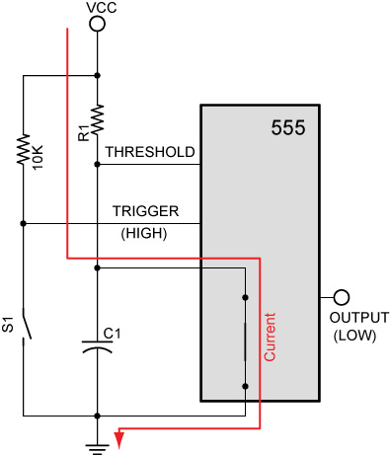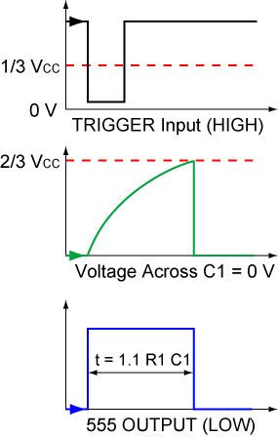
Initially with the input trigger set HIGH due to the 10K pull-up resistor, the 555 timer grounds the capacitor C1 and the 555 output is driven LOW.

Figure 1 – C1 Grounded Initial Timing Chart
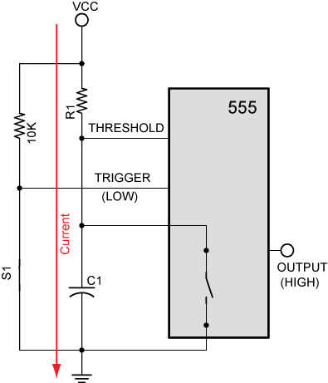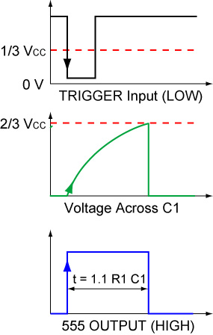
By closing S1, the input trigger voltage drops below 1/3 V_{CC} (LOW), creating a trigger pulse. This pulse causes the 555 to disconnect the capacitor C1 from ground. C1 begins charging through the resistor R1 and the 555 output is driven HIGH.
Figure 2 – C1 Charging through R1 Trigger Pulse Drives the Output Pulse
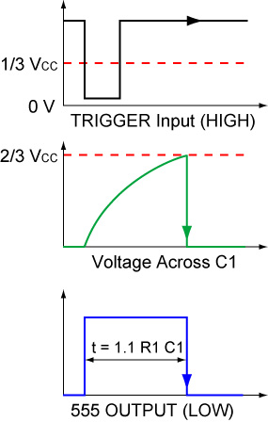
When the voltage across C1 (the threshold input) reaches 2/3 V_{CC}, the 555 discharges the capacitor C1 to ground and the 555 output returns to LOW. The 555 will remain in this stable mode until another LOW trigger pulse is detected.
Figure 3 – C1 Grounded Again Threshold at 2/3 V_{CC} Ends Output Pulse

  - The 555 monostable operation is called monostable because it is stable in only one state which is the LOW output. The HIGH output is a temporary, therefore an unstable state.

- Detailed Presentation of 555 Timer Monostable Operation (Figures 5 – 10):
  - A review of comparator operations may be found just before the labs.

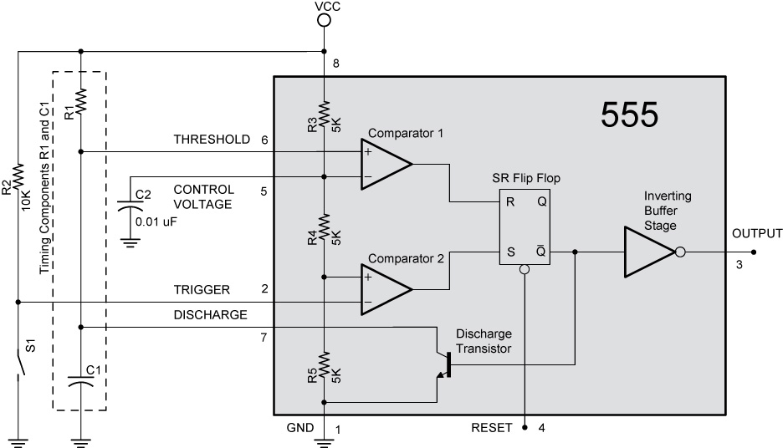

Figure 5 – 555 Timer Set Up for Monostable Operation

  - Stable State:
    - The output Q of the SR flip-flop (also called a RS flip-flop) is initially set HIGH which turns on the discharge transistor. The discharge transistor then grounds the capacitor C1. The outputs of both comparators 1 and 2 are LOW. See Figure 6.

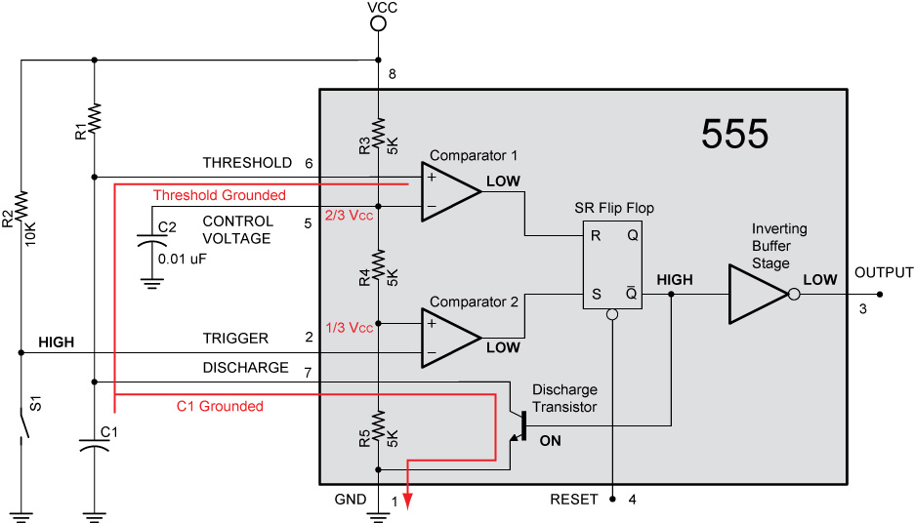

Figure 6 – C1 Grounded Initial Timing Chart
  - Unstable State (C1 Charging):
- Comparator 2 serves as the input S (Set) and comparator 1 serves as the R input (Reset) into the SR flip-flop. With the THRESHOLD grounded in the initial stable state, the output of non-inverting comparator 1 is LOW. When the switch S1 is closed driving the TRIGGER input to LOW (more precisely, when it drops below 1/3 V_{CC}), the output of lower inverting comparator 2 is driven HIGH (See Figure 7). From the SR flip-flop truth table below (Table 1), when the S input is HIGH and R is LOW, the output Q of the SR flip-flop is driven LOW and the 555 timer OUTPUT is HIGH due to the inverting buffer stage.

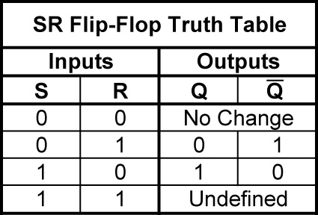

Table 1 – SR Flip-Flop Truth Table

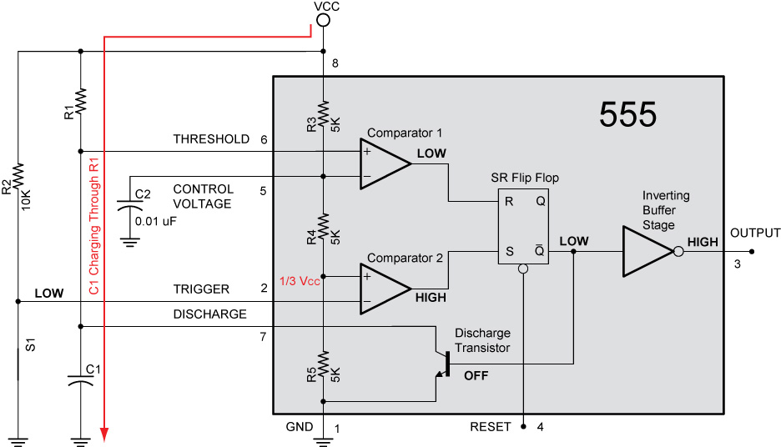

Figure 7 – C1 Charging Through R1

- Since the Q is LOW, the discharge transistor is turned off and C1 begins charging through R1. See Figure 7.
- The switch S1 is opened driving the TRIGGER back to HIGH (Figure 8).
The output of the lower comparator 2 changes to LOW (V_{CC} > 1/3 V_{CC}); comparator 1 remains unchanged at LOW. The trigger pulse must be shorter than the output pulse width allowing time for the timing capacitor to charge and then discharge fully.

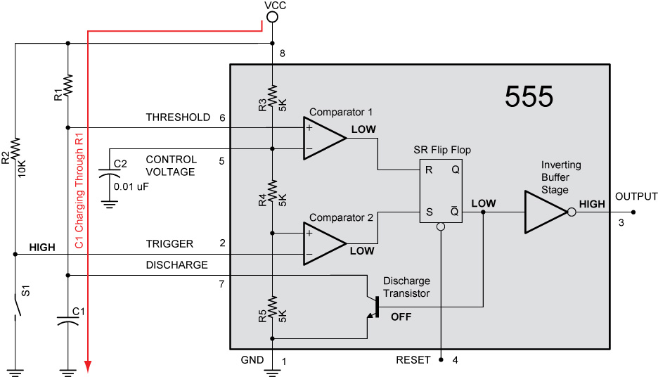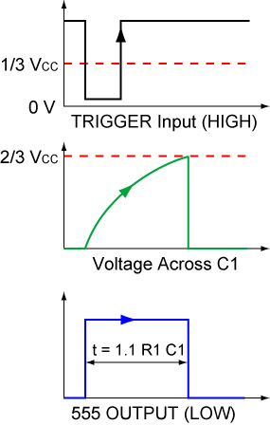

Figure 8 – C1 Continues Charging Through R1

- From the SR flip-flop truth table, the output Q of the SR flip-flop does not change (S=0 & R=0), thus remaining in a LOW state.
  - Unstable State (C1 Discharging):
- C1 continues to charge until the voltage across C1 exceeds 2/3 V_{CC}. At this point, the upper comparator 1 is driven HIGH (Figure 9). From Table 1, the SR flip-flop is driven to HIGH (S=0 & R=1) which turns on the discharge transistor and grounds C1 again.

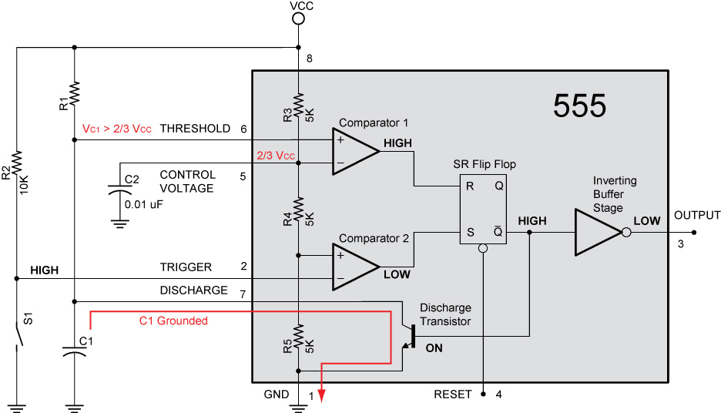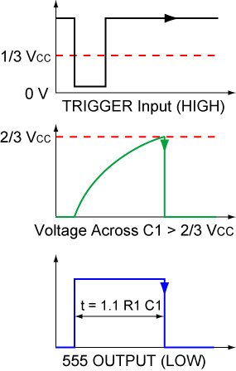

Figure 9 – When the Voltage across C1 > 2/3 V_{CC}, C1 Is Grounded
  - Return to the Stable State:
- The voltage across C1 is greater than 2/3 V_{CC} for only a moment before dropping below 2/3 V_{CC} driving the upper comparator 1 to LOW (Figure 10).

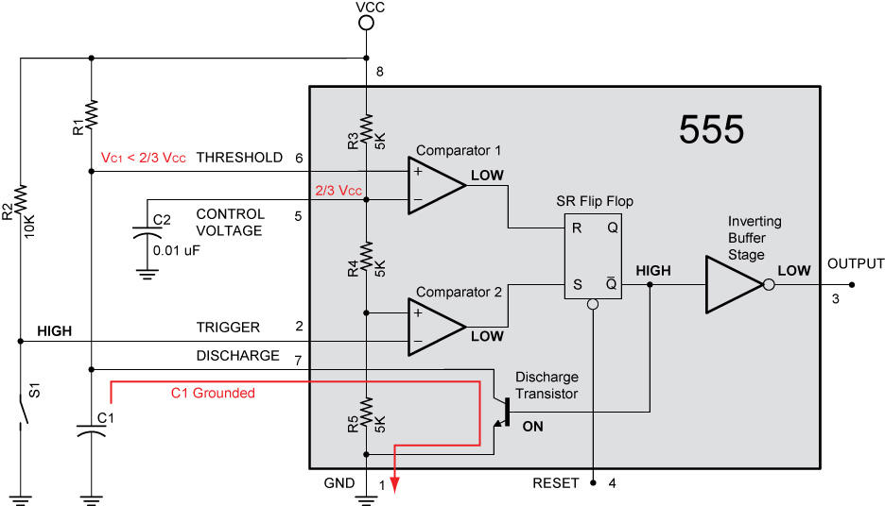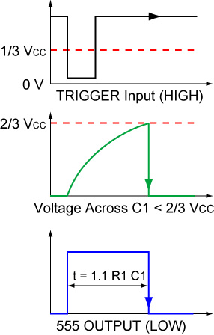

Figure 10 – 555 Timer Returns to Stable State

- From the SR flip-flop truth table, the output Q of the SR flip-flop does not change (S=0 & R=0), thus remaining in a HIGH state and discharge transistor continues to ground C1. The 555 will remain in the stable state until another LOW trigger pulse is detected.

- Timing of Trigger Pulses:
  - The trigger pulse must be of shorter duration than the intended output pulse.
  - A second trigger pulse is ignored when the output is already on. See Figure 11.
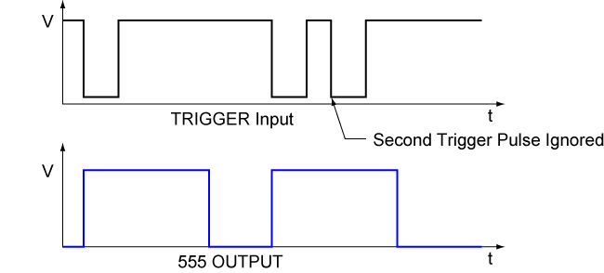

Figure 11 – Second Trigger Pulse during an Output Pulse
- Timing of Output Pulse:
  - The length of the output pulse can be calculated using the following formula.

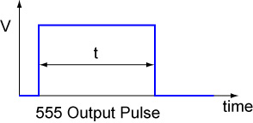

t = 1.1 x R1 x C1

Where:
t = Duration of output pulse in seconds
R1 = Resistance of R1 in Ohms
C1 = Capacitance of C1 in Farads

- 555 Monostable Time Duration (Delay) Graph:
  - Graph 1 can be used to select resistor and capacitor values for a pulse of a given time duration (delay).

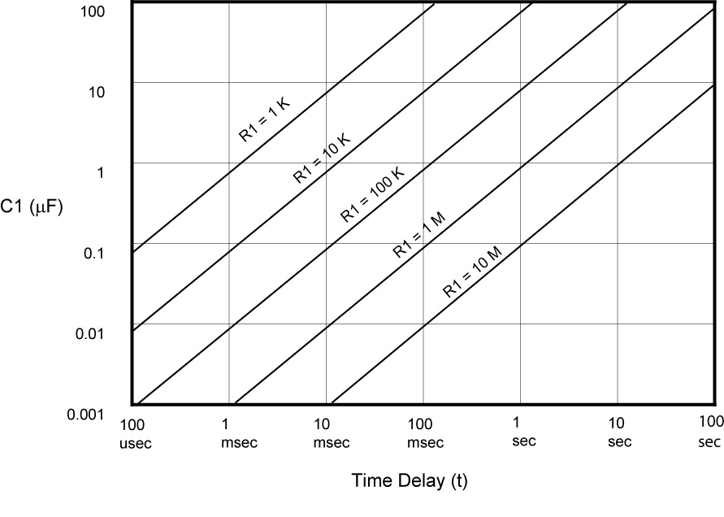
Graph 1 – 555 Timer Monostable Time Duration (Delay) Graph

- Reliable Ranges for R1 and C1:
  - R1: 10K ohms to 10M ohms
  - C1: 100 pF (.0001 uF) to 1000 uF
- Special Notes about the 555 Timer:
  - The timing circuit can produce brief dips in the voltage of the supply. This can be corrected by placing a large value capacitor across the supply rails. This eliminates the voltage change.
  - If electrolytic capacitors are used in the RC circuit, leakage currents and poor tolerances can result in the output pulse being greatly at variance with the value predicted by the formula.
- Perform 555 Timer LAB 1 – Basic Monostable Circuit
- Complete 555 Timer LAB 2 – Designing a Monostable Circuit

- Internet References:
  - http://www.uoguelph.ca/~antoon/gadgets/555/555.html
  - http://www.kpsec.freeuk.com/555timer.htm#astable
  - http://www.doctronics.co.uk/555.htm
  - http://www.dprg.org/tutorials/2005-11a/index.html
  - http://www.leang.com/robotics/info/articles/minison/minison.html
  - http://www.kingcharlesschool.co.uk/admin/files/Public/Departments/5/Downloads/555TIMER.pdf

- Review Basic Comparator Operations:
  - Inverting Operation: When V_{IN} exceeds V_{REF}, the output V_{OUT} goes from HIGH to LOW.

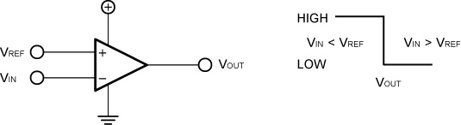

The inverting operation can be represented in another graphical form:

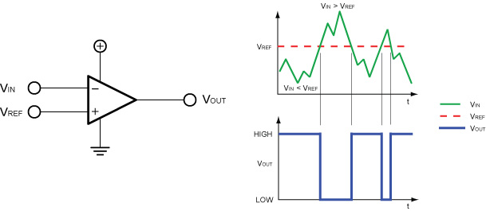

Figure 13 – Inverting Comparator Operation

  - Non-inverting Operation: When V_{IN} exceeds V_{REF}, the output V_{OUT} goes from LOW to HIGH.

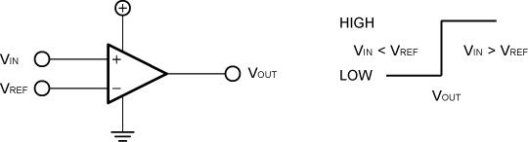

The non- inverting operation can be represented in another graph:

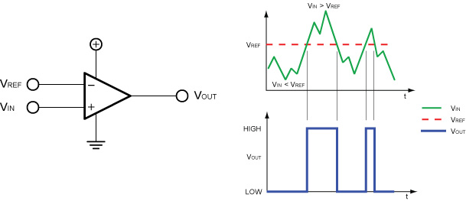

Figure 14 – Non-inverting Comparator Operation
Cornerstone Electronics Technology and Robotics II
555 Timer LAB 1 – Basic Monostable Circuit

  - Purpose: The purpose is to acquaint the student with the basic monostable operation of a 555 timer.

  - Apparatus and Materials:

    - 1 – Breadboard or Analog/Digital Trainer
    - 1 – Stopwatch
    - 1 – 555 Timer IC
    - 1 – NO Momentary Switch
    - 1 – 220 Ohm Resistor
    - 1 – 10 K Resistor
    - 1 – 100 K Resistor
    - 1 – 3.3 μF Capacitor
    - 1 – 10 μF Capacitor
    - 1 – 0.01 μF Capacitor
    - 1 – LED

  - Procedure:
    - Build the circuit below:
    - Let V_{CC} = +5 V. According to the NE555 spec sheet, when V_{CC} = +5 V, the typical output voltage is 3.3 V.
    - Use the 220 ohm resistor in series with an LED as the output.

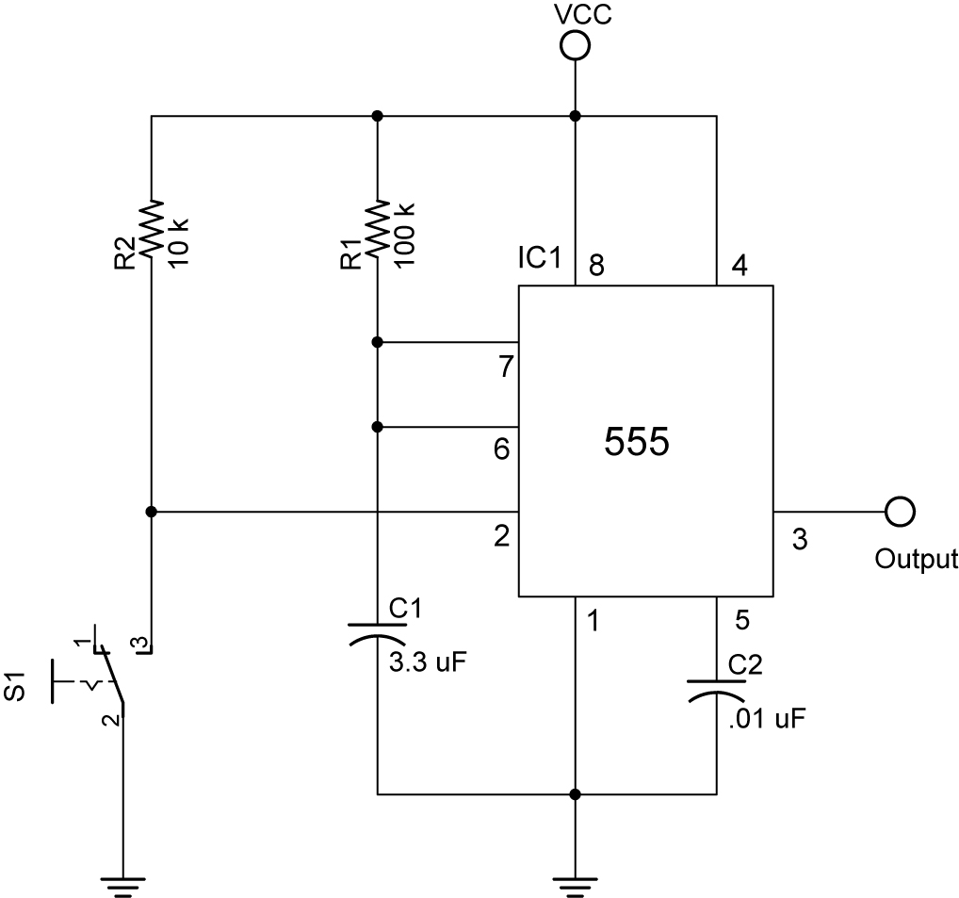

Basic Monostable Operation

    - Calculate the duration of the output pulse t for R1 and C1 in the circuit above. The pulse duration t begins when S1 is closed (Pin 2 is driven LOW). (t = 1.1 x R1 x C1)
    - Now change C1 to 10 μF and recalculate the pulse duration, t
    - Measure the pulse duration t using a stop watch and record your results.
  - Results:

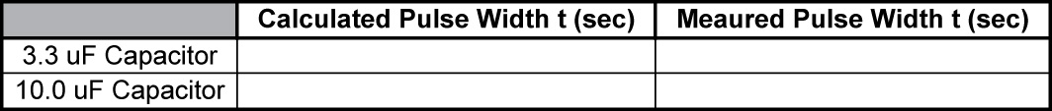
Cornerstone Electronics Technology and Robotics II
555 Timer LAB 2 – Designing a Monostable Circuit

  - Purpose: The purpose is to have the student use the appropriate formulas to design a 555 timer circuit for monostable operation.

  - Apparatus and Materials:

    - 1 - Breadboard or Analog/Digital Trainer
    - 1 – 555 Timer IC
    - 1 – NO (Normally Open) Momentary Switch
    - 1 – 220 Ohm Resistor
    - 1 – 10 K Resistor
    - 1 – Resistor, Value TBD
    - 1 – Capacitor, Value TBD
    - 1 - .01 uF Capacitor
    - 1 - LED

  - Procedure:
    - Build the monostable circuit below after determining the values of R1 and C1.
    - Let V_{CC} = +5 V.
    - Use the 220 ohm resistor in series with an LED as the output.
    - Design a circuit with an output pulse of 5 seconds.
      - Use the 555 Monostable Time Delay Graph on the next page to determine approximate values of R1 and C1.
      - Calculate more precise values using the formula: t = 1.1 x R1 x C1.

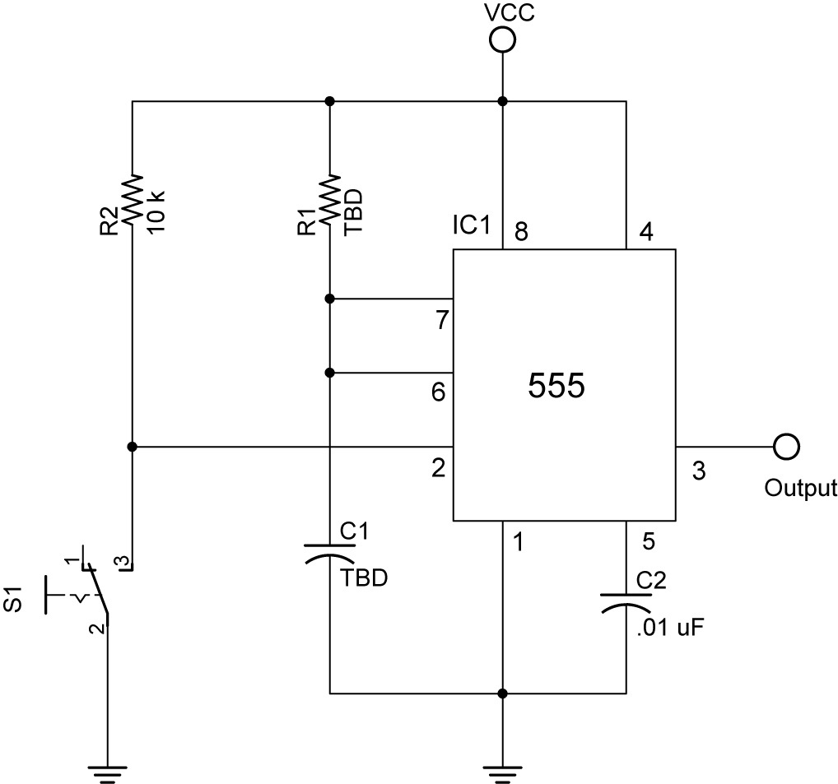

    - 555 Monostable Time Delay Graph:

555 Timer Monostable Time Delay Graph

