PAD-234 Analog/Digital Trainer, Integrated Circuits, and Op Amps
Cornerstone Electronics Technology and Robotics II

- Administration:
  - Prayer
  - Intuitive review of resistive voltage dividers – percentage of V_{CC}
- Analog/Digital Trainer:
  - PAD-234 Operator’s Manual – see: http://cornerstonerobotics.org/curriculum/lessons_year2/erii4_pad234_operators_manual.pdf
  - Complete LAB 1 – Analog/Digital Trainer
- Integrated Circuit: An integrated circuit, or IC, is a complete electronic circuit contained in one package.
  - History:
    - 1951 - Junction transistor invented
    - 1952 – Integrated circuit concept published by Drummer
    - 1954 – First transistor radio marketed
    - 1958 – First integrated circuit built at Texas Instruments - a simple oscillator
    - 1961 – First commercial ICs marketed
    - 1965 – Moore’s Law introduced – the number of components per IC doubles every 12 to 18 months.
    - 1971 – Microprocessor introduced
    - 1982 - Intel introduces the 80286 processor
    - 1993 - Intel Pentium introduced
    - 1997 - Intel Pentium II introduced
    - 2000 - Intel Pentium IV introduced
  - Types of ICs:
    - Linear:
      - Linear ICs have continuous variable outputs, controlled by continuous variable inputs.
      - Also called analog devices or circuits
    - Digital: Digital output operates in either on or off state.
    - See page 311 in the text for uses of each.
- Electricity and Electronics, Section 19.3, Operational Amplifier (Op Amp):
  - Symbol:

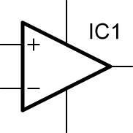

Single Op Amp Package

  - Characteristics that make an op amp an ideal amplifier:
    - High input impedance
    - High voltage gain
    - Low output impedance
  - See: http://www.chem.uoa.gr/Applets/AppletOpAmps/Appl_OpAmps2.html
  - Pin Configuration for 741 Op Amp:
 | 741
1 | OFFSET NULL |  |  | NC |  |  | 8
2 | INVERT IN |  |  | V+ |  |  | 7
3 | NON-INVERT IN |  |  | OUT |  |  | 6
4 | V- |  | OFFSET NULL |  |  |  | 5

    - Pins 1 and 5 are used to adjust for a 0 V at the output in critical applications.
    - Input signals into Pin 2 generate an output signal from Pin 6 of opposite polarity or 180 degrees out of phase (inverted).
    - Input signals into Pin 3 generate an output signal from Pin 6 of same polarity or in phase (noninverting).
    - Pin 4 is the negative power supply voltage
    - Pin 6 is the output
    - Pin 7 is the positive power supply voltage
    - Pin 8 has no connection
    - Need for positive and negative power supply voltages: The dual (+ and -) power supply voltages permit the output voltage to go both positive and negative with respect to ground.
  - Dual and Quad Op Amp Packages:
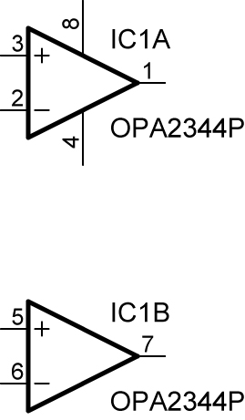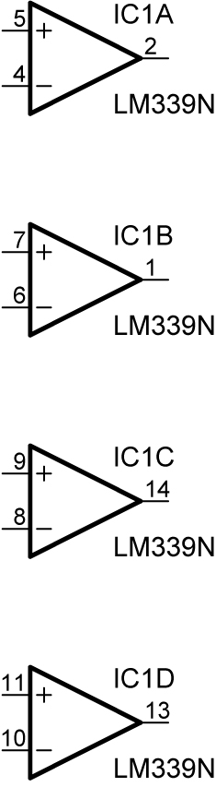

Dual Op Amp Package Quad Op Amp Package

  - Op Amp as a Comparator:
    - A comparator is an analog circuit that compares an input voltage to a reference voltage. The comparator output voltage rises or falls which indicates whether the input voltage is above or below the reference voltage.
    - See applet:
      - http://www.falstad.com/circuit/e-opamp.html
      - http://www.falstad.com/circuit/e-opampfeedback.html
    - Perform LAB 2 - Op Amps as Comparators.
  - Dual Polarity Power Supply: Perform LAB 3 - Dual Polarity Power Supply.
  - Inverting Op Amp Gain (Amount of Amplification):
    - Inverting Op Amp:
      - Feedback Resistor:
        - When a resistor from the output of the op amp is connected to the input of an op amp, it feeds back some of the output signal back into the input. This resistor is called a feedback resistor. As the value of the feedback resistor decreases, more of the output signal is feed back into the input, decreasing the gain.
      - Inverting Op Amp Gain Formulas:
        - From the circuit below,

Gain = - (R_{F}/R₂)
Where:
R_{F} = Feedback Resistor

The gain is negative because of the inverting feature of the circuit.

Also, R₃ = (R₂R_{F}) / (R₂+R_{F})

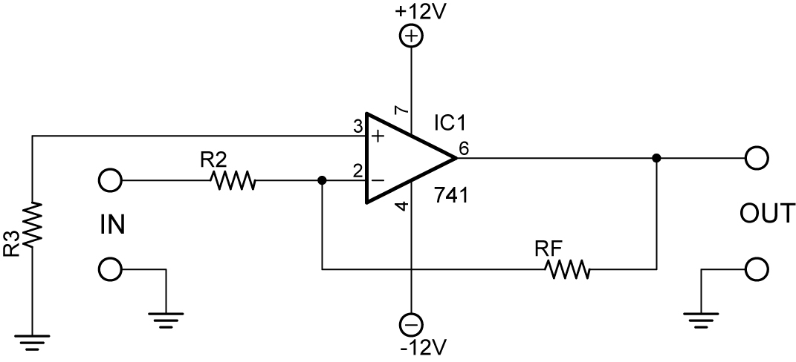

Inverting Op Amp Amplifier

      - See applets:
        - http://www.falstad.com/circuit/e-amp-invert.html
        - http://www.falstad.com/circuit/e-amp-noninvert.html
      - The formula for gain is different for a non-inverting op amp.
      - Do LAB 4 – Inverting Amplifier.

  - Op Amp as an Audio Amplifier:
    - An audio amplifier is a circuit that amplifies an audio signal and drives a speaker to produce sound.
    - Some audio amplifiers, like the LM386, come equipped with an internal resistor for a preset gain. The LM386 preset gain is 20.
    - Perform LAB 5 – Op Amp as an Audio Amplifier
  - Other op-amp functions: See: http://hyperphysics.phy-astr.gsu.edu/hbase/electronic/opampvar.html#c1
- References:
  - Mims, Forrest M. III (2000). Timer, Op Amp & Optoelectronic Circuits & Projects,
pp. 37 – 80.

Cornerstone Electronics Technology and Robotics II
Op Amp LAB 1 – PAD-234 Analog/Digital Trainer

  - Purpose: The purpose of this lab is to acquaint the student with the PAD-234A Analog/Digital Trainer.

  - Apparatus and Materials:

    - PAD-234 Analog/Digital Trainer. Available from Electronix Express, http://www.elexp.com/tst_234.htm
    - 1 – LED
    - 1 – 1K Resistor

  - Procedure:
    - Read General Operating Procedures, page 1, and Maintenance, page 2.
    - Use of 5V Supply:
      - Connect banana plugs to +5V and GND posts and extend to one + and -breadboard distribution bus.
      - Hookup an LED with a series 1 K resistor on the breadboard and connect to the distribution bus.
      - Turn on the trainer and illuminate the LED.
    - Use of the Function Generator:
      - Read and follow the instructions in the Function Generator section on pages 4 and 5 of the Operator’s Manual. Make the load an LED and a series 1 K resistor.
      - Set the frequency to about 2 Hz.
    - Use of + V, Variable DC Supply:
      - See Operator’s Manual, page 4
      - Connect DMM to + V and adjust control knob in lower left corner of control panel.

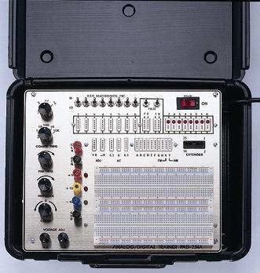

PAD-234 Analog/Digital Trainer
Cornerstone Electronics Technology and Robotics II
Op Amp LAB 2 – Op Amps as Comparators

  - Purpose: The purpose of this lab is to review the basic operation of an op amp used as a comparator. The material was first introduces in Electronics and Robotics I.

  - Apparatus and Materials:
    - 1 – Breadboard with 9 V Supply
    - 2 – Digital Multi-Meters
    - 2 – 10K or 25 K Cermet Potentiometers
    - 1 – 100K Cermet Potentiometer
    - 1 – 1K Resistor
    - 1 - Photoresistor
    - 1 – 741 Op Amp
    - 1 - LED
  - Procedure:
    - Build the basic op amp comparator circuit shown below on your breadboard.
    - Set the two DMMs to measure the voltages at Pins 2 and 3.

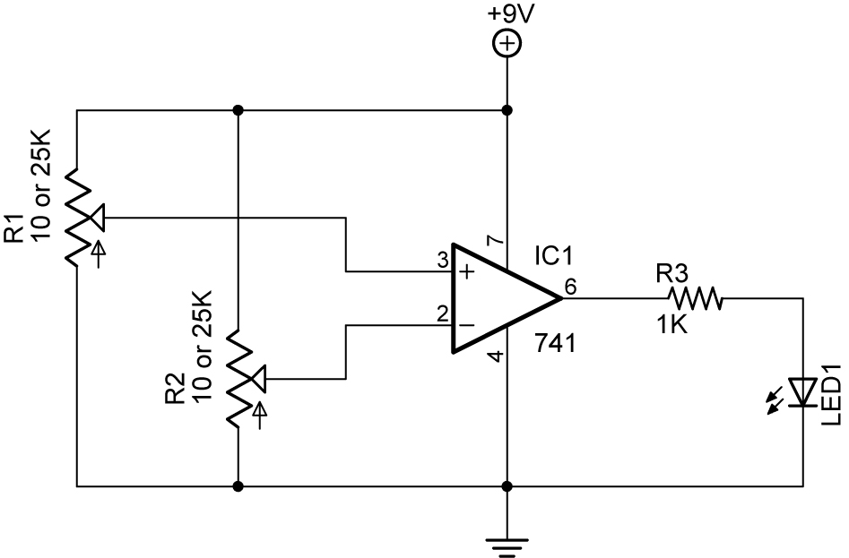

Basic Op Amp Comparator Circuit

    - Pin 2 (Invert Input)(-) as the Reference Voltage:
      - Using R2, set the voltage at Pin 2 to approximately 5 V. This is the reference voltage.
      - Adjust R1 so the voltage on Pin 3 is below the voltage on Pin 2.
      - Increase the voltage at Pin 3 until it exceeds the reference voltage on Pin 2.
      - Observations: When the Invert Input, (Pin 2), is set as the reference voltage and the other input voltage (Pin 3) is adjusted to exceed the reference voltage, the LED ______________________.
    - Pin 3 (Non-Invert Input)(+) as the Reference Voltage:
      - Using R1, set the voltage at Pin 3 to approximately 4 V. This is now the reference voltage.
      - Adjust R2 so the voltage on Pin 2 is below the voltage on Pin 3.
      - Increase the voltage at Pin 2 until it exceeds the reference voltage on Pin 3.
      - Observations: When the Non-Invert Input, (Pin 3), is set as the reference voltage and the other input voltage (Pin 2) exceeds the reference voltage, the LED ______________________.
Cornerstone Electronics Technology and Robotics II
Op Amp LAB 2 – Op Amps as Comparators Continued

  - Practical Application:
    - Build the light-activated circuit below as a practical application of comparators.
    - Notice that R1 and R2 form a voltage divider. The resistance in R1 varies relative to the amount of light illuminating the photoresistor. As R1 changes, the voltage at Point A, V_{A}, changes, which is an input into the comparator.

V_{A} = 9V (R2) / (R1 + R2)

    - R3 is also acting as a voltage divider, varying the reference voltage into Pin 2.
    - Choose a photoresistor for R1. Measure its resistance, R_{DARK}, when it is covered by your hand.
    - Choose R2 with a value close to value R_{DARK}.
    - Set R3 so the LED just lights on, then back it off so the LED just turns off.
    - When a brighter light source illuminates the photoresistor, the LED will light.

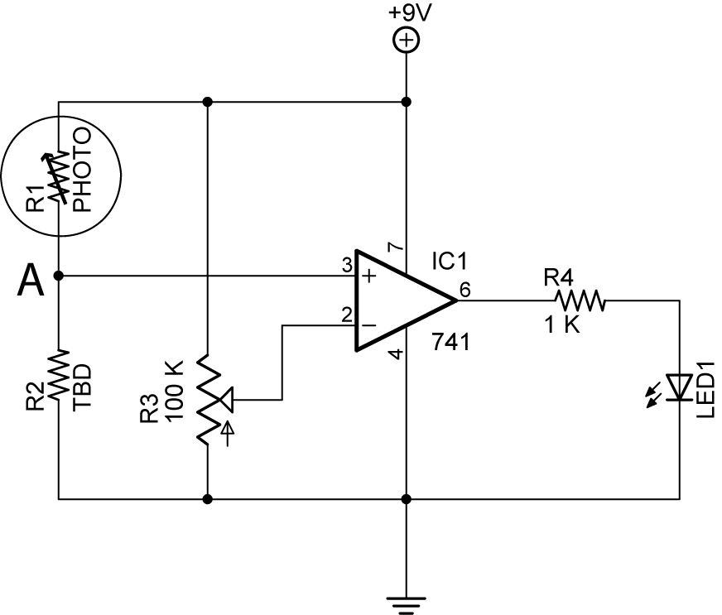

Light Activated Switch
Cornerstone Electronics Technology and Robotics II
Op Amp LAB 3 – Dual Polarity Power Supply

  - Purpose: The purpose is to acquaint the student with a power supply that furnishes both positive and negative voltages, a dual polarity power supply.

  - Apparatus and Materials:

    - 2 - 9 V Batteries
    - 2 – 9 V Battery Snaps
    - 1 - Digital Multi-Meter
    - 1 – Alligator Clip Test Lead

  - Procedure:
    - Use the battery arrangement below to supply +9V and -9V. Connect batteries together using one alligator clip test lead.
    - Use the DMM to verify voltage values shown below. Attach the black common DMM lead to ground for both measurements.

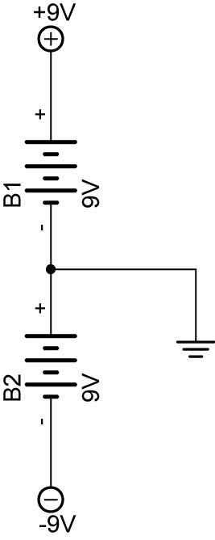

  - Notes:
    - This power supply circuit could be used in the audio amplifier circuit in LAB 4.

Cornerstone Electronics Technology and Robotics II
Op Amp LAB 4 – Inverting Amplifier

  - Purpose: The purpose of this lab is to have the student design an inverting amplifier utilizing the formulas given in the lesson to determine resistor values. The student will then build their inverting amplifier and test its performance.

  - Apparatus and Materials:
    - 1 – Breadboard with 9 V Supply or Analog/Digital Trainer
    - 2 – Digital Multi-Meters
    - 1 – 741 Op Amp
    - 2 – 10K Resistors
    - 1 – 1K Resistor
    - 1 – 10K Cermet Potentiometer
    - 2 – Different Resistors TBD (To Be Determined)

  - Procedure:
    - The +9V and -9V dual polarity power supply in LAB 3 may be substituted for the +12V and -12V shown in the schematic below.
    - Design an inverting operational amplifier with a gain = -10. Let R2 = 1 K ohms.
    - From the formulas in the inverting op amp gain section, determine the values of R3 and RF.
    - Using the values for R3 and RF just calculated; build the amplifier circuit shown below.
    - Measure the input and output voltages using two DMMs. Make sure that input voltage is measured between the point labeled IN (not Pin 2) and ground. The output voltage is measured across the output points. Record several readings below and verify the gain.

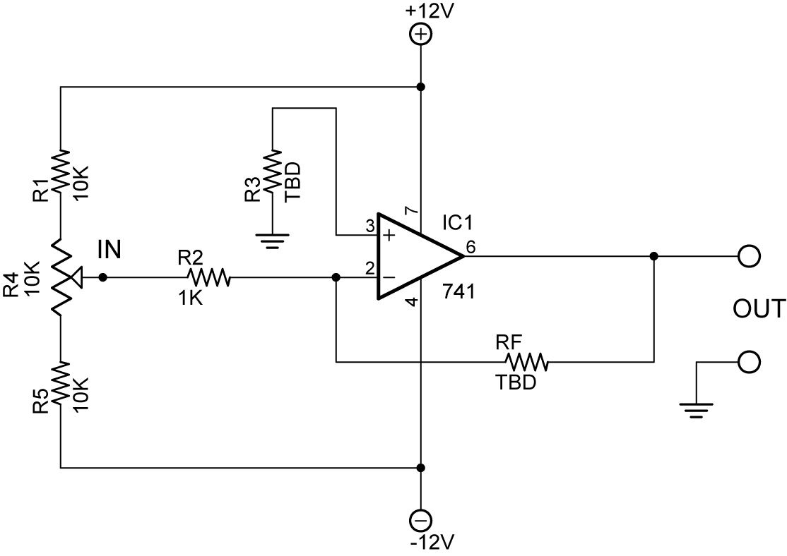

Inverting Operational Amplifier

V_{IN} V_{OUT} Gain = V_{OUT} / V_{IN}
_____ _____ _____
_____ _____ _____
_____ _____ _____
Cornerstone Electronics Technology and Robotics II
Op Amp LAB 5 – Op Amp as an Audio Amplifier

  - Purpose: The purpose of LAB 4 is to introduce the student to an audio amplifier circuit and its performance.

  - Apparatus and Materials:

    - 1 – Breadboard with 9 V and -9 V Supplies (See Op Amp LAB 2 – Dual Polarity Power Supply) or Analog/Digital Trainer
    - 1 – LM380 Audio Amplifier IC
    - 1 – 741 Op Amp IC
    - 1 – 5K Potentiometer
    - 1 – 470 uF Capacitor
    - 1 – 1 uF Capacitor
    - 4 – 0.1 uF Capacitors
    - 1 – 100K Cermet Potentiometer
    - 2 – 1K Resistors
    - 1 – 8 Ohm Speaker
    - 1 – Microphone or Modified Piezo Transducer

  - Procedure:
    - Use the schematic below to build the audio amplifier.
    - If using the analog/digital trainer, +12 vdc can substitute for the +9 v supply.

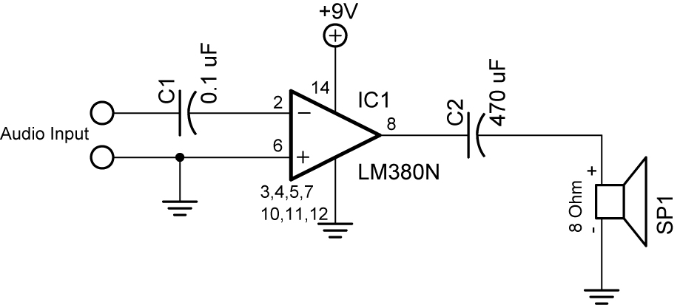

LM380 Audio Amplifier

    - Now add a 741 preamplifier to the circuit:

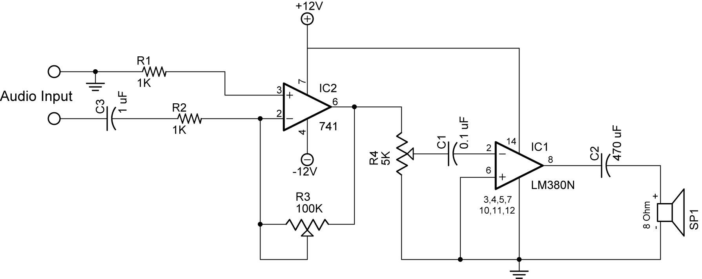

Audio Amplifier with 741 Preamplifier

