Power Systems 4
Cornerstone Electronics Technology and Robotics III
(Notes primarily from “Underwater Robotics – Science Design and Fabrication”, an excellent book for the design, fabrication, and operation of Remotely Operated Vehicles ROVs)

- Administration:
  - Prayer
- Transmission and Distribution of Electrical Power:
  - Major Electrical System Components:
    - Source of electrical power
    - Fuse or circuit breaker close to the power source
    - ON/OFF switch
    - Tether – umbilical to deliver electrical power to vehicle
    - Load – all of the electrical equipment onboard the vehicle

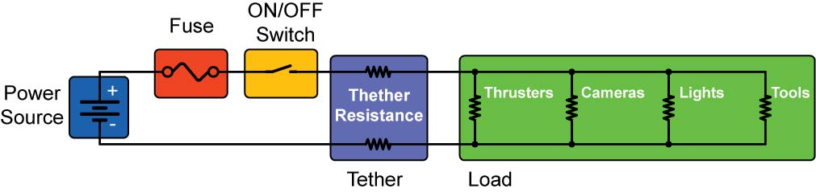

Figure 13: Major Components of a Vehicle’s Electrical System

  - Wires, Cables, and Connectors:
    - Electrical power is conveyed through electrical wires which can be bundled into cables and joined together with connectors.
    - Wire: A usually pliable low-resistance metallic strand often electrically insulated, used chiefly to conduct electricity.
    - Insulator: A material with few or no free electrons which will not let electrons flow freely. Insulators provide a protective coating around a conductor.
    - Cable: A bound or sheathed group of mutually insulated wires.
    - Connector: A device that joins electric conductors mechanically and electrically to other conductors and to the terminals of apparatus and equipment. Makers of subsea connectors include SeaCon, Teledyne Impulse, and Birns.

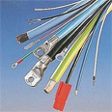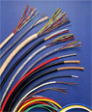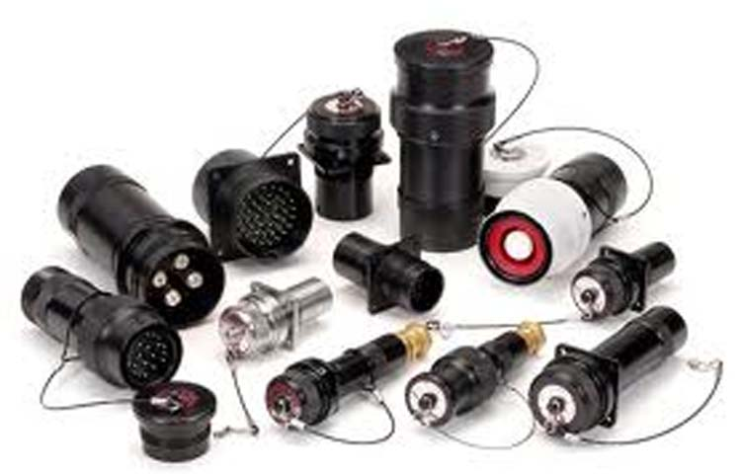

Figure 14: Wires, Cables, and Connectors
  - Fuses: A safety device that protects an electric circuit from becoming overloaded. Fuses contain a length of thin wire (usually of a metal alloy) that melts and breaks the circuit if too much current flows through it. They are used to protect electronic equipment and prevent fires.

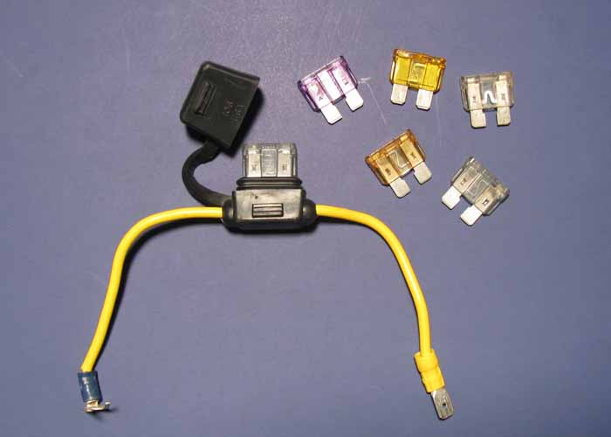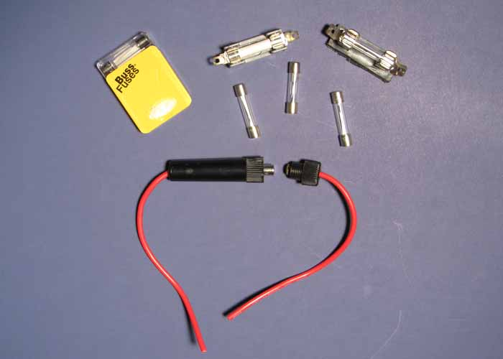

Figure 15: “Blade” and “Cartridge” Fuses with Fuse Sockets

    - Short Circuit: A faulty or accidental connection between two points of different potential in an electric circuit, bypassing the load and establishing a path of low resistance through which an excessive current can flow. It can cause damage to the components if the circuit is not protected by a fuse.
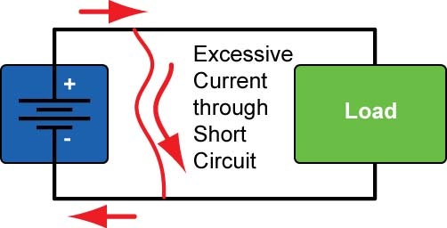

Figure 17: Excessive Current through a Short Circuit in an Unprotected Circuit
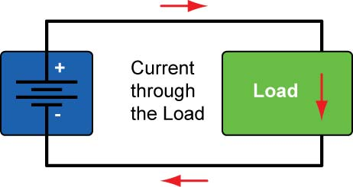

Figure 16: Current through the Load (Its Normal Flow) in an Unprotected Circuit

    - Protect circuits by placing a fuse as close as possible to the positive terminal of the power source to minimize the possibility of damage.
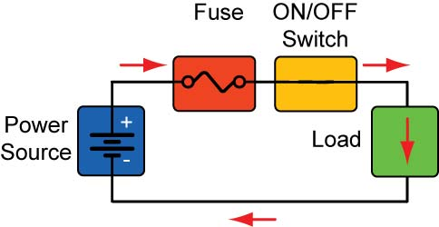

Figure 18: Current flows through the load in a circuit that is protected by a fuse.

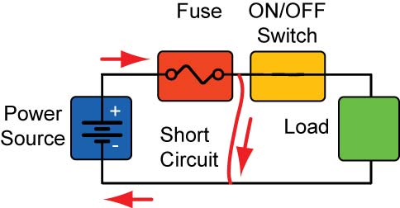

Figure 19: At the instant a short circuit occurs, the excessive current flows through the fuse.

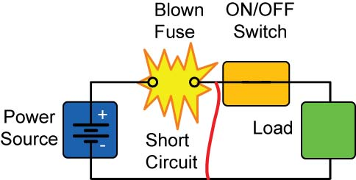

Figure 20: The excessive current melts the fuse wire inside the fuse housing which opens the current path, stopping current flow.

    - Choosing the Right Fuse:
      - First, determine the maximum voltage and current during the normal operation of your circuit.
      - Select a fuse with a voltage rating that is higher than the maximum operating voltage.
      - Picking a fuse with the correct current rating is more crucial. Choose a fuse that has a current rating between 1.5 to 2.0 times the normal operating current. Make certain that the wires in your circuit can withstand this extra current; otherwise they may melt before the fuse blows.
      - Slow-blow type fuses are preferable in motor and relay circuits which exhibit transitory current spikes.
    - Circuit Breakers: A switch that automatically interrupts the flow of electric current if the current exceeds a preset limit, measured in amperes. Unlike fuses, they can usually be reset and reused.
    - Resettable Fuses: The most obvious difference is that resettable fuses are automatically resettable whereas traditional fuses need to be replaced after they are tripped.
      - When the conductive plastic material in a resettable fuse is at normal room temperature, there are numerous carbon chains forming conductive paths through the material. Under fault conditions, excessive current flows through the resettable fuse device. Heating causes the conductive plastic material's temperature to rise. As this self heating continues, the material's temperature continues to rise until it exceeds its phase transformation temperature. As the material passes through this phase transformation temperature, the densely packed crystalline polymer matrix changes to an amorphous structure. This phase change is accompanied by a small expansion. As the conductive particles move apart from each other, most of them no longer conduct current and the resistance of the device increases sharply. The material will stay "hot", remaining in this high resistance state as long as the power is applied. The device will remain latched, providing continuous protection, until the fault is cleared and the power is removed. Reversing the phase transformation allows the carbon chains to re-form as the polymer re-crystallizes. The resistance quickly returns to its original value. From: http://www.schurter.com/en/content/download/8672/115155/file/KapKat_PG01_1.pdf
      - Resettable fuses are convenient on deep-diving ROVs and AUVs because of reset feature.
  - Power Switches:
    - Locate master switch between the fuse and the remaining circuitry.
    - Switches will be discussed in more detail in the next chapter.
  - Transmitting Electrical Power over a Tether:
    - Voltage Drop - a decrease in voltage around a circuit through which current is flowing. For example, in Figure 21, the battery supplies an electrical potential of 10 volts. The voltmeter reading across the battery (from Point A to Point D) is 10 volts, V_{A} = 10 V. As the 10 mA current passes through the resistor R1, the voltage drops 2 volts (V₁ = I₁*R₁; 2 V = 0.01 A * 200 ). The voltage at Point B (V_{B} = 8 V) has dropped 2 volts from Point A (V_{A} = 10V). Since the current is equal through all of the resistors, the voltage drops an additional 3 volts across resistor R2 and 5 volts across R3. If you measure the voltage at Point D (V_{D} = 0 V), you will observe that the voltage has dropped a total of 10 volts across the three resistors.

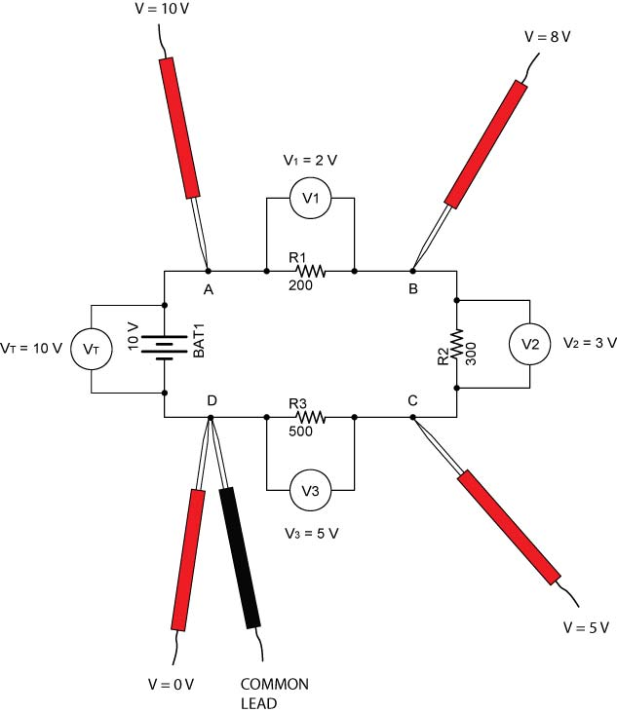

Figure 21: Voltage Drops in a Series Circuit

    - Although wires are considered conductors, every wire has an internal resistance. With this resistance, there is an associated power loss and voltage drop. So the voltage at the end of a tether is less than the voltage at power source. For example in Figures 22 and 23, a 60 foot long #22 gauge wire tether has an internal resistance of 0.0161 Ω/ft. The internal resistance produces a 5.8 V voltage drop across the tether, leaving 6.2 volts for the ROV.

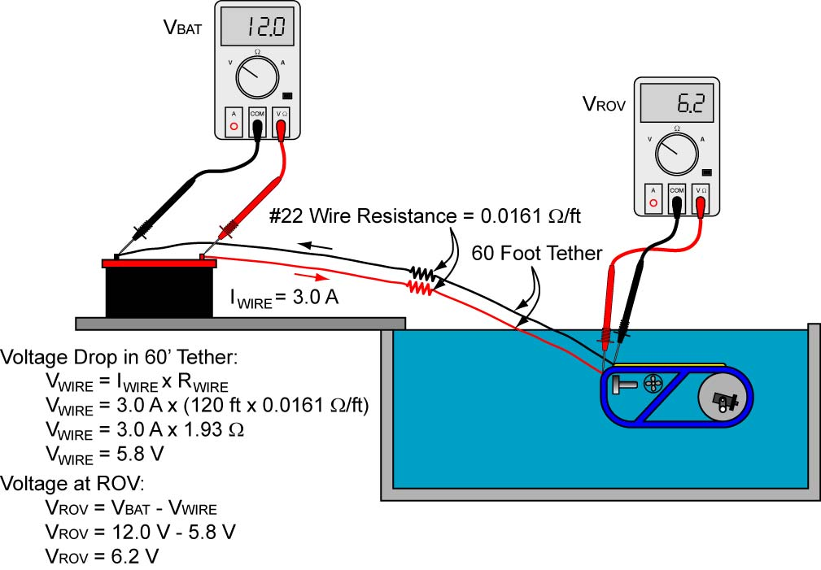

Figure 22: Voltage Drop in a 60’ #22 Wire Tether

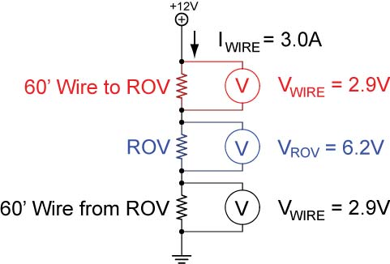

Figure 23: Schematic of Voltage Drops in 60’ #22 Wire Tether
    - Options to reduce power loss in a tether:
      - Shorten the tether
      - Choose a larger gauge wire to reduce the internal resistance
      - Increase the voltage
      - Place the battery on board the vehicle
    - Perform Power Systems 4 Lab 1: Voltage Drop in a Tether
  - Accommodating Multiple Voltages:
    - Your ROV may have subsystems that require different operating voltages. In Figure 24, for example, the thrusters and cameras operate at +12 volts while the microcontroller and compass circuits run on +5 volts.

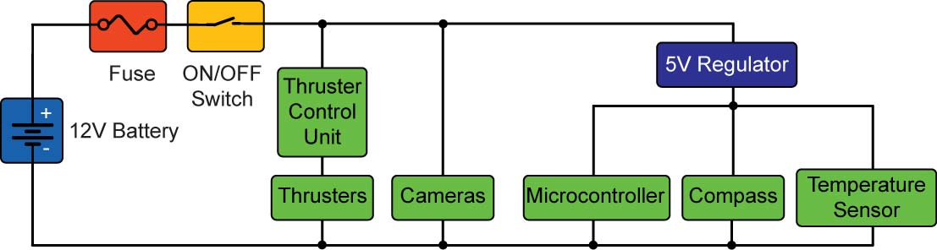

Figure 24: ROV Subsystems Requiring Different Voltages

    - Fixed Output Linear Voltage Regulators: a device that provides a constant regulated output voltage (a constant voltage despite variations in input voltage or output load) as long as the input voltage is greater than the rated output voltage plus the dropout voltage. Typically, voltage regulators are surrounded by heat sinks because they generate significant heat. The unnecessary voltage is disposed by the heat. Check your voltage regulator datasheet for the connection diagram and typical applications.

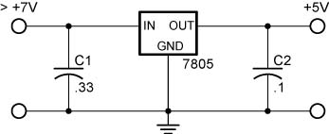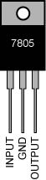

Figure 25: Fixed Output Voltage Regulator Schematic and a 7805 Voltage Regulator in a TO-220 Package

Links to two 7805 datasheets:
http://www.ti.com/lit/ds/symlink/lm340-n.pdf
http://www.fairchildsemi.com/ds/LM/LM7805.pdf

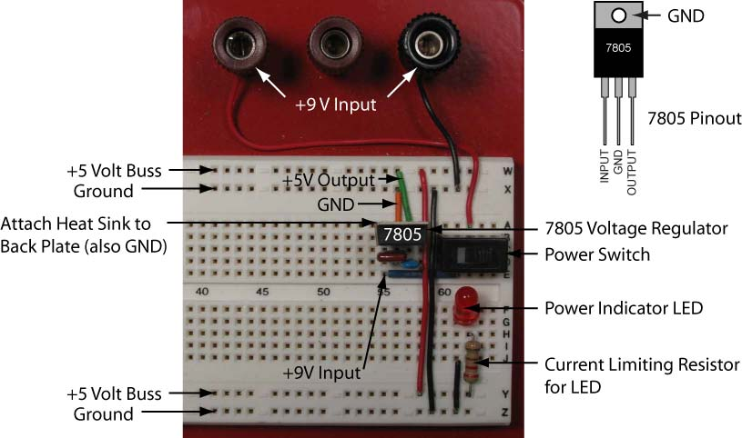

Figure 26: A 7805 Fixed Output Voltage Regulator Circuit on a Solderless Breadboard

All linear regulators require an input voltage at least some minimum amount higher than the rated output voltage. That minimum amount is called the dropout voltage. For example, a common regulator such as the 7805 has an output voltage of 5V, but can only maintain this if the input voltage remains above about 7V. Its dropout voltage is therefore 7V - 5V = 2V.
    - DC-to-DC Converters: DC converters convert power from one DC voltage source to another DC voltage, although sometimes the output is the same voltage. They are usually regulated devices, taking a possibly varying input voltage, and providing a stable, regulated output voltage, up to a design current limit.
- Steps in Circuit Design and Construction:
  - Circuit Design:
    - Formulate your circuit design on paper or other medium before you begin fabrication. Use standardized circuit schematic symbols so others can understand your design. Standard symbols can be found at:
      - http://library.thinkquest.org/10784/circuit_symbols.html
      - http://encyclobeamia.solarbotics.net/articles/symbols.html
      - http://www.kpsec.freeuk.com/symbol.htm
  - Circuit Prototyping:
    - Test your design by fabricating a temporary prototype circuit.
    - Breadboarding: an experimental arrangement of electronic circuits giving access to components so that modifications can be carried out easily.
      - Breadboarding can be arranging larger circuit components on a piece of plywood and connecting them using alligator clip leads.
      - Circuits with smaller circuit components tested using a solderless breadboard. The components are plugged into contact points on the breadboard, allowing for simple modification if needed. For a more detailed session on solderless breadboards, see: http://cornerstonerobotics.org/curriculum/lessons_year1/ER%20Week3,%20Solderless%20Breadboard.pdf

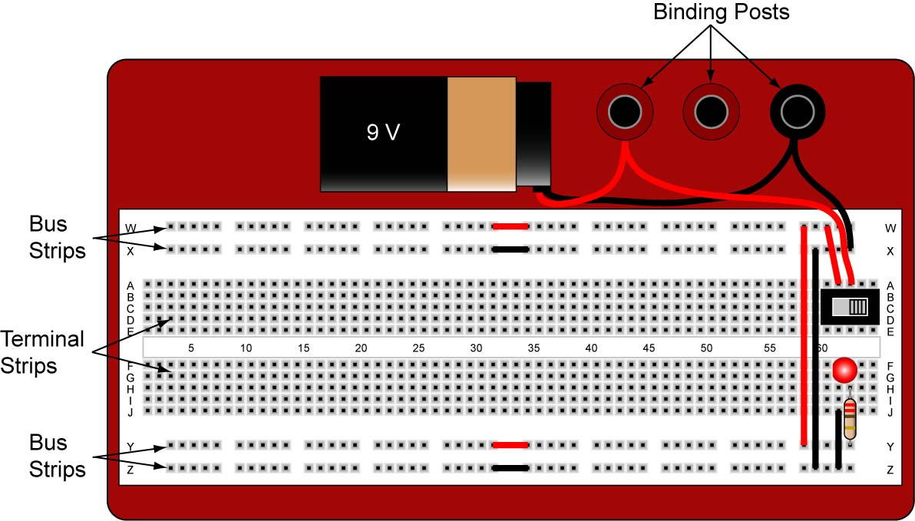

Figure 27: Solderless Breadboard Set-up with +9V Supply Bus

    - Remember to update your schematic after making corrections to the prototype circuit.
  - Robust Circuit Construction; Your Final Circuit:
    - Now that your prototype circuit has tested successfully, you must construct the final assembly so the electrical connections and components stay intact in spite of immersion, bumps, vibrations, and strain.
    - Securely anchor all components, wires, and connections to the chassis box or waterproof canister.
    - Keep crucial parts accessible for repair or replacement.
    - Some Wire Connection Options:

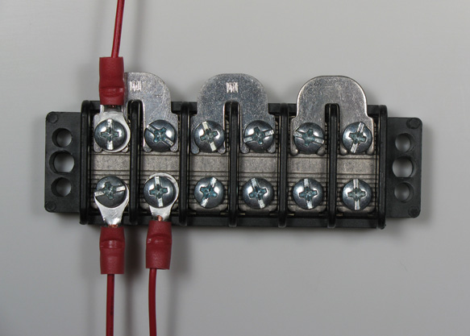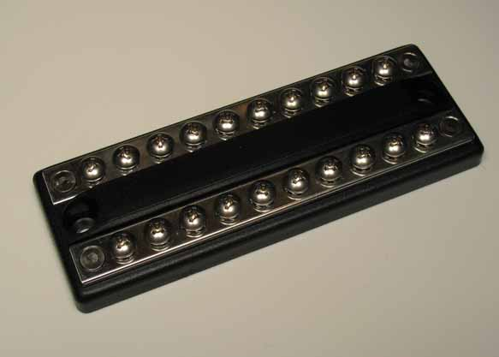

Figure 28: Terminal Strip with Jumpers Figure 29: Marine Busbars

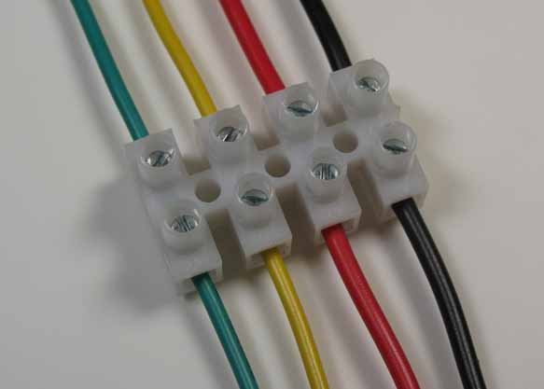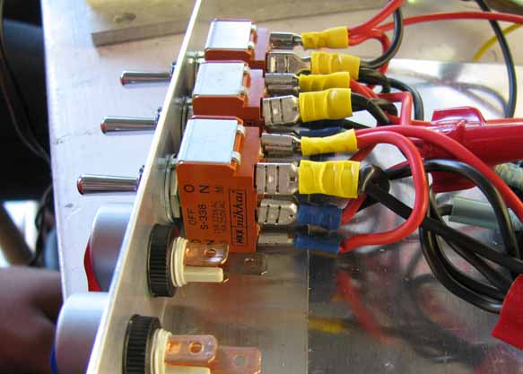

Figure 30: Eurostyle Terminal Strip Figure 31: Crimp-On Terminals

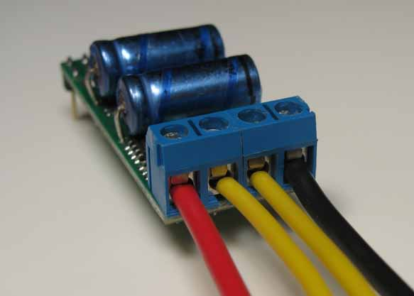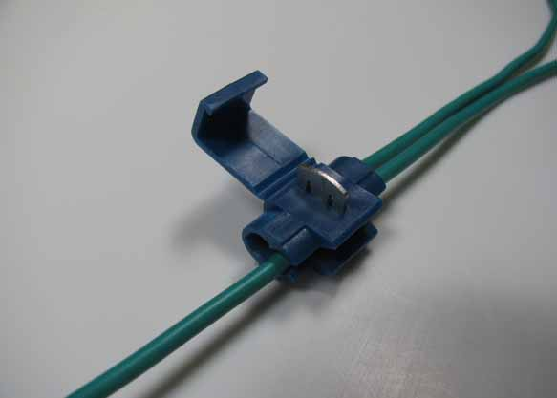

Figure 32: PCB Terminal Blocks Figure 33: Splice Connector

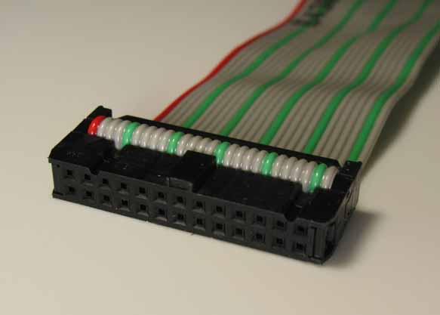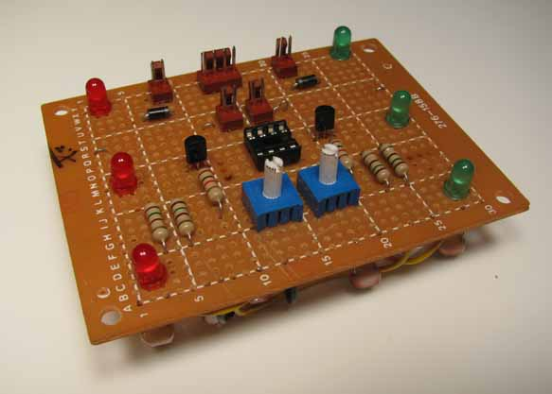

Figure 34: Ribbon Wire Connector Figure 35: Perforated Circuit Board

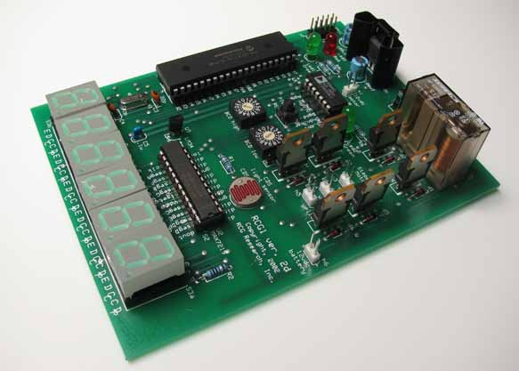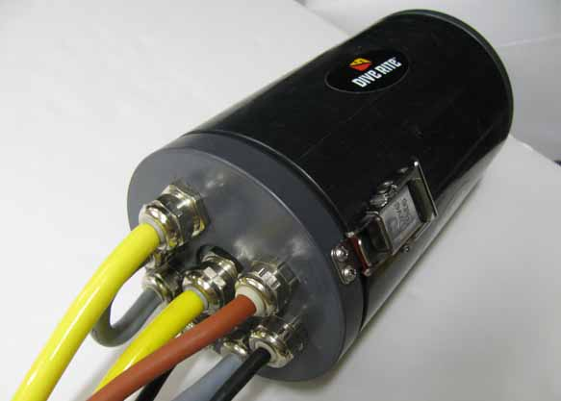

Figure 36: Printed Circuit Board Figure 37: Waterproof Housing
Cornerstone Electronics Technology and Robotics III
Power Systems 4 Lab 1 – Voltage Drop in a Tether

- Purpose: The student calculates, and then measures the voltage drop in several different gauge extension cords.

- Apparatus and Materials:
  - 1 – Digital Multimeter
  - 1 – 12 Volt Marine Battery
  - 2 – 12 V Bilge Pump Thrusters with Propellers Mounted on PVC Frame
  - 1 – 16 Gauge 50’ Extension Cord
  - 1 – 14 Gauge 50’ Extension Cord
  - 1 – 12 Gauge 50’ Extension Cord
  - Alligator Clips
  - Wire Nut Connectors

- Procedure:
  - Mount the bilge pump thrusters onto a PVC frame. See one possible frame below:

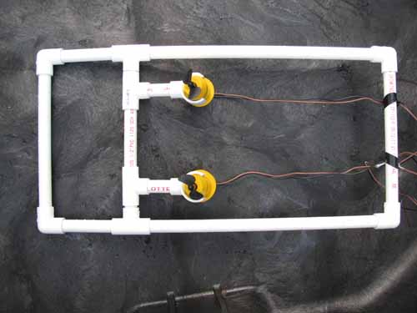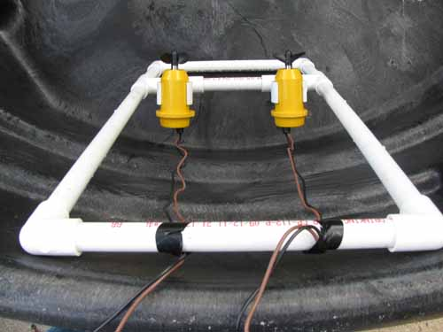

Figures 1 and 2: Bilge Pumps Mounted to a PVC Frame

  - Place the frame into a water tank or garbage can filled with water such that the leads are accessible above the surface of the water.

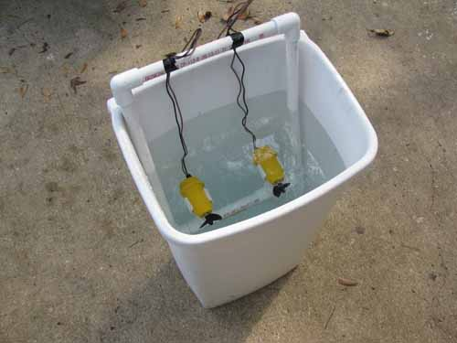

Figure 3: Bilge Pumps Ready for the Test
  - Resistance Measurements:
    - Measure the resistance of the digital multimeter leads by touching the leads together and moving around the contact points to determine the lowest resistance reading. Record your results in Table 1. Note: Most DMMs will have resistance readings of only one decimal place.
    - Twist the wires together at one end of the extension cord and measure the cord resistance at the other end. Repeat the resistance measurements for each gauge extension cord and record your results in Table 1.
    - Calculate the net cord resistance by subtracting the DMM leads resistance from the measured cord resistances. Record the calculated differences in Tables 1, 2, and 3.
  - Tether Voltage Drop with One Motor:
    - Using the alligator clips and wire nuts, connect one end of the 50’ – #16 extension cord to the 12V battery terminals and the other end to the leads of one thruster. Measure and record (in Table 2) the voltages at the battery terminals and at the thruster leads.
    - Now set the DMM to measure 10 A current and place it in series with the extension cord. Measure the current flowing to the thruster through the #16 extension cord. Record the measured current in Table 2.
    - Now calculate the voltage drop due to the 50’ – #16 extension cord by multiplying the cord resistance by the current running through the cord (V = IR). Write your answer in Table 2.
    - Derive the calculated thruster voltage by subtracting the cord voltage drop from the battery voltage. Again, write your answer in Table 2.
    - Now calculate the difference between the calculated thruster voltage and the measured thruster voltage. Record in Table 2.
    - Repeat the Steps 1 – 5 for the #14 and #12 extension cords.
  - Tether Voltage Drop with Two Motors:
    - Now repeat Steps 1 – 6 of the Tether Voltage Drop with One Motor but using two motors connected in parallel. Record the results in Table 3.
- Results:
  - Table 1: Resistance in Extension Cords:

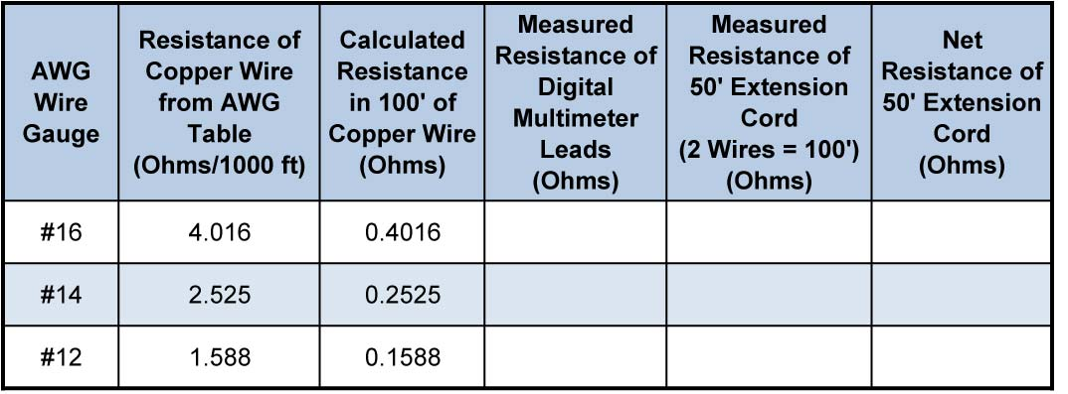
  - Table 2: Voltage Drop with One Thruster Running:

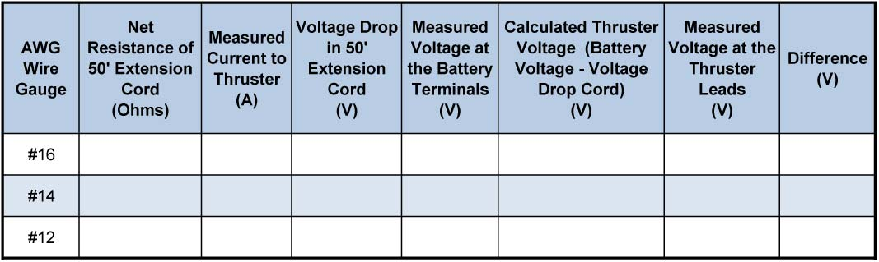

  - Table 3: Voltage Drop with Two Thrusters Running:

  - Example Voltage Drop with One Thruster Running:

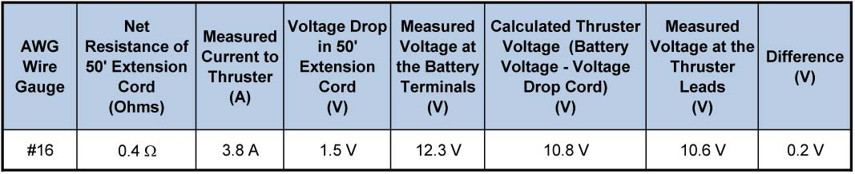

  - Example Voltage Drop with Two Thrusters Running:

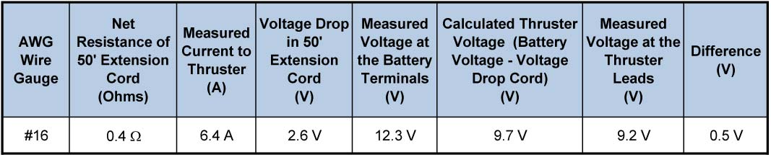

- Conclusions:
  - Complete the following statement: When you add more thrusters on the

end of the extension cord (increase the load), the voltage drop in the

cord__________________ because____________________________

_________________________________________________________.

  - What are some reasons for the differences between the calculated and measured thruster voltages?

  - Which size wire will supply the thrusters with the maximum voltage?

