Sonar Car 4 – Collision Detection
Cornerstone Electronics Technology and Robotics II

- Administration:
  - Prayer
- PicBasic Pro Programs Used in This Lesson:
  - General PicBasic Pro Program Listing: http://www.cornerstonerobotics.org/picbasic.php
  - Lab 2 – Programming the Sonar Car with sonar_car_d.pdf: http://cornerstonerobotics.org/code/sonar_car_d.pdf
- Introduction: Up to this point, the sonar car navigation system depends solely on data collected by the ultra-sonic range finder. The obstacle avoidance algorithm uses this data from the ultra-sonic sensor to make decisions about how to navigate around its environment. Unfortunately, ultra-sonic sensors have two weaknesses - angle of the target, and the 'softness' of the target which can produce faulty readings. Please refer to the lesson http://cornerstonerobotics.org/erii24_ultra_sonic_sensor_testing.pdf
for a series of informal tests that illustrate the short-comings of the ultra-sonic range finder.
- Obstacle Avoidance and Collision Detection:
  - Collision Detection: Due to the drawbacks of the range finder, there will be occasions when the ultra-sonic range finder does not detect an object and the car then collides with the obstacle, in which case, the obstacle avoidance system has failed. The car must be equipped with sensors that perceive the collision so the car can take evasive action or it may become hopelessly stuck against the obstacle.
  - Our collision detection sensor system consists of two switches mounted on the front of the car. When either of the switches is pressed (Figure 1), the car should back up and then turn to avoid the object encountered (Figure 2).
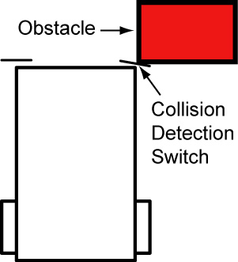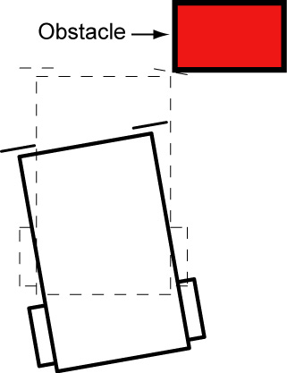
Figure 1 Figure 2

  - What kind of algorithm should we now use to make use of the switch sensors? (an algorithm is an effective method for solving a problem using a finite sequence of instructions). Look at the following pseudo code: (pseudo code is a notation that combines some of the structure of a programming language, such as IF..THEN and FOR..NEXT statements, with a natural language, such as plain English)

      - Sonar car goes straight forward
      - IF right switch pressed THEN backup and turn slightly left
      - IF left switch pressed THEN backup and turn slightly right
      - Loop to take sonar readings
  - Perform Sonar Car 4 – Collision Detection Lab 1 – Backup Routine
  - Perform Sonar Car 4 – Collision Detection Lab 2 – Programming the Sonar Car with sonar_car_d.pbp.

Sonar Car 4 – Collision Detection LAB 1 – Backup Routine
Cornerstone Electronics Technology and Robotics II

- Purpose: The purpose of this lab is to challenge the student to solve a common problem in robotics, collision detection.

- Apparatus and Materials:

  - 1 – Sonar car with Sonar Car Circuitry 1 & 2 on breadboard – see schematics at: http://cornerstonerobotics.org/schematics/pic_programming_sonar_car1.pdf and http://cornerstonerobotics.org/schematics/pic_programming_sonar_car2.pdf

- Procedure:
  - Program your ultra-sonic car such that when the car travels forward and an object presses one of the switches mounted on the front of the car:
    - The car will backup for 1 second,
    - Turn slightly in the direction opposite of the activated switch,
    - And then have the sonar car pan through the 7 servo positions again and take new readings.
  - Hint:
    - If the car is programmed to travel forward for a long time using a long PAUSE and the front switch is pressed during the long PAUSE, the PIC will not recognize the pressed switch event. You must design the program to move forward in short increments so the program can keep monitoring (polling) the front switches. Use an IF..THEN loop.
Sonar Car 4 – Collision Detection
LAB 2 – Programming the Sonar Car with sonar_car_d.pbp
Cornerstone Electronics Technology and Robotics II

- Purpose: The purpose of this lab is to review the fourth in a series of four programs that takes the class through the development of the final program sonar_car1.pbp. This lab reviews the portion of the program that detects collisions with obstacles when the ultra-sonic sensor fails to detect an object.

- Apparatus and Materials:

  - 1 – Sonar car with Sonar Car Circuitry 1 & 2 on breadboard – see schematics at: http://cornerstonerobotics.org/schematics/pic_programming_sonar_car1.pdf and http://cornerstonerobotics.org/schematics/pic_programming_sonar_car2.pdf

- Procedure:
  - Open the program as sonar_car_d.pbp (the same program as sonar_car1.pbp). See: http://cornerstonerobotics.org/code/sonar_car_d.pbp
  - Discuss operation of the program.

