“Hacking” Servos Tutorial
Cornerstone Electronics Technology and Robotics II

- Administration:
  - Prayer
- PicBasic Pro Programs Used in This Lesson:
  - General Program Listing:
http://cornerstonerobotics.org/picbasic.php
  - Lab 1 Program servo1 as PDF: http://www.cornerstonerobotics.org/code/servo1.pdf
  - Lab 1 Program servo1 as PBP: http://www.cornerstonerobotics.org/code/servo1.pbp
- Servos Review:
  - A servo is a specialized motor that can be controlled to turn to a specified position. Typically, a servo is used in hobby applications such as controlling steering for an RC (radio-controlled) car or the rudder for an RC airplane.
  - Most servos have a position range of 180 degrees (check your servo). If the input position does not match the existing position of the servo, the motor will rotate until the position matches the input position.
  - The rotational position of the servo is determined by the length of the pulse in the waveform.
    - Pulse width for counterclockwise position:

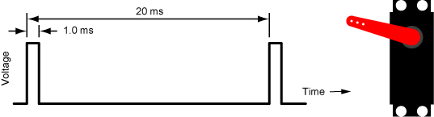

1.0 ms Pulse Width and Corresponding Servo Position

    - Pulse width for center position:

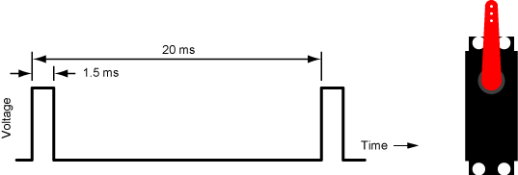

1.5 ms Pulse Width and Corresponding Servo Position

    - Pulse width for clockwise position:

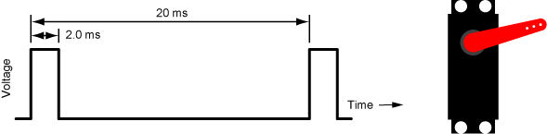

2.0 ms Pulse Width and Corresponding Servo Position

Typical Servo Signal Pulse

  - The pulse width is critical in the servo control signal. The period of the waveform (20 ms) is not as critical.
  - Oscilloscope demonstration for motor control.
- Hacking Servos for Continuous Rotation:
  - A servo may be hacked in a couple of ways. In the first method, the entire servo control board is removed leaving the dc motor encased in the servo housing. The motor is controlled as any other dc motor would be run. This approach will not be covered here but a photo sequence on flickr gives the general idea how the hacking is performed. See: http://www.flickr.com/photos/guibot/sets/72157617531839610/ . Another technique to hack a servo is to leave the servo control board intact but remove just the potentiometer. The servo motor control remains the same by using the servo pattern of pulses reviewed above. This method is dealt with below.
  - By making a couple of modifications (hacking), we can fool the servo into continuous rotation in either direction. The steps to modify a Futaba S3003 servo are as follows:
    - Remove the black horn screw and servo horn.

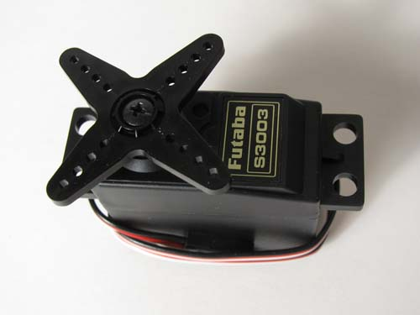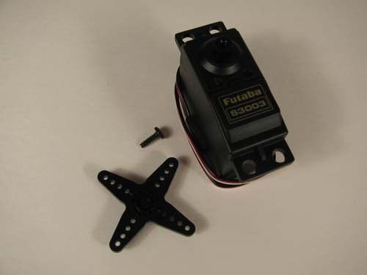

New Futaba S3003 Remove Servo Horn

    - Remove the four long screws from the back of the servo and back panel.

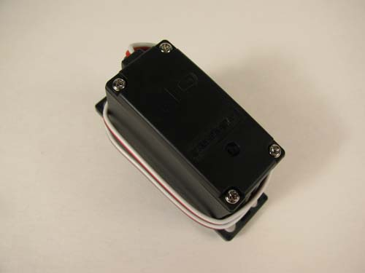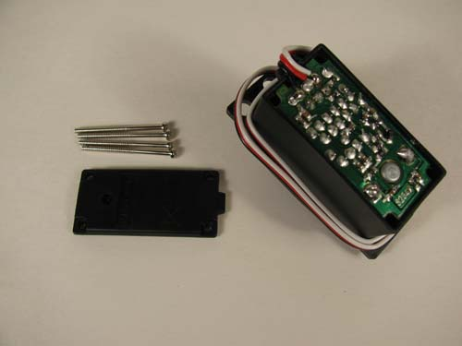

Four Rear Mounting Screws Remove 4 Screws and Rear Panel

    - Gently remove the front panel, making sure none of the gears fall out.

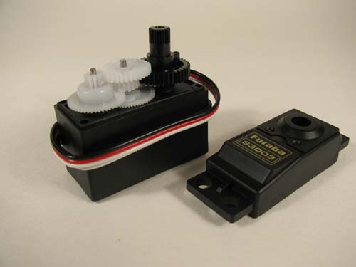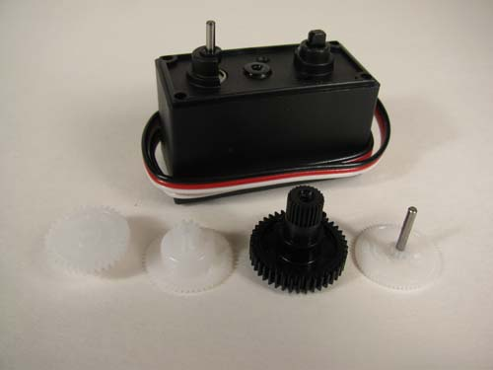

Remove Front Cover Remove and Organize 4 Gears

    - Remove all four gears in order from the front of the panel. The last gear that is against the housing can be removed by lifting the pin and gear at the same time. Place the gears in a row the way they came off the servo to help in reassembly.
    - Cut the stop from the black potentiometer gear using a small back saw or file.

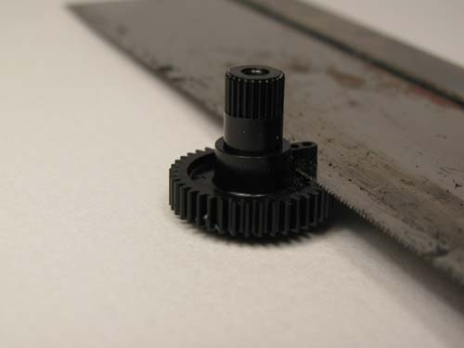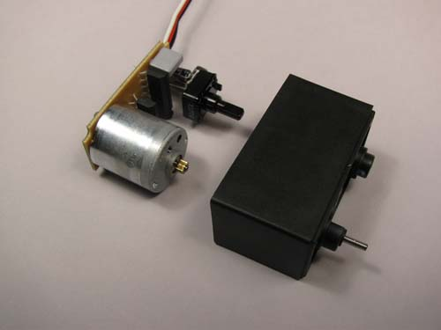

Cut Off the Potentiometer Stop Remove Control Board

    - Gently pull the servo control board out of the servo package. It is best to start by pushing the potentiometer shaft flush to the black servo housing. Then take a small screwdriver to pry at the corners to remove the control board.
    - Carefully desolder the potentiometer from the servo control board. The desoldering tool from Electronix Express (part # 060848) works extremely well for this task.

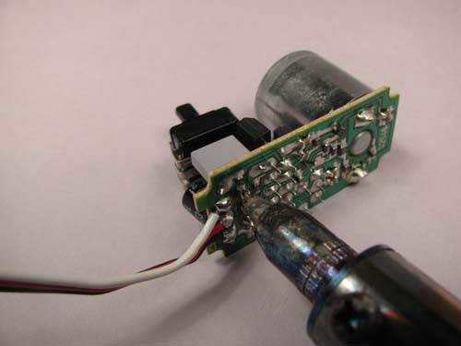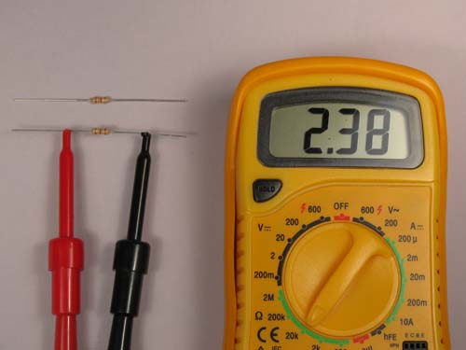

Desolder Potentiometer Measure and Match Resistors

    - Measure the resistances of several ¼ watt 2.4 K resistors (red, yellow, red) and pick two resistors with matching values; the 2.4 K resistors mimic the center position of the discarded 5 K potentiometer.
    - Twist two resistor leads together and solder twisted leads. Cut one of the leads off and straighten the other lead.

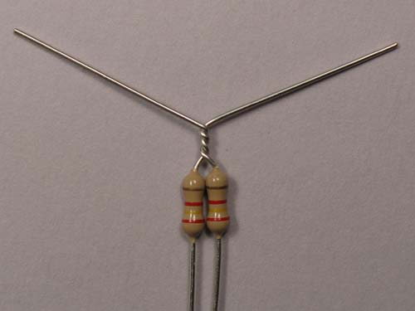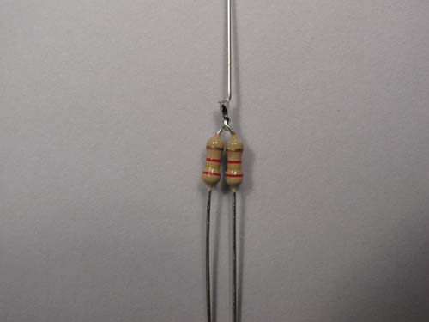

Twist Resistor Leads Solder Leads and Cut One Off

    - Insert a 10 mm piece of heat shrink tubing over the soldered lead and bend the resistor leads as shown in the photo.

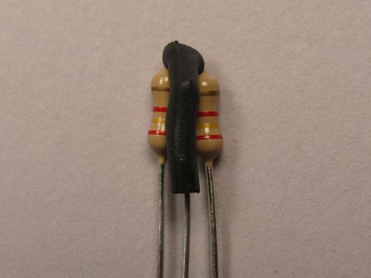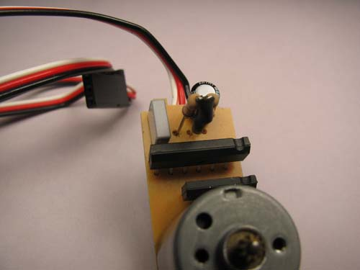

Install Heat Shrink Tubing Insert Resistors into Control Board

    - Insert the two 2.4K Ω resistors where the potentiometer once occupied. Insert the soldered lead into the center hole and the other resistor leads in the outer holes. Solder the new resistors into the control board and cut off the excessive leads.

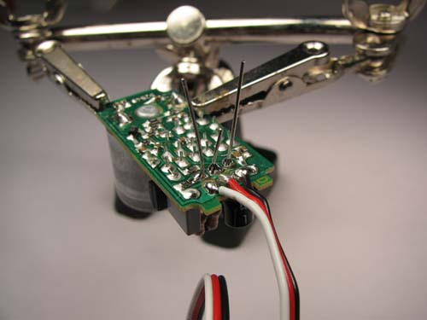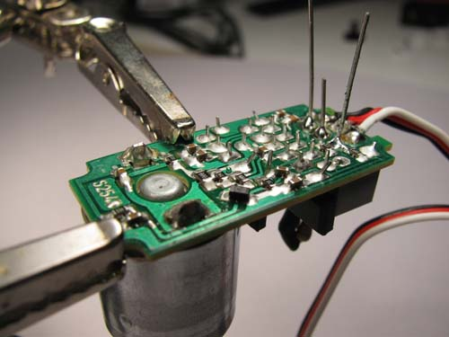

Solder Resistors in Place Solder Resistors in Place

    - Reassemble the servo.

  - Perform Hacking Servos LAB 1 – servo1.pbp
  - Details for mounting foam wheels to servos are available at: http://cornerstonerobotics.org/wheel_making.php

Cornerstone Electronics Technology and Robotics II
Hacking Servos LAB 1 – servo1.pbp

- Purpose: The purpose of this lab is to acquaint the student with the operation and programming of a “hacked” hobby servo.

- Apparatus and Materials:

    - 1 – Breadboard
    - 1 – PIC16F88 Microcontroller
    - 1 – 4.7 K, ½ Watt Resistor
    - 1 – Futaba 3003 Servo

- Procedure:
  - Assemble the following circuit on a breadboard. Make sure that the servo has a separate power supply (wire another +5V voltage regulator circuit on the breadboard).

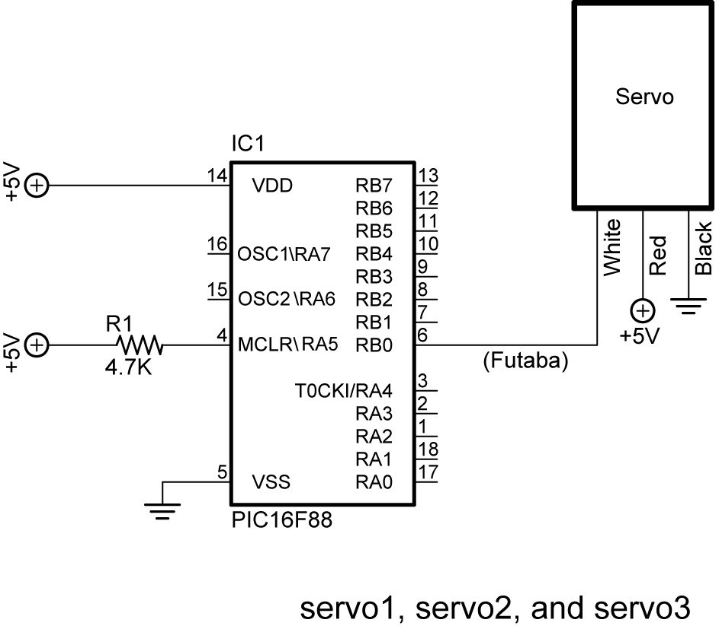

  - Now, open servo1.pbp and experiment with the PIC16F88 chip on your breadboard using test values between 100 and 200 for the pulse length. Find the setting around 150 that stops the servo from rotating.

- Challenge:
  - Pair up with another student and take two hacked servos and build a car that will navigate through the tape course on the table. Save the program as servo10.pbp. Here are the challenge conditions:
    - Dead reckoning may be used to navigate the course.
    - An LCD must display which direction the car is traveling, such as, forward, right, left, or backup.
    - Create and call up subroutines for each direction of movement including backup. Do not use the word “reverse” since it is a reserved word in PicBasic Pro. See Appendix C in the green PicBasic Pro Compiler Manual by microEngineering Labs, Inc for a listing of all the reserved words in PBP.
    - Electrical tape may be utilized to attach the servos to the car.
    - Use Maxx Products 2.5” light foam wheels (EPW250) mounted on round servo horn as the wheels. Wheels available at Colonial Hobby, Orlando, FL ($6.69 +/-) or http://www.maxxprod.com/mpi/mpi-29.html ($3.50 +/- plus shipping).
    - Alternate wheels are: Du-Bro 2.5” Micro Sport Wheels – Cat No. 250MS ($3.70 +/- plus shipping). See: http://www.shopatron.com/products/productdetail/part_number=250MS/101.0.1.1
    - Wheel mounting details are available at: http://cornerstonerobotics.org/wheel_making.php
    - Use small Irwin Quick Clamp for front pivot.

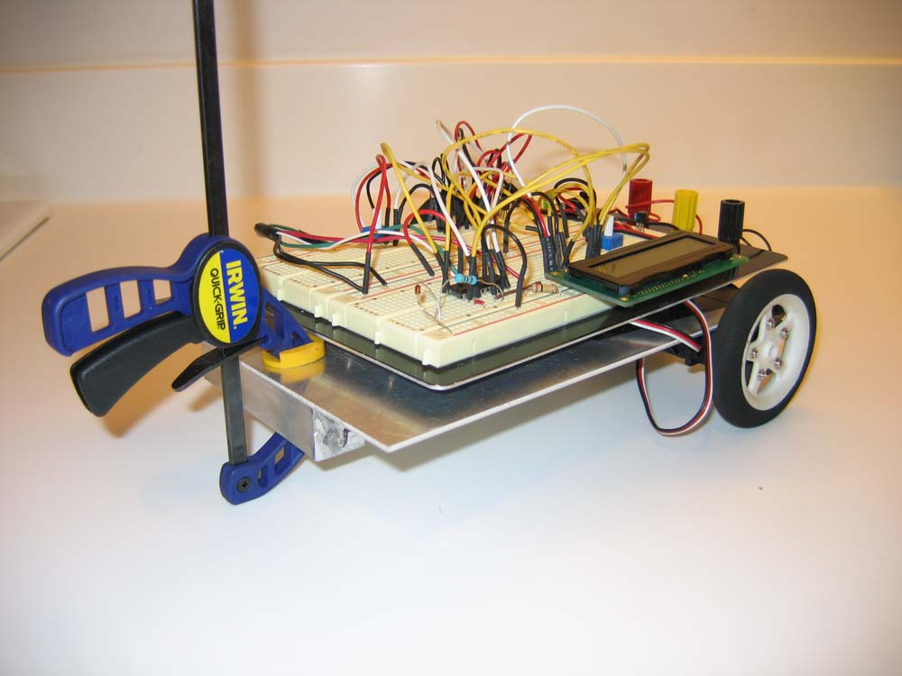

Sample Servo Driven Robotic Car

