Programming PIC Microcontrollers in PicBasic Pro – LCD Lesson 3
Cornerstone Electronics Technology and Robotics II

- Administration:
  - Prayer
- PicBasic Pro Programs Used in This Lesson:
  - General PicBasic Pro Program Listing: http://www.cornerstonerobotics.org/picbasic.php
  - Lab 1 lcd3 as .pdf file: http://www.cornerstonerobotics.org/code/LCD3.pdf
  - Lab 4 lcd1 as .pdf file: http://www.cornerstonerobotics.org/code/LCD1.pdf
- LCD PicBasic Programming:
  - New PICBasic Command:
    - POT:
      - Format

POT Pin,Scale,Var

Reads a resistive component (5K to 50K) such as a potentiometer on Pin. Pin may be called in the usual format, PORTB.0, or as a constant, 0 – 15, 0 is PORTB.0 and 15 is PORTA.7 (See section 4.11 Pins in the green PBP Compiler manual). To set Scale, see the POT command in the green microEngineering Labs PicBasic Pro Compiler manual or the explanation and table below.
      - Explanation of Scale:
        - Scale must be set empirically (with observation and experiments) such that the LCD readout value is 0 with the potentiometer set to one end and 255 when set to the other end. See the illustrations below.

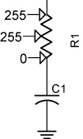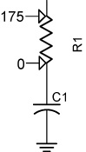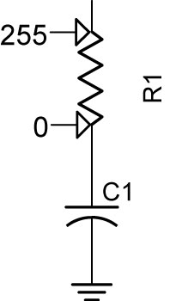

Scale Set Too High Scale Set Too Low Scale Set Properly

Figure 1, POT Scale Settings
Approximate Scale Values for Resistor R3
Resistor R3 in Schematic Below | Approximate Scale Value
5K | 165
10K | 91
25K | 45
50K | 38

      - Example:

POT 0,178,x ‘POT reading on Pin RBO assigned to variable, x. Scale = 178 to give a full range of values over the potentiometer (0 to 255) for the variable, x.

LCD Command Table

Command | Operation
$FE, 1 | Clear display
$FE, 2 | Return home
$FE, $0C | Cursor off
$FE, $0E | Underline cursor on
$FE, $0F | Blinking cursor on
$FE, $10 | Move cursor left one position
$FE, $14 | Move cursor right one position
$FE, $18 | Display shift left
$FE, $1C | Display shift right
$FE, $80 | Move cursor to beginning of first line
$FE, $C0 | Move cursor to beginning of second line
$FE, $94 | Move cursor to beginning of third line
$FE, $D4 | Move cursor to beginning of fourth line

  - Perform LCD3 LAB 1 – lcd3.pbp
  - Perform LCD3 LAB 2 – 5–10K Series Resistors
  - Perform LCD3 LAB 3 – LED Status on LCD
- Defining LCD Pins:
  - PicBasic Pro permits changing of LCD pin connections by using DEFINE statements. The LCD default pin connections are shown in Figure 2:

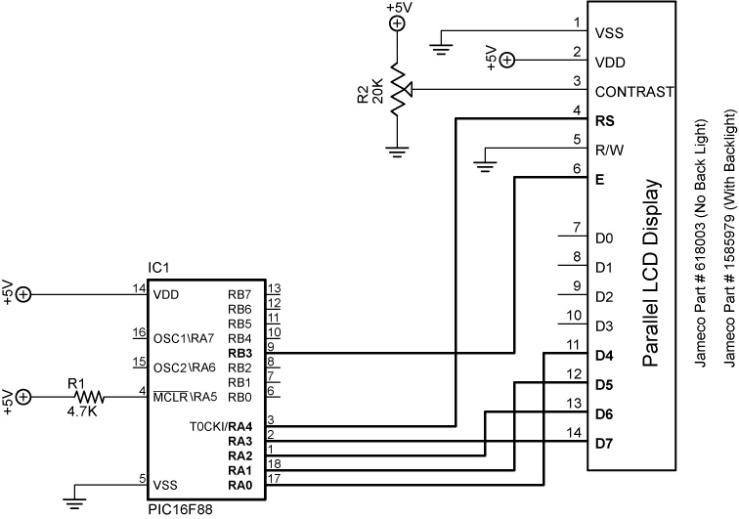

Figure 2, LCD Default Connections
  - To move the data connections, use the following DEFINE statements:
    - DEFINE LCD_DREG sets the LCD data port.
      - Examples:
        - DEFINE LCD_DREG PORTA ‘Sets PORTA as LCD data port
        - DEFINE LCD_DREG PORTB ‘Sets PORTB as LCD data port
      - If an 8-bit data bus is used, all 8 bits must be in one port
      - If a 4-bit data bus is used, the top 4 LCD data bits (DB4-DB7) must be either wired to the bottom 4 or top 4 bits of the port selected. For example, if DEFINE LCD_DREG PORTB is declared, then the top LCD bits DB4-DB7 must be connected to either RB0-RB3 or RB4-RB7 (see DEFINE LCD_DBIT immediately below).
      - PicBasic Pro assumes the data lines DB4-DB7 are connected to PORTA.0-PORTA.3 (RA0-RA3).
    - DEFINE LCD_DBIT sets starting data bit for 4-bit bus.
      - Examples:
        - DEFINE LCD_DBIT 0 ‘Set starting data bit to 0
        - DEFINE LCD_DBIT 4 ‘Set starting data bit to 4
      - PicBasic Pro default starting bit is bit 0 of PORTA or PORTA.0
    - Example: Move the data port AN0-AN3 to PORTB and the starting data bit to bit 4. Let Register Select and Enable connections remain unchanged.
      - DEFINE Statements:
        - DEFINE LCD_DREG PORTB ‘Sets PORTB as LCD data port
        - DEFINE LCD_DBIT 4 ‘Set starting data bit to 4
      - The schematic in Figure 3 shows relocated the data port connections:

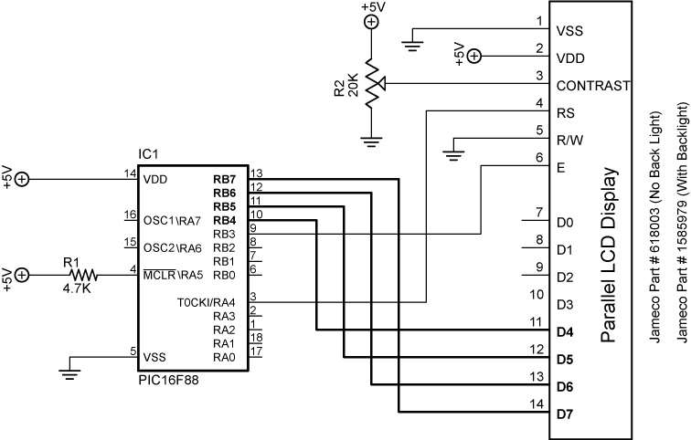

Figure 3, Revised Data Port Connections

  - To move the Register Select and Enable connections, use the following DEFINE statements:
    - DEFINE LCD_RSREG sets the Register Select (RS) port.
      - Examples:
        - DEFINE LCD_RSREG PORTB ‘Sets PORTB as the RS port
        - DEFINE LCD_RSREG PORTE ‘Sets PORTE as the RS port
      - Register Select may be connected to any port pin.
      - PicBasic Pro default setting for Register Select is PORTA.
    - DEFINE LCD_RSBIT sets the Register Select (RS) bit.
      - Examples:
        - DEFINE LCD_RSBIT 2 ‘Sets bit 2 as RS bit
        - DEFINE LCD_RSBIT 6 ‘Sets bit 6 as RS bit
      - Register Select may be connected to any port pin.
      - PicBasic Pro default setting for Register Select is bit 4 of PORTA or PORTA.4.
    - DEFINE LCD_EREG sets the Enable (E) port.
      - Examples:
        - DEFINE LCD_EREG PORTB ‘Sets PORTB as Enable port
        - DEFINE LCD_EREG PORTD ‘Sets PORTD as Enable port
      - Enable may be connected to any port pin.
      - PicBasic Pro default setting for Enable is PORTB.
    - DEFINE LCD_EBIT sets the Enable (E) bit.
      - Examples:
        - DEFINE LCD_EBIT 3 ‘Sets bit 3 as the Enable bit
        - DEFINE LCD_EBIT 7 ‘Sets bit 7 as the Enable bit
      - Enable may be connected to any port pin.
      - PicBasic Pro default setting for Enable is bit 3 of PORTB or PORTB.3.
    - Example: Move the Register Select from AN4 to RB0 and the Enable from RB3 to RB1. Leave the data port connections in their default configuration.
      - DEFINE Register Select Statements:
        - DEFINE LCD_RSREG PORTB ‘Sets PORTB as the RS port
        - DEFINE LCD_RSBIT 0 ‘Sets bit 0 as RS bit
      - DEFINE Enable Statements:
        - DEFINE LCD_EREG PORTB ‘Sets PORTB as Enable port
        - DEFINE LCD_EBIT 1 ‘Sets bit 1 as the Enable bit
      - The schematic in Figure 4 on the next page shows the relocated Register Select and Enable connections:

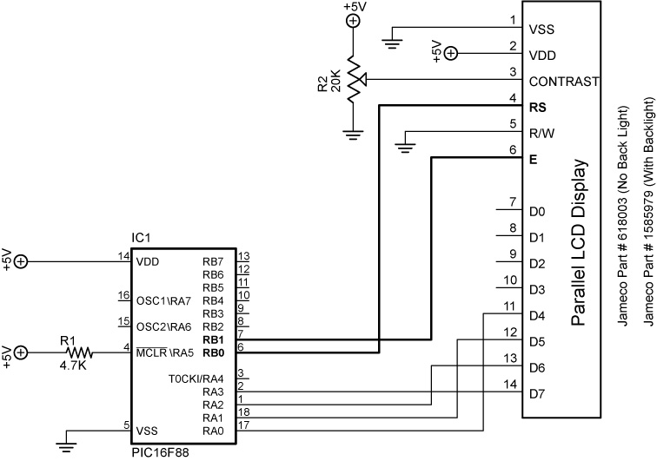

Figure 4, Revised Register Select and Enable Connections

    - DEFINE LCD_BITS sets the bus size (4-bits or 8-bits).
      - Examples:
        - DEFINE LCD_BITS 4 ‘Sets 4-bit bus
        - DEFINE LCD_BITS 8 ‘Sets 8-bit bus
      - PicBasic Pro default setting for bus size is a 4-bit bus.
    - DEFINE LCD_LINES sets the number of lines on the LCD.
      - Examples:
        - DEFINE LCD_LINES 4 ‘Sets LCD to display 4 lines
        - DEFINE LCD_LINES 2 ‘Sets LCD to display 2 lines
      - PicBasic Pro default setting is for the number of lines on the LCD is a 2 line LCD display.
  - In summary, LCD connections to PICs can be changed from their PIC default settings by using the DEFINE statements listed above.
  - We will need use these features in our lesson on analog-to-digital conversion.
  - Perform LCD3 LAB 4 – Changing LCD Pins on a PIC

Cornerstone Electronics Technology and Robotics II
LCD Lesson 3 LAB 1 – lcd3.pbp

- Purpose: The purpose of this lab is to acquaint the student the PicBasic Pro command POT and the use of an LCD to monitor variable input values.

- Apparatus and Materials:

    - 1 – Analog/Digital Trainer
    - PIC 16F88 Microcontroller
    - Hantronix HDM16216H-5-300S 16x2 LCD, Jameco #618003
    - 20 K Potentiometer
    - 10K Potentiometer (R3)
    - 4.7 K Resistor
    - 0.1 uF Capacitor
- Procedure:
  - Wire the in-circuit serial programming connections before proceeding. See Lesson 15A, In-Circuit Serial Programming for details.
  - Now add the following circuitry. Use a 10K trimpot for R3:

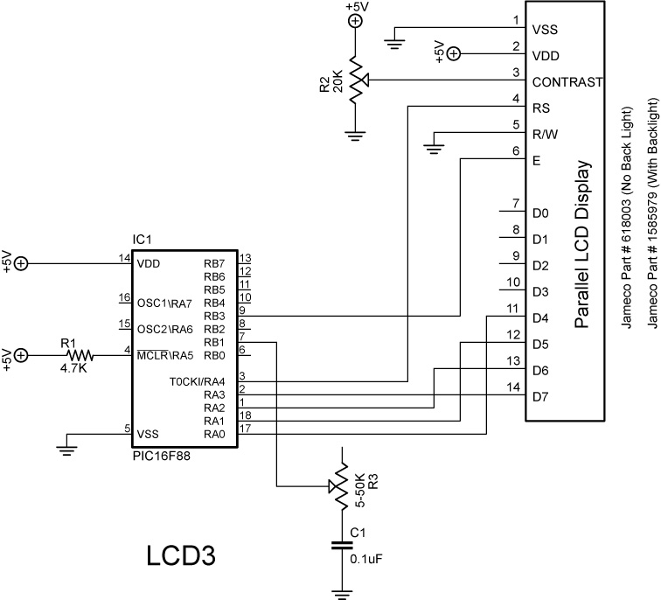

  - Open lcd3.pbp and download into the PIC16F88.
    - Adjust the 10K potentiometer R3 to see if the full range of the potentiometer is engaged.
    - If the full range is not active, adjust the Scale value in the POT command to make the full range active. Do this by empirically (through observation and experimentation) setting the Scale value to its lowest number while the LCD displays 255.
Cornerstone Electronics Technology and Robotics II
LCD Lesson 3 LAB 2 – Five 10K Series Resistors

- Purpose: The purpose of this lab is to acquaint the student the fact that the PicBasic Pro command POT in non-linear in nature.

- Apparatus and Materials:

    - 1 – Analog/Digital Trainer
    - PIC 16F88 Microcontroller
    - Hantronix HDM16216H-5-300S 16x2 LCD, Jameco #618003
    - 20 K Potentiometer
    - 5 - 10K Resistors
    - 4.7 K Resistor
    - 0.1 uF Capacitor
- Procedure:
  - Wire the circuit LCD4 below and program the chip with lcd3.pbp.
  - Connect pin RB1 to Point A as shown in the schematic below. Set the POT command Scale value such that the 255 is the full range for the 5 – 10K resistors. Start by setting the Scale low so the LCD reads a number below 255, and then raise the Scale until you reach a full range reading of 255.
  - Now connect RB1 to Points B through F and plot the results on the accompanying graph. Observe the non-linear nature of the plot.

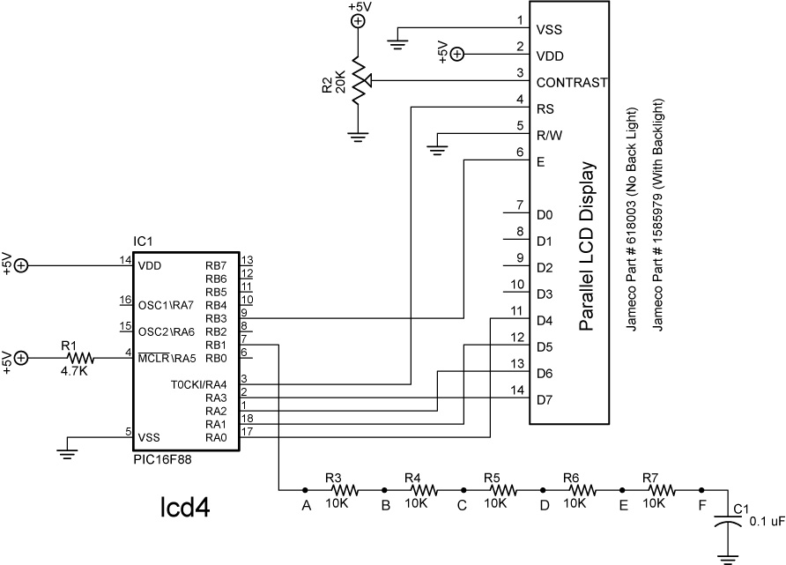

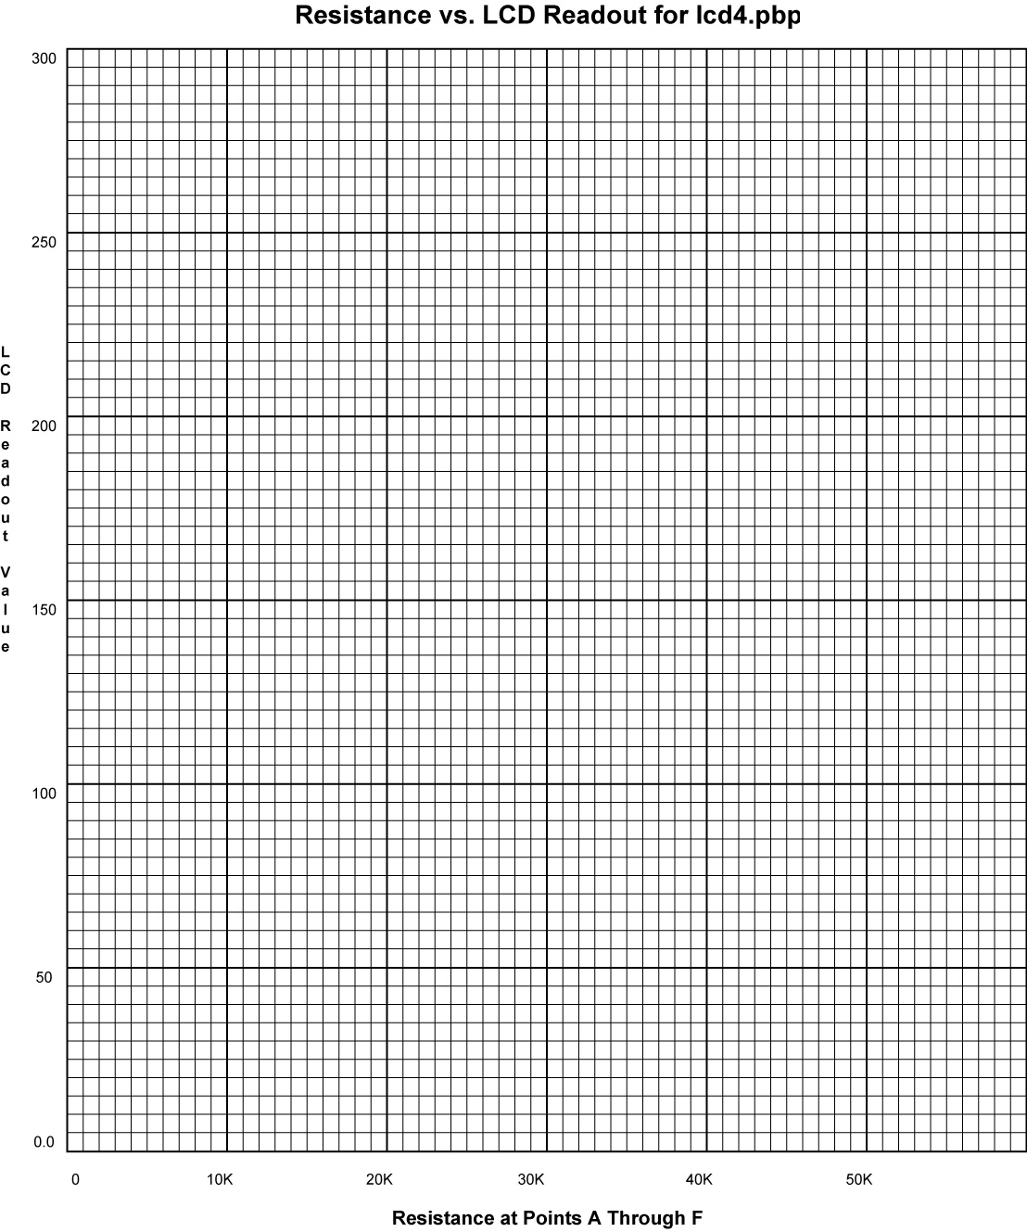
Cornerstone Electronics Technology and Robotics II
LCD Lesson 3 LAB 3 – LED Status on LCD

- Purpose: The purpose of this lab is to acquaint the student with using an LCD to display the state of an output.

- Apparatus and Materials:

    - Analog/Digital Trainer or Breadboard w/ 5VDC Supply
    - PIC 16F88 Microcontroller
    - Hantronix HDM16216H-5-300S 16x2 LCD, Jameco #618003
    - 1 – 4.7K Resistor
    - 2 – 150 Ohm Resistors
    - 20 K Potentiometer
    - 2 – LEDs

- Procedure:
  - Wire the following circuit lcd1.
  - Open blink1.pbp from your folder and run the program.

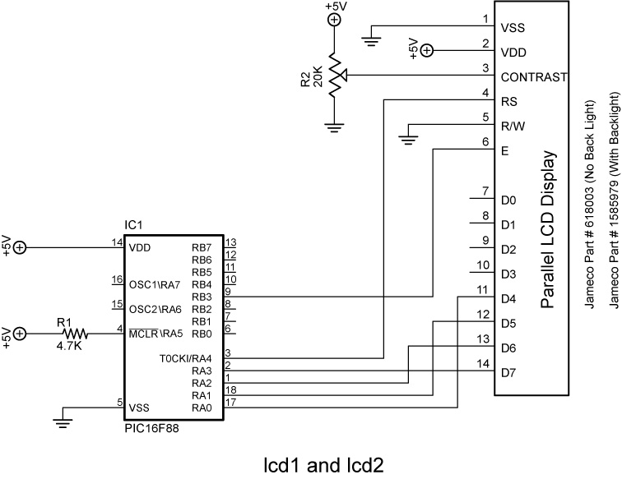
- Challenges:
  - Connect one LED (LED1) with a 150 ohm resistor to PORTB.1 and program it to blink on and off every second. Display “LED1” and its state (0 or 1) as a variable on the LCD. Save the program as lcd16.pbp. Don’t forget to set the proper bits in the TRISB register to outputs as needed.
  - Connect a second LED (LED2) to PORTB.2 and program it to blink opposite LED1. Display “LED1” on the first line and “LED2” on the second line with their respective states as variables. Save the program as lcd17.pbp.
Cornerstone Electronics Technology and Robotics II
LCD Lesson 3 LAB 4 – Changing LCD Pins on a PIC

- Purpose: The purpose of this lab is to acquaint the student with changing the default connections of an LCD to a PIC chip.

- Apparatus and Materials:

    - Analog/Digital Trainer or Breadboard w/ 5VDC Supply
    - PIC 16F88 Microcontroller
    - Hantronix HDM16216H-5-300S 16x2 LCD, Jameco #618003
    - 1 – 4.7K Resistor
    - 1 – 20 K Potentiometer

- Procedure:
  - Wire the following circuit lcd1.
  - Download lcd1.pbp into the PIC16F88
  - Change the LCD pin connections from their default settings to:
    - Data port: PORTB
    - Starting data bit: 0
    - Register Select port: PORTB
    - Register Select bit: 4
    - Enable port: PORTB
    - Enable bit: 5
    - 4 or 8-bit bus: 4-bit bus, the PBP default setting
    - Lines on LCD: 2, the PBP default setting
  - Save the revised lcd1.pbp as lcd18.pbp
  - Rewire the circuit to reflect the change in LCD pin connections.

