Electronics and Robotics I Week 25
Resistive Sensors

- Administration:
  - Prayer
- PicBasic Pro Programs Used in This Lesson:
  - General PicBasic Pro Program Listing: http://www.cornerstonerobotics.org/picbasic.php
  - Lab 1 adc1 as a .pdf file: http://www.cornerstonerobotics.org/code/adc1.pdf
  - Lab 1 adc2 as a .pdf file: http://www.cornerstonerobotics.org/code/adc2.pdf
  - Lab 1 adc3 as a .pdf file: http://www.cornerstonerobotics.org/code/adc3.pdf
  - Lab 2 braitenberg1 as a .pdf file: http://www.cornerstonerobotics.org/code/braitenberg1.pdf
  - Lab 3 bend_sensor1.pbp as a .pdf file: http://www.cornerstonerobotics.org/code/bend_sensor1.pdf
- Resistive Sensors:
  - PicBasic Pro POT vs. ADCIN Commands:
    - Depending upon the circuit conditions, resistive sensors may be read using the POT or ADCIN commands.
    - POT Command:
      - Resistive device normally within the 5 – 50 K ohm range.
      - The POT command measures the time it takes to charge a capacitor in a resistor/capacitor series circuit. Knowing the value of the capacitor and the charging time, the PIC converts the time value into an 8-bit resistance value of 0 - 255.
      - There is no voltage source when using the POT command therefore it does not measure a voltage drop. See the schematic comparison below.
      - Restricted to an 8-bit variable, giving outputs from 0 – 255.
      - See the following website for further discussion: http://books.google.com/books?id=XYwuCq5u2oEC&pg=PA189&lpg=PA189&dq=resistive+sensors+picbasic+pro&source=web&ots=d9Vra7g0Z2&sig=dZ5Ml3R4vSSOCE9aeaxEronc8gw

    - ADCIN Command:
      - ADCIN, which reads an A/D converter (analog to digital converter), measures a voltage drop across a resistor.
      - There is a voltage source when using the A/D command ADCIN.
      - Variables may be 8, 10, or 12-bit, generating outputs of 0 – 255, 0 – 1024, or 0 – 4096 respectfully. The ADCIN command is more accurate than the POT command.
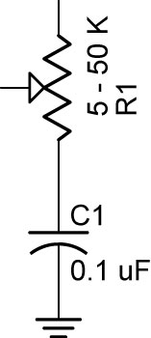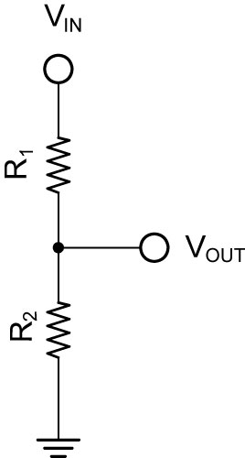

POT Uses No Voltage Source ADCIN Has a Voltage Source, V_{IN}

      - This lesson will focus on the ADCIN command.

  - Voltage Divider Review:
    - Voltage at Point A, V_{A}:

      - Current through the series resistors:

V_{IN} = I R_{TOTAL}, since R_{TOTAL} = R₁ + R₂,

V_{IN} = I (R₁ + R₂)

Solving for I,

I = V_{IN} / (R₁ + R₂)
      - V_{OUT}:

V_{OUT} = I R₂, since the current, I, was solved above,

V_{OUT} = [V_{IN} / (R₁ + R₂)] x R₂, and

V_{OUT} = V_{IN} x R₂ / (R₁ + R₂)

      - Cases:
        - When R₂ equals R₁, then V_{A} equals ½ V_{IN}.
        - When R₂ is smaller than R₁, then V_{OUT} will be closer to 0 volts or ground; conversely, when R₂ is larger than R₁, then V_{OUT} will be closer to V_{IN}.
      - In our application, V_{IN} = +5V, so V_{OUT} varies from near 0 V to near +5 V.
    - Perform Resistive Sensors LAB 1 – Reading a Potentiometer
  - Photoresistor Sensors (Cadmium Sulfide, CdS, Photo Sensor):
    - Cadmium sulfide changes in resistance when exposed to varying degrees of light. The resistance of a CdS photoresistor or photocell decreases as it receives more light (an inverse relationship).
    - Photocells have a relatively slow response to changes in light. The characteristic blinking of overhead fluorescent lamps, which turn on and off at the 60 Hertz line frequency, is not detected by photocells.
    - Demonstrate 60 Hz frequency using a photocell and phototransistor circuits and a frequency counter and oscilloscope. Video?
    - If a photoresistor is substituted for R₂ in the voltage divider above and it is illuminated brightly, its resistance will be low and V_{A} will be near 0V.
    - In contrast, if the same photoresistor is shielded from light, its resistance will be high and V_{A} will be near +5V.
    - Photoresistors normally require shielding because they are sensitive to ambient or surrounding light.
    - Use the photoresistor as R₂ in the voltage divider. See below:
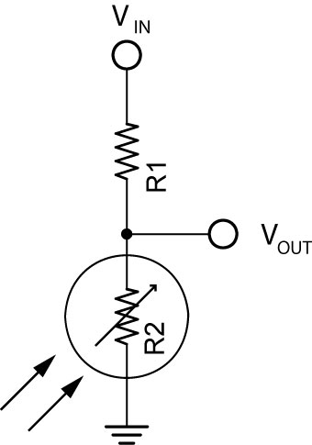

CdS Photocell in Voltage Divider
      - Use the following formula to calculate the value for R₁:

R₁ = SQRT(CdS_{DARK} * CdS_{BRIGHT})

Where:
R₁ = Resistance of Resistor 1,
Cds_{DARK} = Resistance of the CdS photocell in the darkest condition the photocell will operate,
CdS_{BRIGHT} = Resistance of the CdS photocell in the brightest condition the photocell will operate

      - Source and derivation of the equation: http://www.societyofrobots.com/schematics_photoresistor.shtml

    - Complete Resistive Sensors LAB 2 – CdS Photoresistors
  - Other Resistive Sensors:
    - Bend Sensors:
      - The resistance of the sensor increases in proportion to the degree of bending or flexing. For the Jameco #150551, 0 degrees is about 10K ohms and 90 degrees is 30K – 40K ohms.
      - Perform Resistive Sensors Lab 3 – Bend Sensors
      - Source for bend sensors: http://www.robotshop.ca/home/products/robot-parts/sensors/stretch-bend-sensors/

Electronics and Robotics I Week 25
Resistive Sensors LAB 1 – Reading a Potentiometer

- Purpose: The purpose of this lab is to teach the student how to wire a PIC18F88 for analog/digital conversion, to expose the student to the PicBasic Pro command ADCIN, and to introduce the linear slide sensor.

- Apparatus and Materials:

  - 1 – Breadboard with +5V supply or an Analog/Digital Trainer
  - 1 – PIC 16F88 Microcontroller
  - 1 – 10 K Tripot
  - 1 – Phidgets Slide Sensor, Product # RB-Phi-20 from:
http://www.robotshop.ca/home/products/robot-parts/sensors/linear-rotary-resistors/index.html

- Procedure:
  - Wire the circuit below. Use a 10K tripot for R3. Make sure to read the note in the schematic.
  - Program the PIC16F88 with adc1.pbp, adc2.pbp, and then adc3.pbp. Adjust R3 and note the values on the LCD screen for each program.
  - Now substitute the slide sensor for the 10K tripot. Note the changes in the LCD value as the linear position of the slide sensor moves.
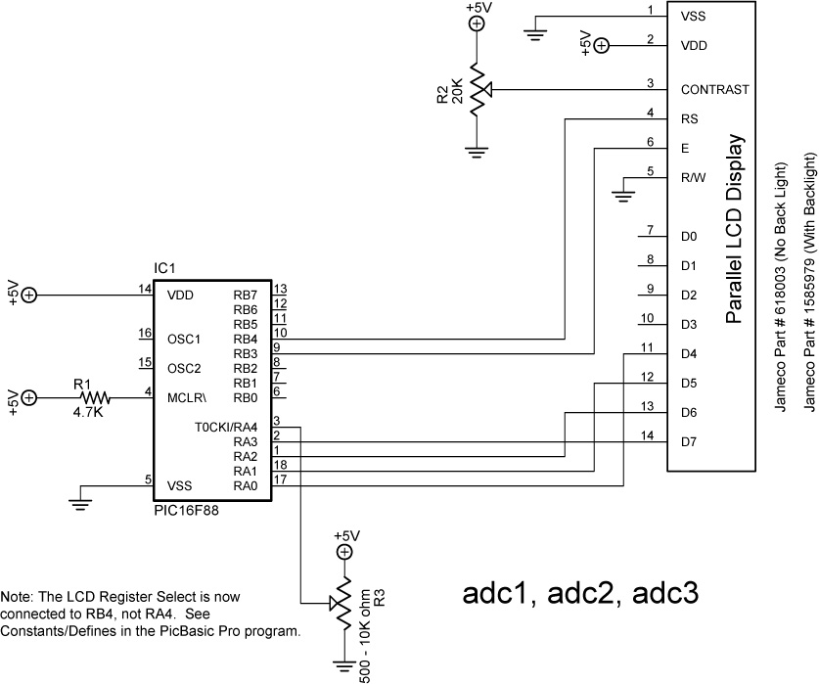
Electronics and Robotics I Week 25
Resistive Sensors LAB 2 – CdS Photoresistors

- Purpose: The purpose of this lab is to acquaint the student with the use of a CdS photocell as a resistive sensor.

- Apparatus and Materials:

  - 1 – Robotic Car Platform
  - 1 – PIC 16F88 – I/P Microcontroller
  - 1 – LCD Screen, Jameco #618003
  - 1 – 20 K Ohm Potentiometer
  - 2 – CdS Photoresistors, Jameco #120299 (300K-Dark, 8K-Light)
  - 1 – 4.7K Resistor
  - 4 – 1K Resistor, Includes R3 and R8
  - 2 – 2N2222A NPN Transistors

- Procedure:
  - Wire the following circuit.
  - Program the PIC16F88 with braitenberg1.pbp.
  - Adjust the CdS photocells for the car to be attracted to the light. See: http://www.youtube.com/watch?v=N_X4_VVxOrE
- Challenges:
  - Line-follower: Mount CdS sensors on your robotic car for the car to follow a taped line. See: http://www.youtube.com/watch?v=ut0iTLZykog
  - Light-Steering: Use one photocell to activate steering or forward motion for the robotic car. Use a second photocell to turn the robotic car off. The car must begin in the starting box and come to a complete stop in the finish box.
  - CdS switch: Wire a circuit and program a PIC16F88 to serve as a light activated switch which turns on and off an LED.

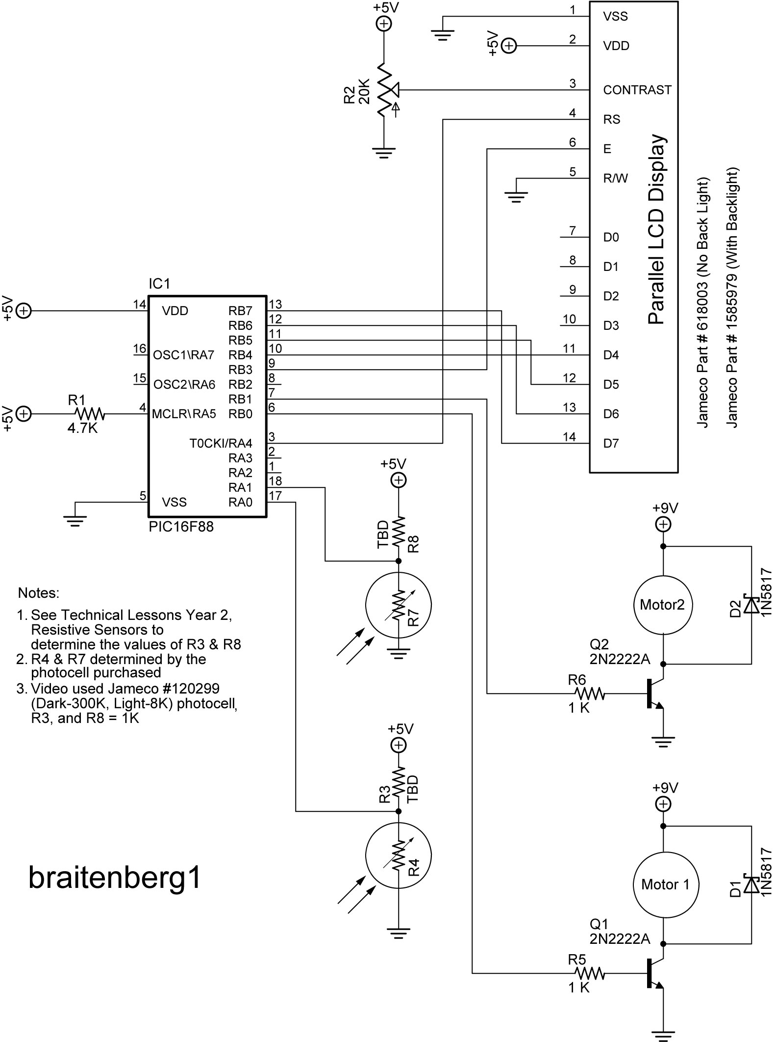

Electronics and Robotics I Week 25
Resistive Sensors LAB 3 – Bend Sensors

- Purpose: The purpose of this lab is to acquaint the student with the function of a bend sensor.

- Apparatus and Materials:

    - 1 – Breadboard
    - 1 – PIC 16F88 Microcontroller
    - 1 – 4.7K Ohm Resistor
    - 1 – 22K Resistor
    - 1 – 20K Tripot
    - 1 – Bend Sensor, Jameco #150551
    - 1 – LCD Screen, Jameco # 618003
    - 1 – Futaba 3003 Hobby Servo

- Procedure:
  - Wire the circuit bend_sensor1.
  - Program the PIC16F88 with bend_sensor1.pbp
  - Bend flex sensor and note servo movement.
  - Review the derivation of the equation in the graph below.

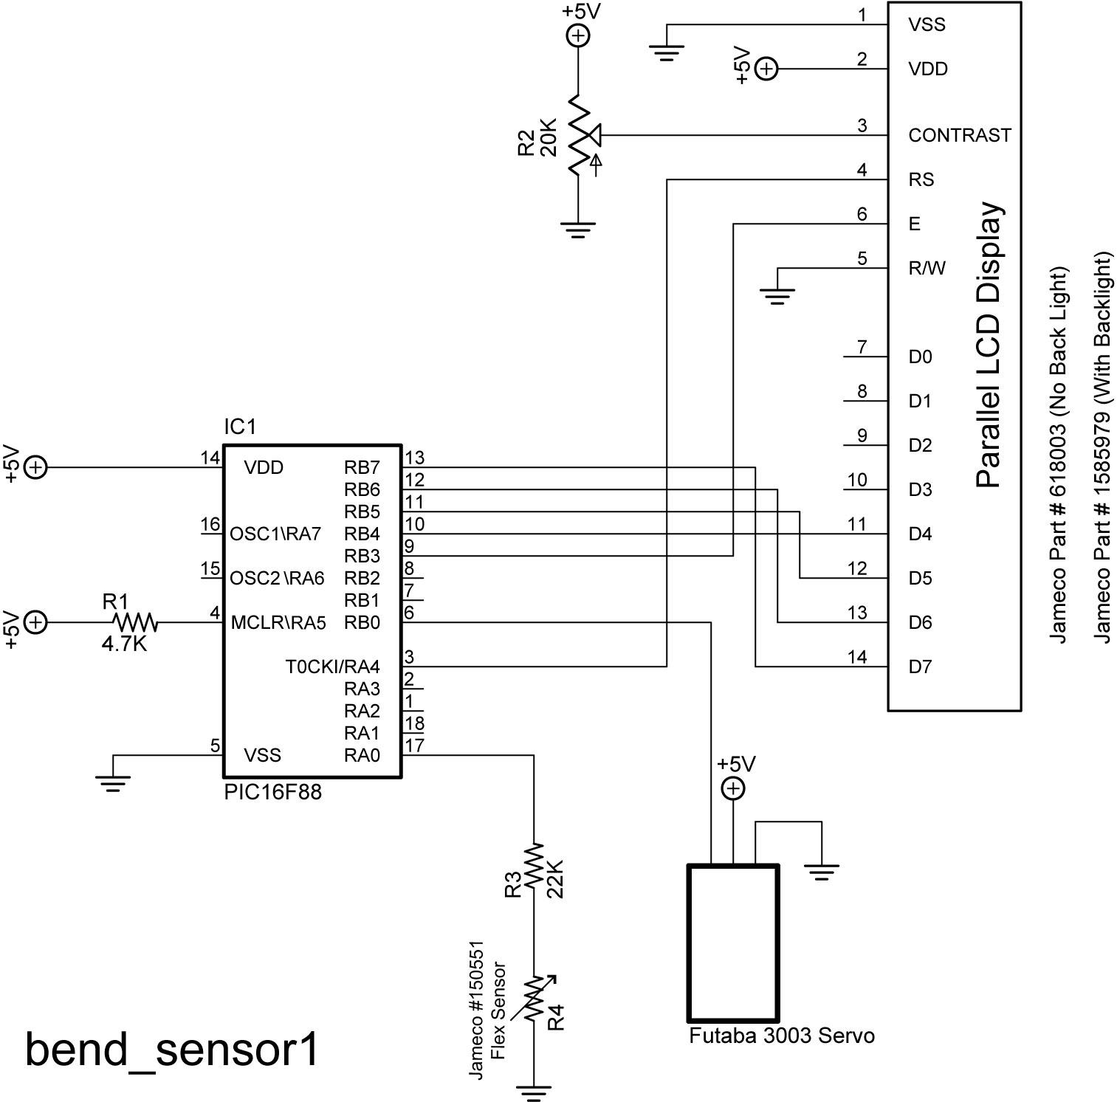

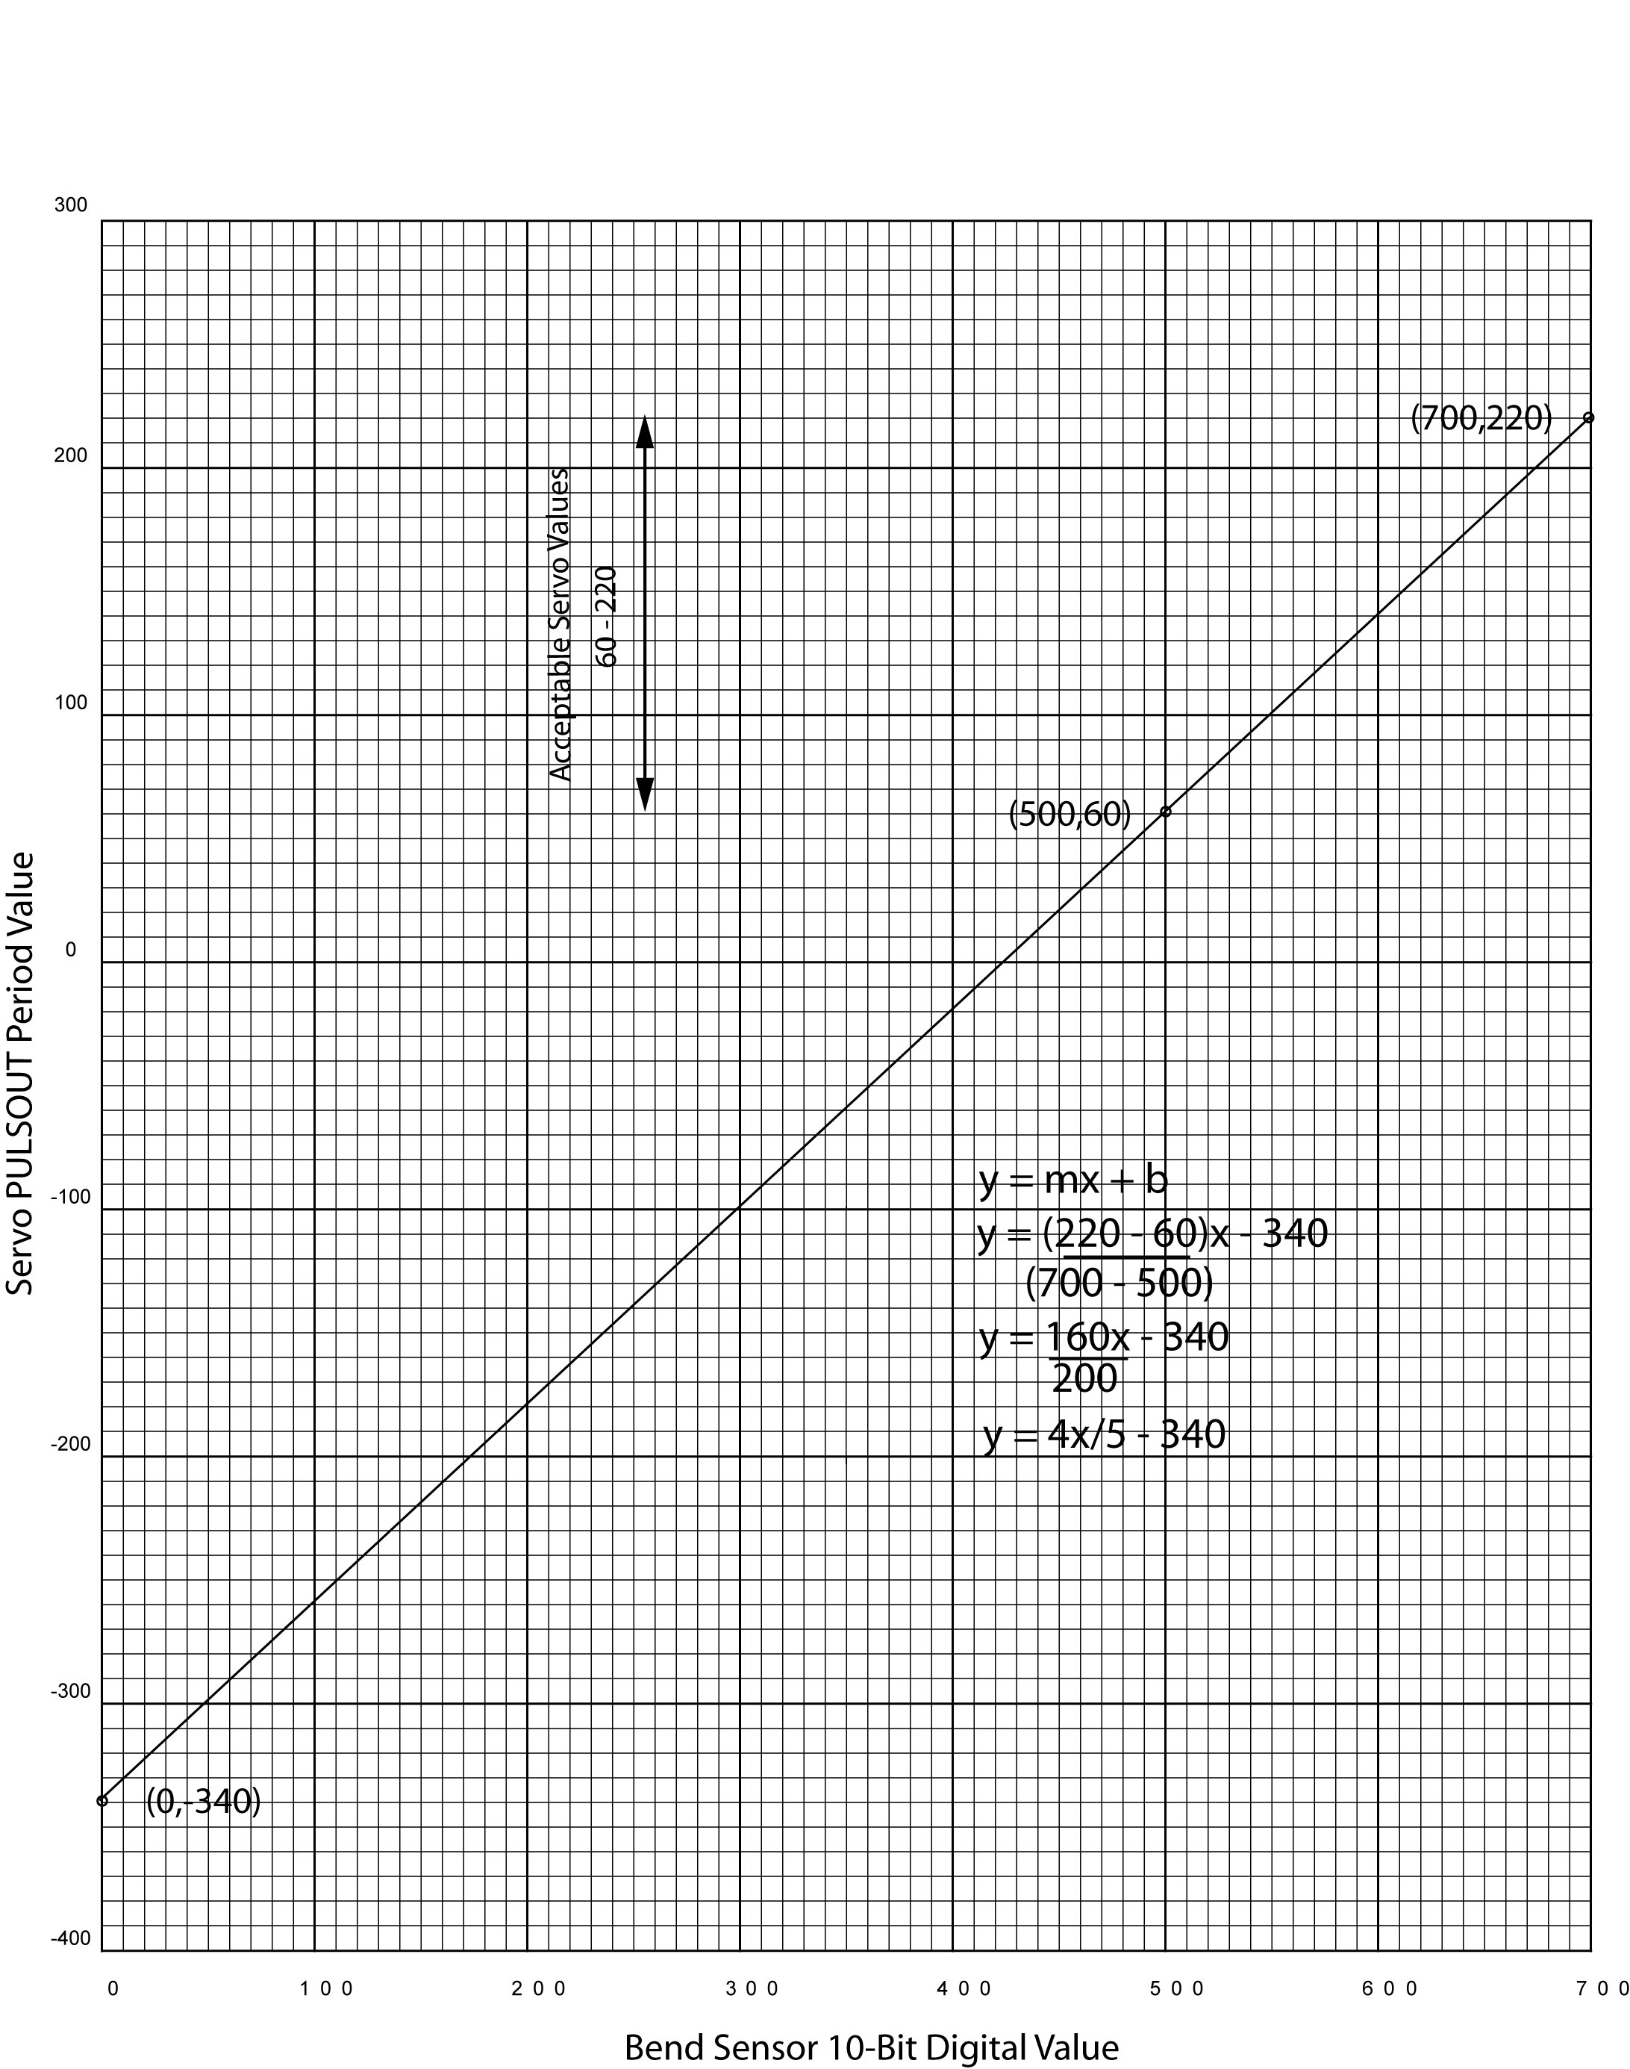

Derivation of Formula Used in bend_sensor1.pbp

