Cornerstone Electronics Technology and Robotics I Week 12a
Digital Applications

- Administration:
  - Prayer
  - Turn in quiz
- Logic Probes:
  - Basic test equipment for digital circuits
- 7- Segment Displays:
  - A display made of 7 separate LEDs that have been combined into one package for displaying numbers.
  - Standard 7-segment display layout and 10 digits:

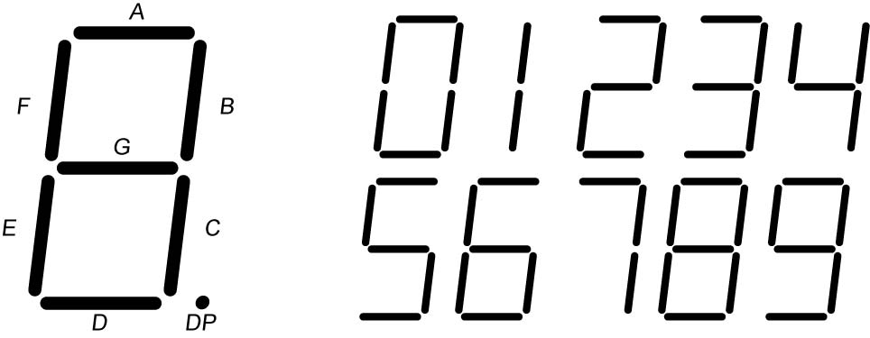

  - Common Cathode 7-Segment Display:
    - In a common cathode 7-segment display, all of the cathodes from all the LED’s are connected together. The 150 ohm resistor limits current through all of the LED’s to ground.
    - Each one of the LED’s, (A through DP), will light only when it is connected to V_{CC}, (+5V), either manually or through a device such as a PIC microcontroller.

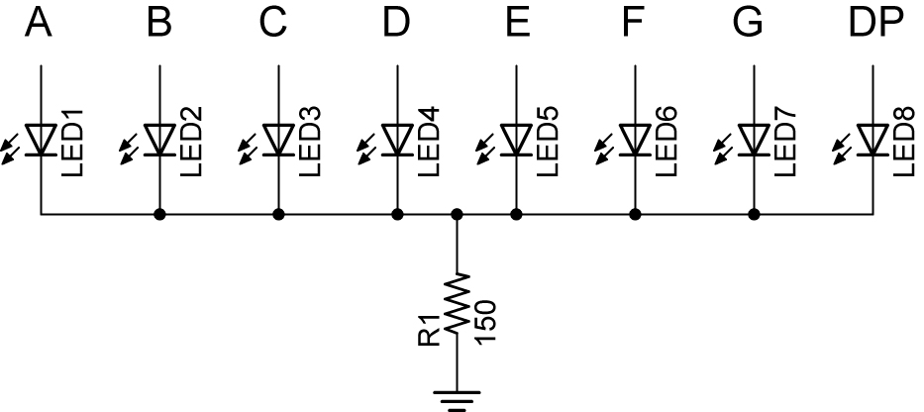

7-Segment Display with Common Cathode

  - Common Anode 7-Segment Display:
    - In a common anode 7-segment display, all of the anodes of all the LED’s are connected together to V_{CC}, or in our case, +5 volts. The 150 ohm resistor limits current through all of the LED’s.
    - Each one of the LED’s will light only when cathode is connected to ground, either manually or through a device like a 74LS47 decoder (see Digital Applications LAB 2).

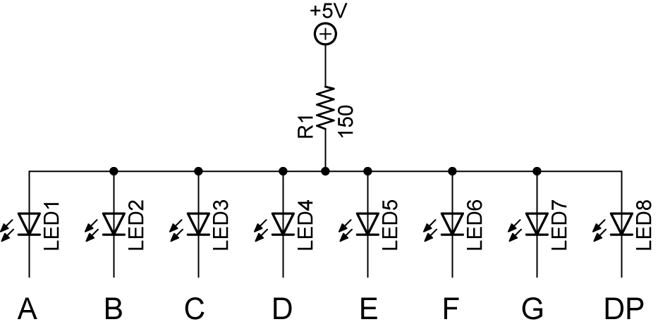

7-Segment Display with Common Anode

- Perform Digital Applications LAB 1 – 7-Segment Displays
- BCD or Binary Coded Decimal:
  - A hybrid or mixture of decimal and binary numbering systems
  - Each decimal digit is replaced by its 4-bit binary number equivalent.
  - Used at input/output ports of digital systems, e.g. Digital Applications LABs 2, 3, and 4.

Decimal | BCD
0 | 0000
1 | 0001
2 | 0010
3 | 0011
4 | 0100
5 | 0101
6 | 0110
7 | 0111
8 | 1000
9 | 1001
10 - 15 | Invalid

Decimal Digits and BCD Equivalent

  - Only valid BCD codes are 0000 – 1001; binary numbers above 1001 are not valid. For example, 1010 is not a valid BCD code. BCD codes have 4 bits.
  - The decimal number 95 is represented by 1001 0101 (9 5) or 10010101. The decimal number 9 is converted to the BCD code equivalent 1001 and the decimal number 5 is converted to the BCD code equivalent 0101, then they are joined together as 10010101.
  - The decimal number 631 is represented by 0110 0011 0001 (6 3 1) or 011000110001.
  - Write the decimal number 8160 in BCD code.
- Digital Encoders and Decoders:
  - A decoder is a digital circuit device that converts coded information (like a binary number) into a noncoded form (like a 7–segment display of a decimal number).
  - Complete LAB 2 – BCD-to-7-Segment Decoder
- Flip-Flops:
  - Used in counters, timers, sequencing devices, and memories.
- Counters:
  - A counter is a digital circuit that counts electronic events, such as pulses, usually indicating consecutive integers.
  - There are two types of counters: up counters which increase in value and down counters which decrease in value.
  - A counter may be:
    - A 2 – bit binary counter (%00 to %11)
    - A 3 – bit binary counter (%000 to %111)
    - A 4 – bit binary counter (%0000 to %1111)
    - A decade counter (0 to 9)
    - This list is not exhaustive
  - Synchronous Counters - all memory elements are simultaneously triggered by the same clock.
  - Decade Counter:
    - A decade counter is a counter that has ten states.
  - Complete LAB 3 – BCD Decade Counter
  - Complete LAB 4 – Cascade BCD Decade Counter

Cornerstone Electronics Technology and Robotics II
Digital Applications LAB 1 – 7-Segment Displays

- Purpose: The purpose of this lab is to acquaint the student with a common cathode and common anode 7-segment displays.

- Apparatus and Materials:
  - 1 – Analog/Digital Trainer
  - 1 – Jameco 24782 Common Cathode 7-Segment Display
    - Maximum voltage rating is 2.8V
  - 1 – Jameco 97172 Common Anode 7-Segment Display
    - Maximum voltage rating is 2.8V
  - 1 – 150 Ohm Resistor

- Procedure:
  - Using +5 volts as V_{CC}, connect the Jameco 24782 common cathode 7-segment display to display the number 3. Connect the 7-segment display pins to the HI/LO switches as shown in the table below. Remember, the maximum voltage rating for this 7-segment display is 2.8V, i.e., remember the 150 ohm resistor.

7-Segment Pin | HI/LO Switch
A | 0
B | 1
C | 2
D | 3
E | 4
F | 5
G | 6

  - Use the logic probe to measure each pin and record the results in the first table below.
  - Now generate all of the codes for all of the digits 0 – 9 and fill in the table on the next sheet.

 |  | Jameco 24782
 |  | Common Cathode
 |  | Pin Layout
 |  | F |  |  |  |  |  |  |  |  |  | A
 |  |  |  |  |  |  | A
 |  | G |  |  |  |  |  |  |  |  |  | B
 |  |  |  | F |  |  |  |  |  | B |  | GND
 |  |  |  |  |  |  | G
GND
 |  |  |  | E |  |  |  |  |  | C
 |  | E |  |  |  |  |  |  |  |  |  | DP
 |  |  |  |  |  |  | D
 |  | D |  |  |  |  |  |  |  |  |  | C

- Results for Displaying the Number 3:

Pin | - | G | F | E | D | C | B | A
1 or 0 | 0

- Discussion: Notice that the line of 1’s and 0’s in the table can be thought of as a 7-segment code where each number (0-9) has a distinct binary code. Unlike a binary number where each bit is weighted, this binary code is unweighted. This means that the position of each bit does not indicate a magnitude represented for that position.
- Results Continued:

Decimal | - | G | F | E | D | C | B | A
0 | 0
1 | 0
2 | 0
3 | 0
4 | 0
5 | 0
6 | 0
7 | 0
8 | 0
9 | 0

7-Segment Display Look-up Table

  - Using a calculator or pc, convert the following hexadecimal numbers to binary numbers and display them on the analog/digital trainer. The least significant bit of the binary number is displayed using the 0 HI/LO switch of the analog/digital trainer. This switch corresponds to the “A” LED on the standard 7-segment display layout. The hexadecimal numbers are: $6F, $7F, $7, $7D, $6D, $66, $4F, $5B, $6, $3F. In the binary numbers, the zeros to the left of the most significant “1” are not shown.

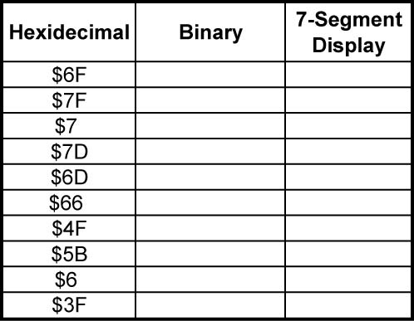
Cornerstone Electronics Technology and Robotics II
Digital Applications LAB 1 – 7-Segment Displays Continued

  - Connect the Jameco 97172 common anode 7-segment display to display the number 2. Remember, the maximum voltage rating for this 7-segment display is 2.8V.

Jameco 97172
Common Anode
Pin Layout
 |  |  |  |  | A
 |  |  |  |  | N
 |  |  |  |  | O
 |  |  |  |  | D
 |  |  | G | F | E | A | B
 |  |  |  |  | A
 |  | F |  |  |  |  |  | B
 |  |  |  |  | G
 |  | E |  |  |  |  |  | C
 |  |  |  |  |  |  | .
 |  |  |  |  | D
 |  |  | E | D | A | C | DP
 |  |  |  |  | N
 |  |  |  |  | O
 |  |  |  |  | D
 |  |  |  |  | E

Cornerstone Electronics Technology and Robotics II
Digital Applications LAB 2 – BCD-to-7-Segment Decoder

- Purpose: The purpose of this lab is to acquaint the student with the operation of a BCD-to-7-Segment Decoder.

- Apparatus and Materials:

  - 1 – Analog/Digital Trainer
  - 1 - 150 Ohm, ½ watt Resistor
  - 1 – Jameco 97172 Common Anode 7-Segment Display
  - 1 - 74LS47 BCD-to-Seven-Segment Decoder

- Procedure:
  - Wire the 74LS47 decoder to the 7-segment display as shown. Pin 8 is grounded; Pin 16 is +5V on the 74LS47 chip.
  - Use the HI/LO toggles to create the BCD inputs for Pins 7, 1, 2, and 6. See Table 1 below.

74LS47 Pin | HI/LO Switch
7 | 0
1 | 1
2 | 2
6 | 3

Table 1

  - Using BCD code as the inputs, display each number, (0 – 9) on the 7-segment display.
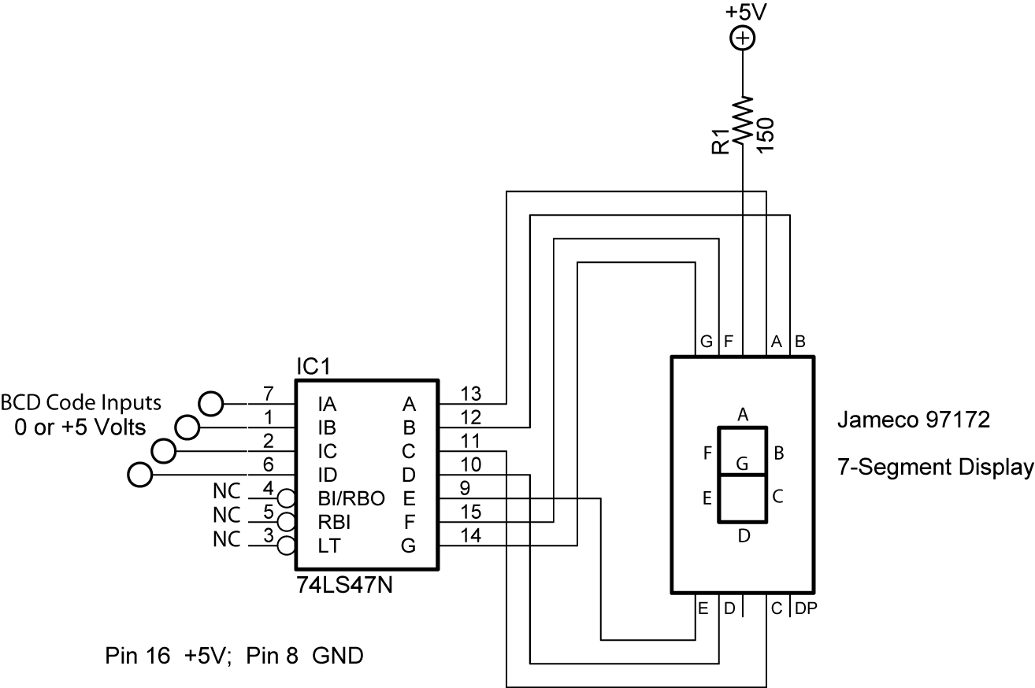

74LS47 BCD to Decimal Decoder

- Table 2 lists 74LS47 inputs and 7-segment display outputs:

BCD Code | 74LS47 Pin Inputs (BCD Code) |  |  |  | 7-Segment
 | Pin 6 | Pin 2 | Pin 1 | Pin 7 | Display
 | ID | IC | IB | IA | Decimal Output
0000 | 0 | 0 | 0 | 0 | 0
0001 | 0 | 0 | 0 | 1 | 1
0010 | 0 | 0 | 1 | 0 | 2
0011 | 0 | 0 | 1 | 1 | 3
0100 | 0 | 1 | 0 | 0 | 4
0101 | 0 | 1 | 0 | 1 | 5
0110 | 0 | 1 | 1 | 0 | 6
0111 | 0 | 1 | 1 | 1 | 7
1000 | 1 | 0 | 0 | 0 | 8
1001 | 1 | 0 | 0 | 1 | 9

Table 2
Cornerstone Electronics Technology and Robotics II
Digital Applications LAB 3 – BCD Decade Counter

  - Purpose: The purpose of this lab is to acquaint the student with the operation of a BCD decade counter.

  - Apparatus and Materials:

    - 1 – Analog/Digital Trainer
    - 1 – 150 Ohm, ½ watt Resistor
    - 1 – Jameco 97172 Common Anode 7-Segment Display
    - 1 – 74LS47 BCD-to-Seven-Segment Decoder
    - 1 – 74LS160 BCD Decade Counter

  - Procedure:
    - Wire the following BCD decade counter circuit using LEDs as outputs.
    - The LEDs give a binary representation of the counter BCD code output. Toggle the pulse on Pin 2 to advance the BCD count. Pulse (Pin 2) is connected to S1, one of the Pulse toggle switches on the analog/digital trainer.
    - If using a breadboard, S1 must be debounced. See the following links:
      - http://www.ganssle.com/debouncing.pdf
      - http://www.geocities.com/thetonegod/debounce/debounce.html
      - http://www.bioinspired.com/users/ajg112/electronics/debounce.shtml
    - Use the HI/LO toggle switches as the inputs for Pins 3, 4, 5, and 6. See Table 3 below.

74LS160 Pin | HI/LO Switch
3 | 0
4 | 1
5 | 2
6 | 3

Table 3

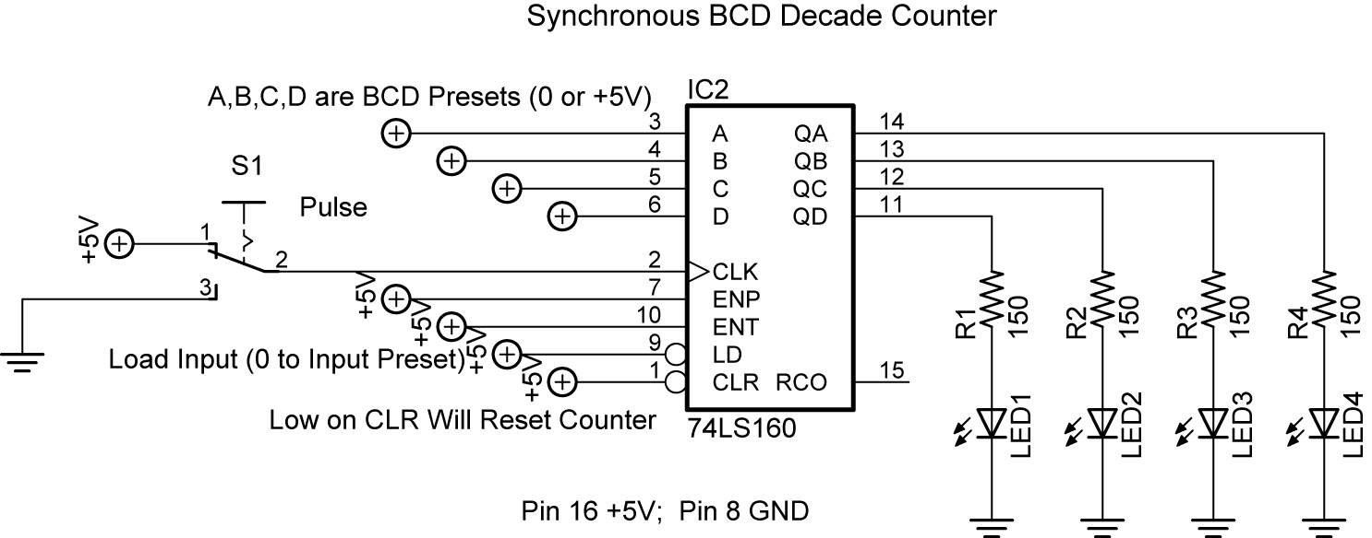

Decade Counter Circuit Driving LEDs

    - Connect the counter to the decoder as shown below. Note: When connecting the 74LS160 to the 74LS47, just add the 74LS160 BCD decade counter onto the 74LS47 decoder circuit already on the breadboard.

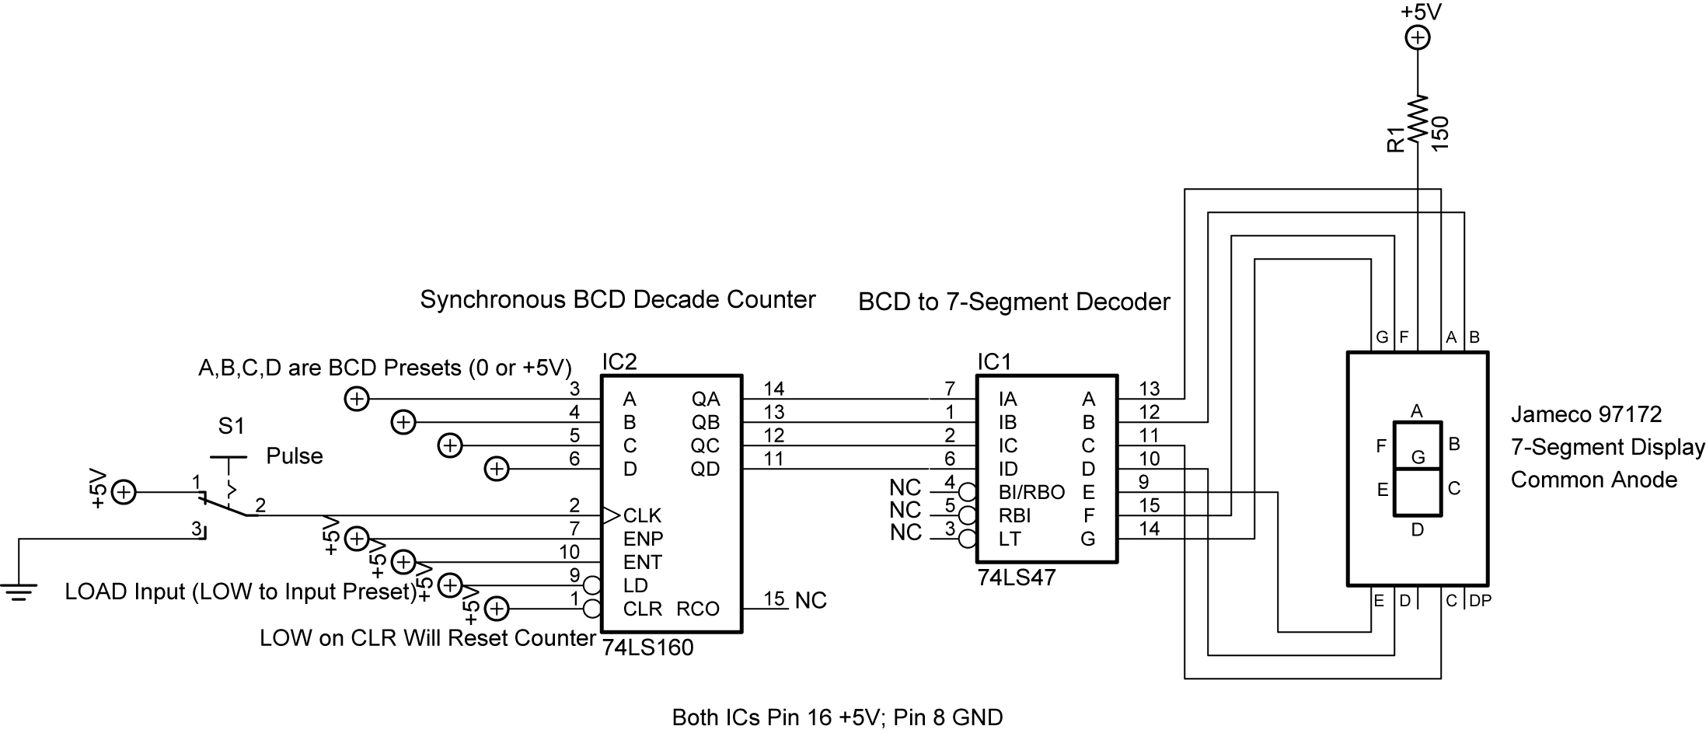

Decade Counter Circuit Driving BCD to 7-Segment Decoder

Cornerstone Electronics Technology and Robotics II
Digital Applications LAB 3 – BCD Decade Counter Continued

    - 74LS160N Features:
      - ENP and ENT, pins 7 and 10 respectively, must be HIGH for the counter to advance. When one or both are LOW, the counter is disabled.
      - LOW on CLR, pin 1, will reset counter to 0.
      - Can preset counter to any BCD count between 0 and 9. Use A, B, C, and D to preset BCD number. A is the LSB, or the Least Significant Bit, and D is the MSB, or the Most Significant Bit. LD (Load), pin 9, must be on LOW to accept the preset number on the next pulse.
      - RCO (Ripple Clock Output), not used here, goes HIGH when the counter reaches the terminal count of 9. This output in conjunction with the enable inputs allows these counters to be cascaded for higher count sequences.
      - See: http://www.datasheetcatalog.com/datasheets_pdf/7/4/L/S/74LS160.shtml
Texas Instruments page 5 for schematic of counter.

Cornerstone Electronics Technology and Robotics II
Digital Applications LAB 4 – Cascade BCD Decade Counter

  - Purpose: The purpose of this lab is to acquaint the student with the method of cascading BCD decade counters.

  - Apparatus and Materials:

    - 1 – Analog/Digital Trainer
    - 2 – 150 Ohm, ½ watt Resistors
    - 2 – Jameco 97172 Common Anode 7-Segment Displays
    - 2 – 74LS47 BCD-to-Seven-Segment Decoders
    - 2 – 74LS160 BCD Decade Counters

  - Procedure:
    - Wire the two cascade BCD decade counter circuit on the following page.
    - Use the HI/LO toggle switches as the inputs for Pins 3, 4, 5, and 6 for both BCD decade counters according to Tables 4 and 5.

LSD 74LS160 Pin | HI/LO Switch |  | MSD 74LS160 Pin | HI/LO Switch
3 | 0 |  | 3 | 4
4 | 1 |  | 4 | 5
5 | 2 |  | 5 | 6
6 | 3 |  | 6 | 7

Table 4 Table 5

    - LOW on CLR (pin 1) will reset counter to 00 since both CLRs are tied together.
    - The counter may be preset to any count between 00 and 99. Use presets A, B, C, and D on each counter to preset BCD number for each counter. A is the LSB, or the Least Significant Bit, and D is the MSB, or the Most Significant Bit for each BCD number. LD (Load), pin 9 on either chip, must be on LOW to accept the preset number on the next pulse. Both of the pin 9s on the counter chips are tied together.
    - Use S1 to activate the count.
    - Be careful not to connect pin 7 to +5V in the MSD counter.
    - Additional counters may be cascaded onto this arrangement as shown on page 22 of the Texas Instrument 74LS160 datasheet. See: http://www.datasheetcatalog.com/datasheets_pdf/7/4/L/S/74LS160.shtml

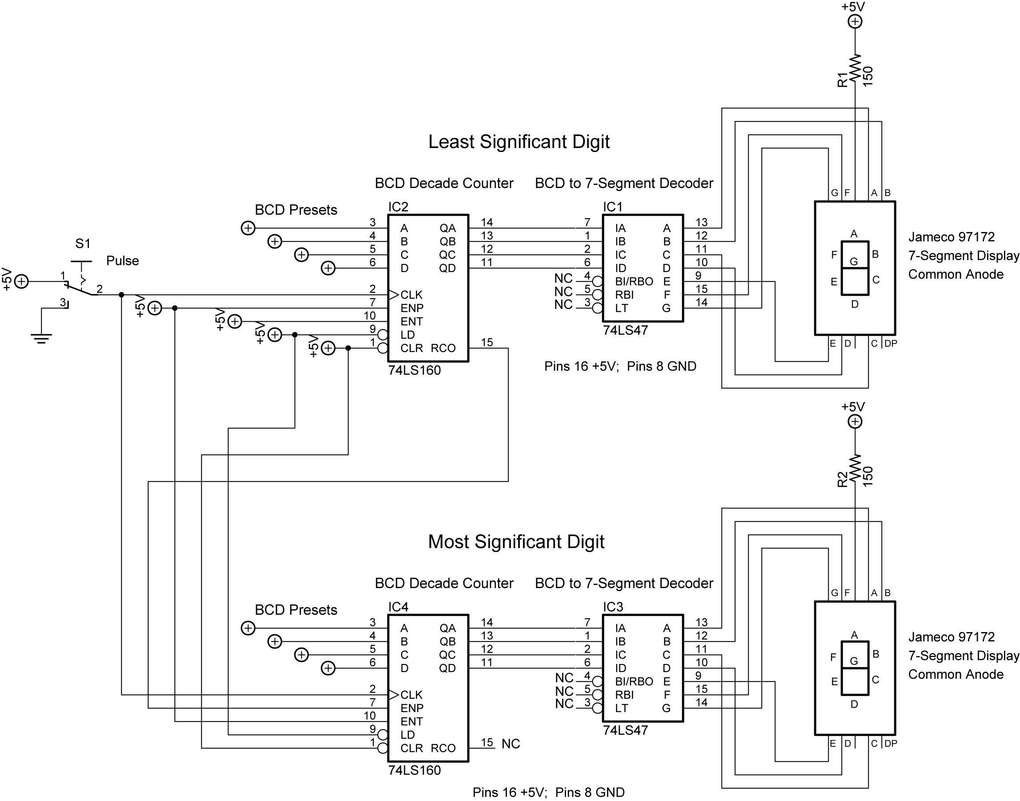

Cascade BCD Decade Counter

See applet: http://www.falstad.com/circuit/e-deccounter.html

