Lighting Tutorial
Cornerstone Electronics Technology and Robotics I Week 8

- Electricity and Electronics, Section 3.4, Lighting
  - Symbol:

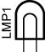

  - Incandescent lamp: The current flows through a tungsten filament within a lamp filled with an inert gas.
  - Halogen lamp: Similar to the incandescent lamp except halogen gas replaces the inert gas. The tungsten filament lasts longer in the halogen gas environment.
  - Fluorescent lamp: The tube is coated with a phosphor which glows when the mercury vapor inside the lamp produces ultraviolet light.
  - Mercury vapor: It requires a long starting time.
  - Neon lamp: Requires a transformer to produce voltages of 10,000 volts or more to create a current through the neon gas.
  - LED lamp: Very low wattage.
  - Lumens: A term used to measure the amount of light generated in a light bulb or a lighting system.
    - Typical lumen ratings:
      - 60 Watt bulb: 830 lumens (14 lm/wt)
      - 4’ Fluorescent T8 bulb (32 watts): 2850 - 3100 lumens (89-97 lm/wt)
    - See table on page 64 for values of lumens/watt.
  - Web references: http://www.kpsec.freeuk.com/components/lamp.htm
- Robot Building for Beginners, Chapter 10, Light Emitting Diodes:
  - Example and Symbol:

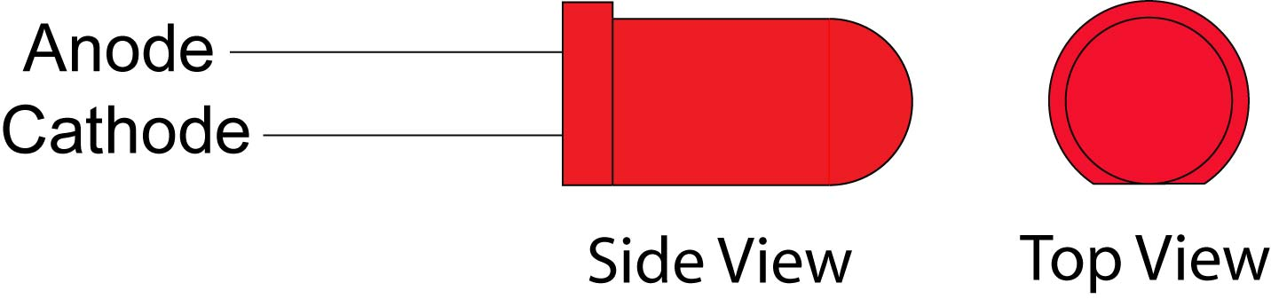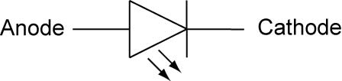

Example Symbol

  - Light emitting diodes are semi-conductors that give off infrared and visible light when electrical current is applied in the correct direction.
  - The primary use of an LED is an indicator device. The LED can tell the user that power is present in that part of the circuit or it can be used to help troubleshoot a computer program by indicating when a segment of code is executed.
  - Connections:
    - An LED should never be connected directly to a battery or power source. A current limiting resistor must be in series with the LED. See the section below on calculating the value of resistor in an LED circuit.
    - The anode must be connected toward the positive side of the battery and the cathode toward the negative side of the battery.
    - If LEDs are connected in parallel, each one should have its own current limiting resistor.
  - The cathode lead is the one nearest a "flat" on the body; see the example above.
  - Bi-colored LEDs: A bi-colored LED is two LEDs wired with one forwards and one backwards in a single LED package. See schematic below:
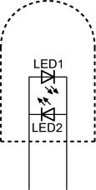
  - Tri-colored LEDs: A tri-colored LED is two LEDs wired in the following manner:
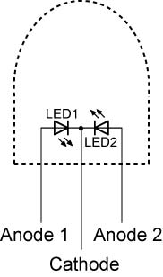

Tri-colored LED

    - The most common type of tri-colored LED has a red and green LED wired in one package with three leads.
    - The term tri-colored derives from the fact that when both the red and green LEDs are lit their colors mix as yellow.
  - Advantages of an LED:
    - Most operate at low voltages and currents, such as 2 volts and 20 mA.
    - LED’s have a fast switching time, on the order of 10 ns (10 nanoseconds, .00000001 sec.)
    - LED’s have a narrow spectrum of light giving relatively pure light.
  - LED sizes and shapes:
    - “T” refers to bullet shape

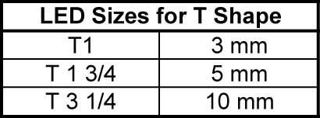

  - LED colors:
    - Electromagnetic Spectrum

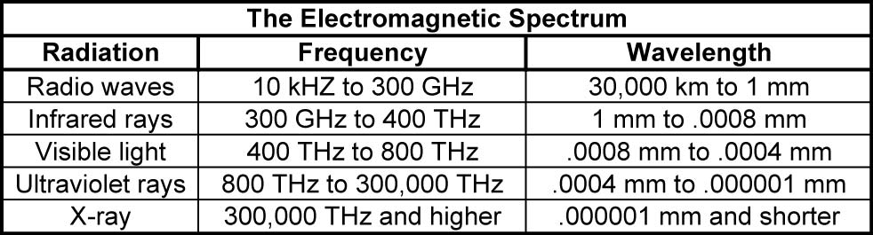

See the wavelengths of individual visible colors below.

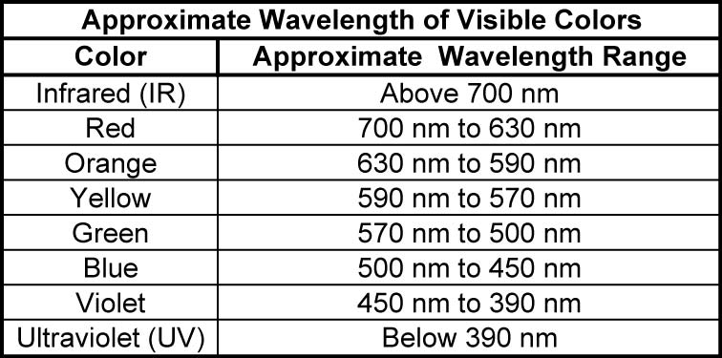

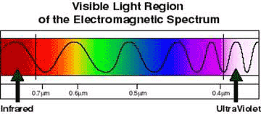

From http://www.high-techdigital.com/integration/Camera_t_1.htm

See electromagnetic wavelength applet: http://www.colorado.edu/physics/2000/waves_particles/index.html

  - Calculating the value of resistor in an LED circuit:
    - To calculate the value of the series resistor we need to know the diode forward voltage and current at its connections. The necessary data can be obtained from a catalogue or the LED data sheet.
    - See LED Resistor Calculator applet at: http://www.daycounter.com/Calculators/LED-Tutorial-Calculator.phtml

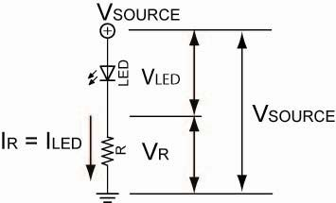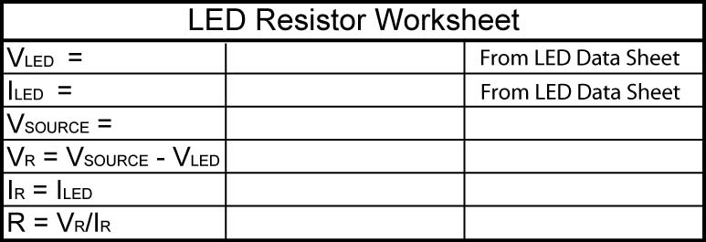

For Example; If V_{SOURCE} = 12 V
V_{LED} = 2 V
I_{LED} = 30 mA

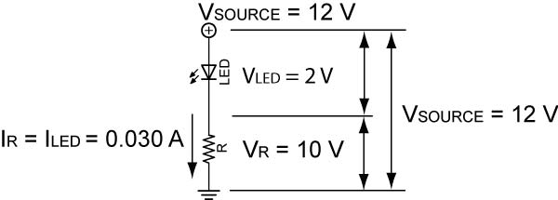

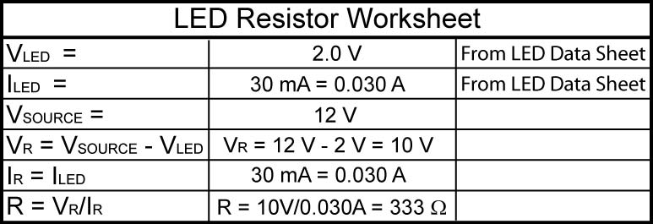
Since 333 Ω is not a standard value, we can use a 330 Ω resistor as this application is not critical of values.
  - Complete Lighting Lab 1 – LED Voltage Drops
  - Complete Lighting Lab 2 – Forward/Reverse Bias
  - Complete Lighting Lab 3 – Voltage/Current Curve
  - Complete Lighting Lab 4 – Stroboscopic Circuit

- Use class time for Student Activity Sheets 3-4 and 3-5.
- Suggested homework Student Activity Sheet 3-6.
Electronics Technology and Robotics I Week 8
Lighting Lab 1 – LED Voltage Drops

- Purpose: The purpose of this lab is to have the students test a variety of different colored LEDs to see if color affects the voltage drop.

- Apparatus and Materials:

  - 1 – Breadboard with 9 V Battery
  - 2 – Digital Multimeters
  - 1 – 470 Ohm Resistor, Use the Same Resistor for Both Circuits
  - 1 – Red LED
  - 1 – Green LED

- Procedure:
  - Wire Circuits 1 and 2 as shown and measure and record the voltage drops across resistors and each LED sample.

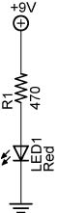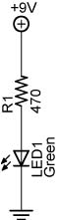

Circuit 1 Circuit 2

- Results:

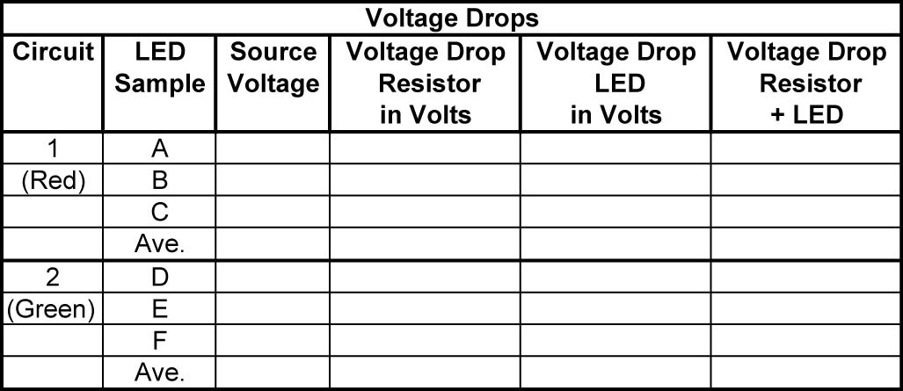

- Conclusions:
Electronics Technology and Robotics I Week 8
Lighting Lab 2 – Forward/Reverse Bias

- Purpose: The purpose of this lab is to acquaint the students with forward and reverse bias of LEDs.

- Apparatus and Materials:

  - 1 – Breadboard with 9 V Battery
  - 2 – Digital Multimeters
  - 1 – 470 Ohm Resistor
  - 1 – Red LED

- Procedure:
  - Wire Circuits 3 and 4
  - Record the results and write your conclusions

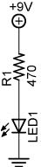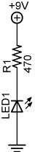

Circuit 3 Circuit 4
Forward Biased Reversed Biased

- Results:

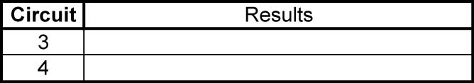

- Conclusions:

Electronics Technology and Robotics I Week 8
Lighting Lab 3 – Voltage/Current Curve

- Purpose: The purpose of this lab is to have the students plot a V-I characteristic curve for an LED.

- Apparatus and Materials:

  - 1 – Breadboard with 9 V Supply
  - 2 – Digital Multimeters
  - 1 – 150 Ohm Resistor
  - 1 – 25K Tripot
  - 1 –Green LED

- Procedure:
  - Wire the following circuit
  - Vary the voltage from 0 to +2.5 volts. Plot the voltage vs. current curve using the attached graph.
  - Observe as the instructor reverse biases the LED to -30 volts.

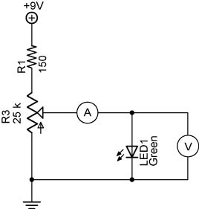

- Results:

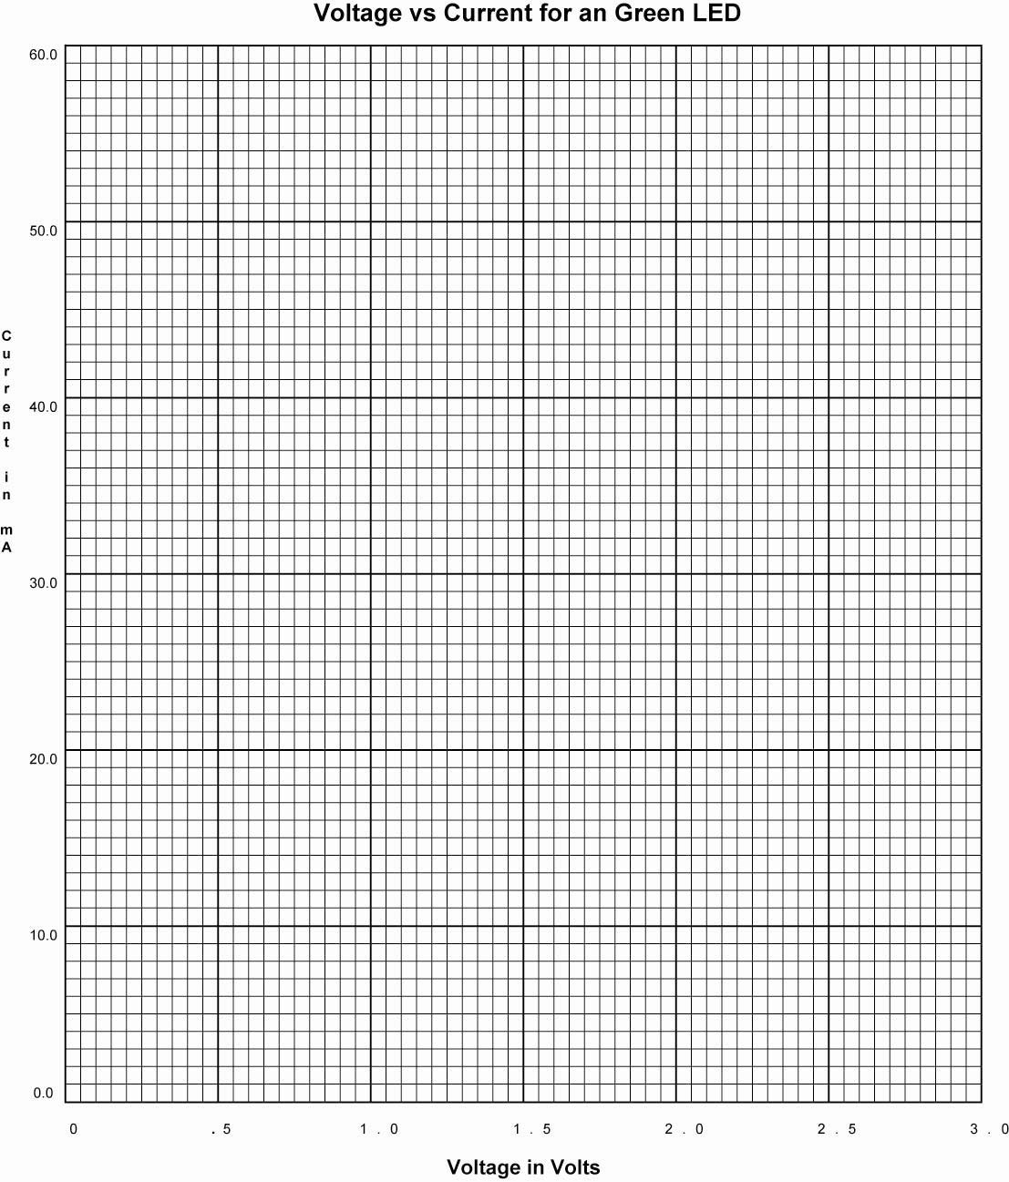

Electronics Technology and Robotics I Week 8
Lighting Lab 4 – LED Flashlight

- Purpose: The purpose of this lab is to have the student calculate the resistor needed for an 9 Volt LED flashlight and then assemble the circuit.

- Apparatus and Materials:

  - 1 – Resistor TBD
  - 1 – Super Bright White LED (Electronix Express #08LCHW5, See: http://www.elexp.com/opt_hr10.htm)
  - 1 – Battery Snap (Jameco #216452, See: http://www.jameco.com/webapp/wcs/stores/servlet/ProductDisplay?langId=-1&productId=216452&catalogId=10001&freeText=216452&app.products.maxperpage=15&storeId=10001&search_type=jamecoall&ddkey=http:StoreCatalogDrillDownView
  - 1 – Tube Liquid Electrical Tape
  - 1 – 9 Volt Battery

- Procedure:
  - Using the LED Resistor Worksheet in this lesson, calculate the current limiting resistor value needed to protect the LED specified. See spec sheet below for the typical voltage drop and current ratings.
  - Route the wires as shown in the drawing below and solder.
  - Apply liquid electrical tape to shield the wires from each other. Be careful not to use an excessive amount, the battery snap top may not fit.

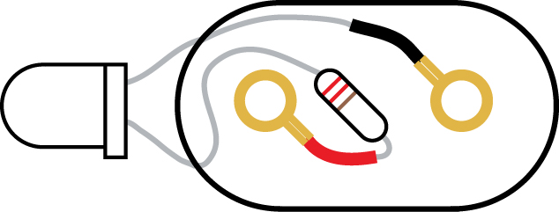

  - Photos:

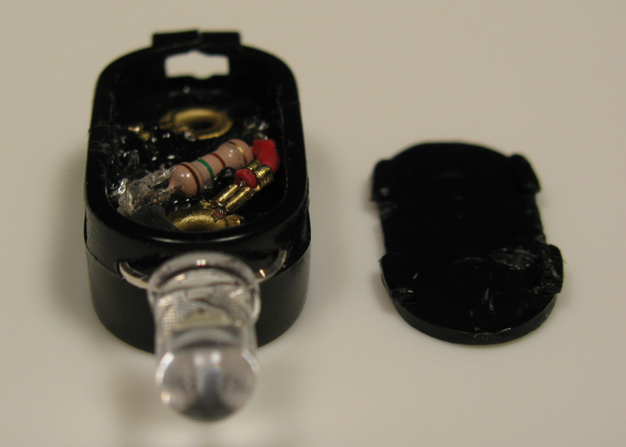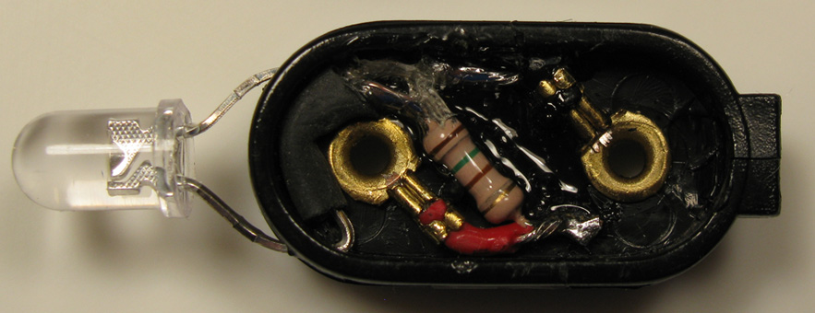

WHITE LIGHT EMITTING DIODE
08LCHRW5

The LWH-510CWH is high power InGaN blue chip and phosphor technologies mounted in clear package.

1. Features  1-1. High luminous white emission  1-2. Available for pulse operating  2. Applications  2-1. Electronic signs and signals  2-2. Small area illumination  2-3. Back-light  2-4. Indicator  3. Absolute Maximum Ratings ( Ta=25℃) |  |  |  |  | *NOTE 1. All dimensions in "mm"
 | Item |  | Symbol |  |  | Rating |  |  |  | Unit
 | Reverse Voltage |  | V_{R} |  |  | 5 |  |  |  | V
 | Forward Current |  | I_{F} |  |  | 30 |  |  |  | mA
 | Pulse Forward Current*¹ |  | I_{FP} |  |  | 100 |  |  |  | mA
 | Power Dissipation |  | P_{D} |  |  | 125 |  |  |  | mW
 | LED Junction Temperature |  | Tj |  |  | 100 |  |  |  | ℃
 | Operating Temperature |  | Topr |  |  | -25~+80 |  |  |  | ℃
 | Storage Temperature |  | Tstg |  |  | -30~+100 |  |  |  | ℃
 | *¹ tw=100μsec, T=10msec
4. Electro-Optical Characteristics ( Ta=25℃)
 | Item | Symbol |  | Condition |  |  | Min | Typ | Max | Unit
 | Forward Voltage | V_{F} |  | I_{F}=20mA |  |  |  | 3.6 | 4.0 | V
 | Reverse Current | I_{R} |  | V_{R}=5V |  |  |  |  | 50 | μA
 | Luminous Intensity | I_{V} |  | I_{F}=20mA |  |  |  | 5000 |  | mcd
 | Capacitance | Ct |  | f=1MHz |  |  |  | 40 |  | pF
 | Angle |  |  |  |  |  |  | 30 |  | deg.
5. Notes
LEDs are class 1 ESD sensitive.

Electronics Technology and Robotics I Week 8
Lighting Lab 5 – Stroboscopic Circuit

- Purpose: The purpose of this lab is to have the students practice assembling practical circuits.

- Apparatus and Materials:

  - 1 – Breadboard with 9 V Supply
  - 1 – 78L05 Voltage Regulator
  - 1 – 0.1 uF Capacitor
  - 1 – 1 uF Capacitor
  - 2 – 10 K Ω Resistor
  - 1 – 1 K Ω Resistor
  - 2 – 47 Ω Resistor
  - 1 – 1 M Ω Tripot
  - 1 – 2N2907A PNP Transistor
  - 1 – 555 Timer
  - 2 –Green LEDs
  - 2 – Red LEDs

- Procedure:
  - Wire the following 5 volt regulator and stroboscopic LED circuits.
  - Adjust R₂ to change the timing of the stroboscope.
    - 5 Volt regulator circuit:

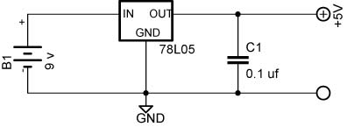

    - Stroboscopic Circuit:



