Electrical Meters
Cornerstone Electronics Technology and Robotics I Week 3

- Administration:
  - Prayer
  - Turn in quiz
- Meters:
  - Terms and Definitions:
    - Analog vs. Digital Displays: Analog displays have a continuous infinite range of values while digital displays have discrete finite range of values.
    - Concept: If you were climbing the ramp in Figure 1, you could stop at any level on the ramp; say 4.23’ above the ground. The ramp has a continuous slope with an infinite number of possible levels in between each foot marker. However, if you climb the steps, you can only stop at the discrete levels of the foot markers. You could not stop at 4.23’ above the ground; you could only stop at the 4’ or 5’ levels.
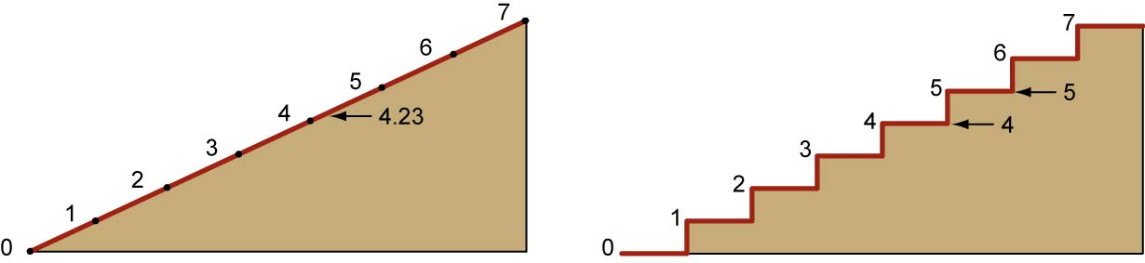

A Ramp (Analog) Steps (Digital)

Figure 1: Continuous Values with Analog and Discrete Values with Digital

    - Electronic Signals: An electronic signal is a fluctuating electric quantity that conveys information. In electrical engineering the quantity that fluctuates is usually voltage. Signals are passed between devices in order to send and receive information, which might be video, audio, or some sort of encoded data. Usually signals are sent through wires, but they could also be transmitted through the air using radio frequency (RF) waves.

    - Analog vs. Digital Signals: Analog signals are continuous while a digital signal is a signal for which amplitude and time are discrete.
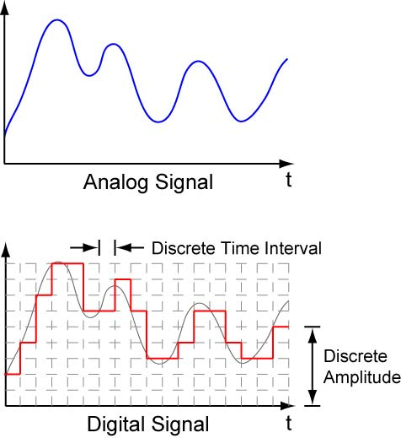
The amplitude of an analog signal changes continuously with time. An analog signal has a theoretically infinite resolution.
An analog signal may be converted to a digital signal by sampling the analog signal at discrete time intervals and converting the analog amplitude to discrete digital amplitudes.

Figure 2: The Differences between Analog and Digital Signals

  - Analog Meters: A meter that uses a scale with continuous range of values. A multimeter is an electrical test instrument that measures several values, usually voltage, current, and resistance.
    - An analog multimeter has three elements on its face panel:
      - Scales with a Pointer
      - Function and Range Switch or Selector Switch
      - Ports or Terminals

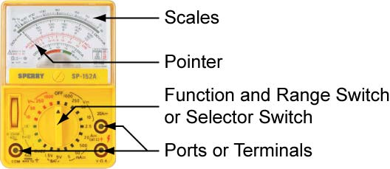

Figure 3: Analog Multimeter Face Panel

    - The pointer deflection measures the voltage, current, or resistance values on the appropriate meter scale.
    - The user sets the function and range switch to select the electrical quantity to be measured. For each function, the selector switch offers several ranges; the user selects the range suitable for their purposes.
    - Hook up the black probe into the COM port. The red probe connects to either the high current port or the mAVΩ port depending upon the application.
    - The analog multimeter scales in Figure 4 have four functions: ACV, Resistance in Ohms, DCmA, and DCV. The meter is laid out with three volt ranges, 250V, 50V, and 10V. The 250 V and 10 V ranges each are used for three DCV positions of the selector switch.

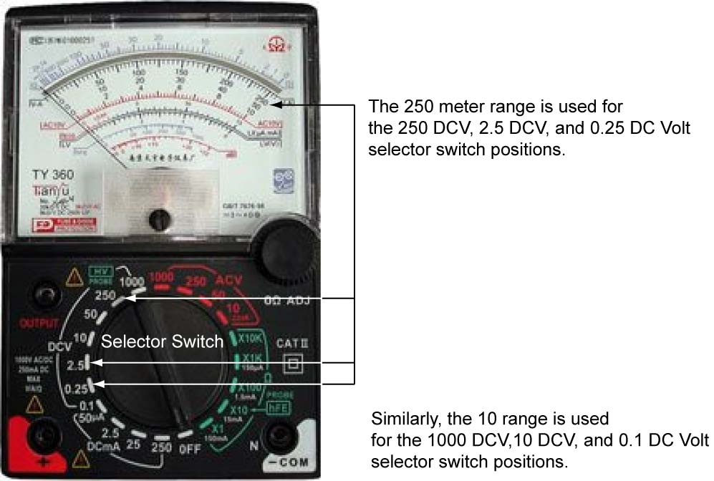

Figure 4: Analog Multimeter

    - Using Analog Multimeters:
      - Make sure the black probe is inserted into the COM port and the red probe is connected to the appropriate terminal port. Usually there are three terminal ports on a multimeter: common, voltage/resistance/low current, and high current.
      - The selector switch must be on the proper range setting before testing a circuit.
      - Do not “peg” the meter. In other words, do not have the meter reach full deflection.
      - If the electrical quantity is of unknown value, start at the highest range on the selector switch.
      - Make sure the polarity of the meter matches the polarity of the circuit you are testing.
    - Reading Analog Meters:
      - Analog Example 1: In Figure 5, the selector switch and the meter scale are both at the 250 maximum reading. The measurement can be read directly from the meter. The enlarged insert demonstrates the grey values that are mentally added between 50 and 100 to arrive at the reading of 85.

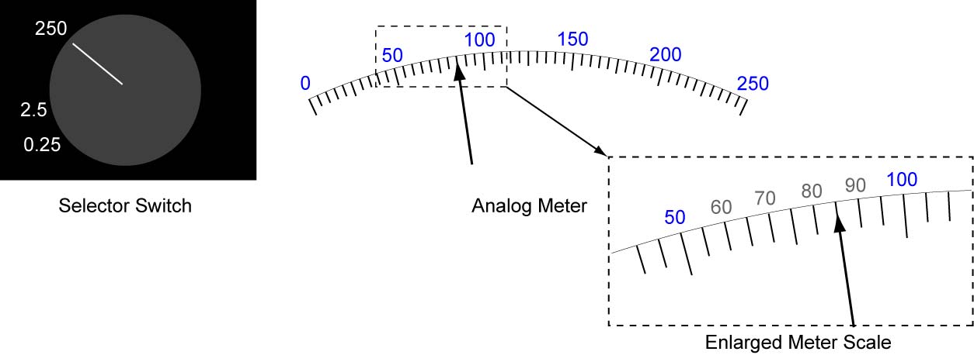

Figure 5: Reading Analog Meter Example 1

      - Analog Example 2: In Figure 6, the selector switch is set to 2.5, so full scale is now 2.5, not 250. The revised grey scale values in parenthesis are added mentally. The enlarged insert demonstrates the grey values that are also mentally added between (1.5) and (2.0) to arrive at the reading of 1.8.
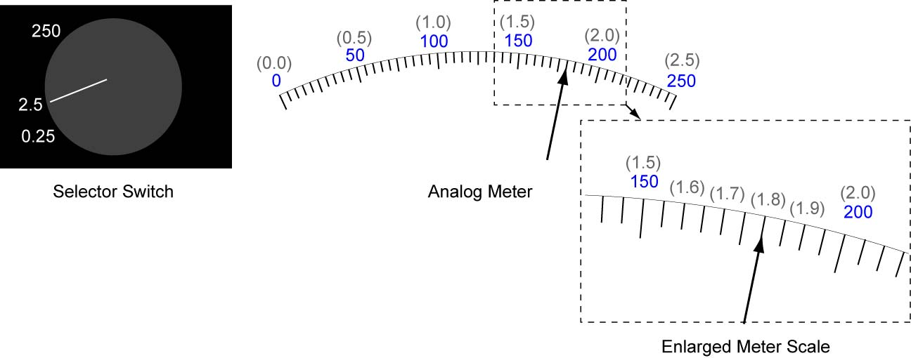

Figure 6: Reading Analog Meter Example 2

      - Analog Example 3: In Figure 7, the selector switch is set to 0.25, not 250. The revised grey scale values in parenthesis are added mentally. The enlarged insert demonstrates the grey values that are also mentally added between (0.00) and (0.005). The reading is an intermediate value between 0.0035 and 0.004. Using interpolation (i.e. estimation) between these two known values, the reading is 0.0037.

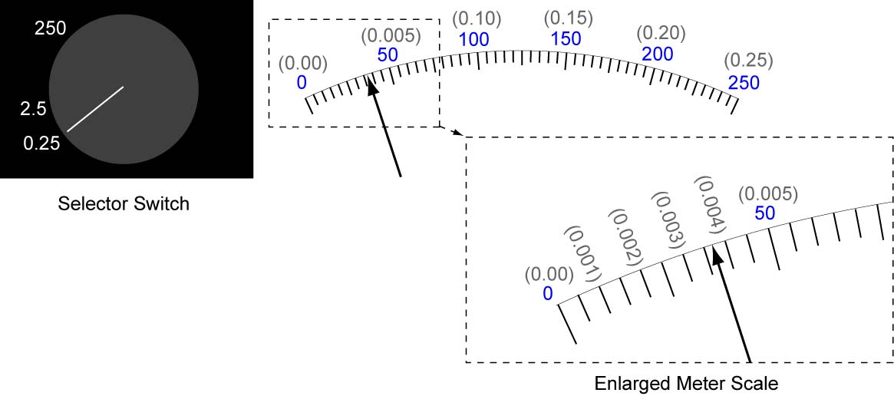

Figure 7: Reading Analog Meter Example 3

  - Digital Multimeters (DMM): A meter that gives values only in discrete amounts.
    - Digital multimeters are so named because they have the ability to measure a multiple of variables: voltage, current, resistance, transistors, and often many others.
    - An digital multimeter also has three elements on its face panel:
      - Display
      - Function and Range Switch or Selector Switch
      - Ports or Terminals

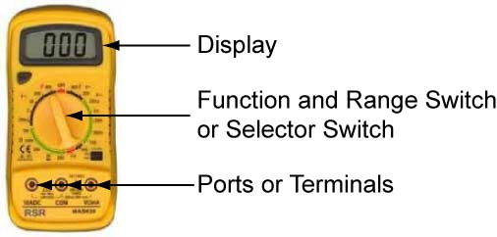

Figure 8: Digital Multimeter Face Panel

      - The display usually has four digits to show the measurement and it has the capability to display a negative value.
      - The Selector Switch and Ports work the same way as with the analog multimeter.
    - Using Digital Multimeters:
      - Make sure the black probe is inserted into the COM port and the red probe is connected to the appropriate terminal port. Usually there are three terminal ports on a multimeter: common, voltage/resistance/low current, and high current.
      - The selector switch must be on the proper range setting and the probes plugged into the correct port before testing a circuit.
      - Make sure the leads do not cross over or come in contact with other connection points, causing a possible short circuit.
      - If the electrical quantity is of unknown value, start at the highest range on the selector switch.
      - Make sure the polarity of the meter matches the polarity of the circuit you are testing.
    - Reading Digital Meters:
      - Digital Example 1: In Figure 9, the selector switch is set at the 2 volt maximum reading. The range is in volts (not millivolts) so the reading is 1.834V. If you were to measure a voltage over 1.999 volts, the meter would normally read ‘1’, meaning you have exceeded the selected range maximum reading (Figure 10). The first digit on many multimeters is only able to display a ‘1’ so the voltage ranges in the meter in Figure 9 are limited to 199.9mV, 1.999V, 19.99V, and 199.9V,

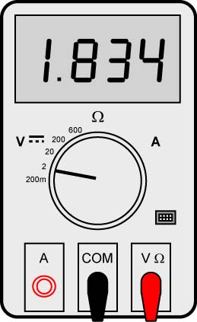

Figure 9: Reading Digital Meter Example 1

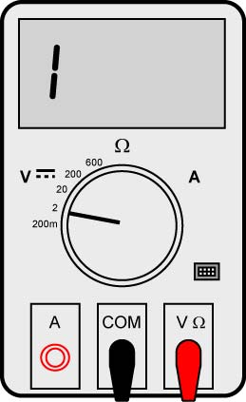

Figure 10: When Exceeding the Range Setting the Meter Will Read “1”

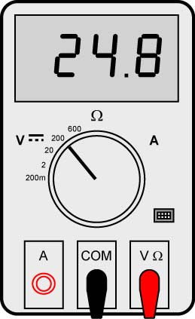

Figure 10: Reading Digital Meter Example 2

      - Digital Example 2: In Figure 10, the selector switch is set at the 200 volt maximum reading. Again the range is in volts so the reading is 24.8V.

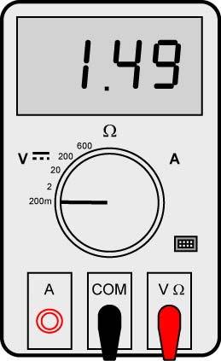

Figure 11: Reading Digital Meter Example 3

      - Digital Example 3: The example in Figure 11 has the selector switch at 200 mV maximum. The range is now in millivolts, so the reading is 1.49mV.

    - Practice reading digital meters:

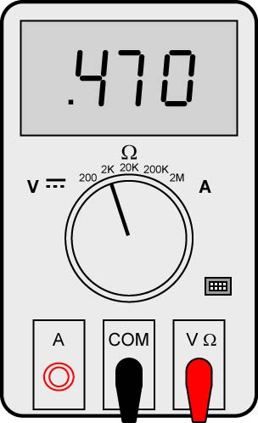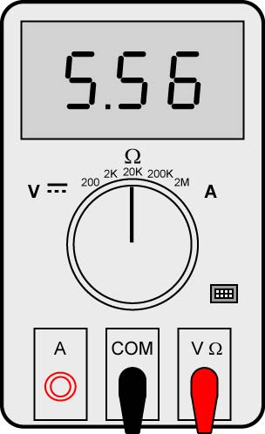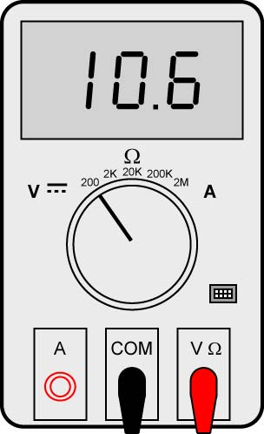

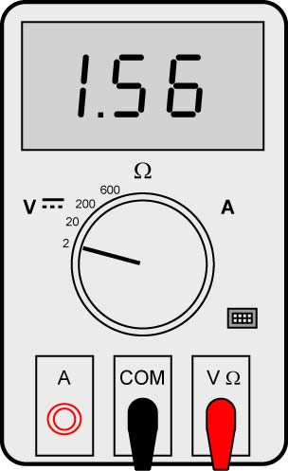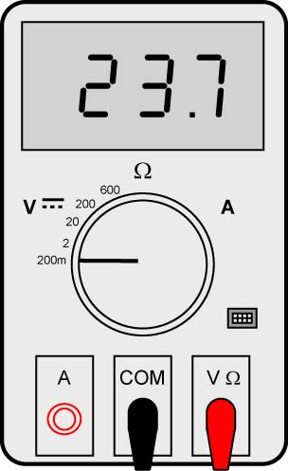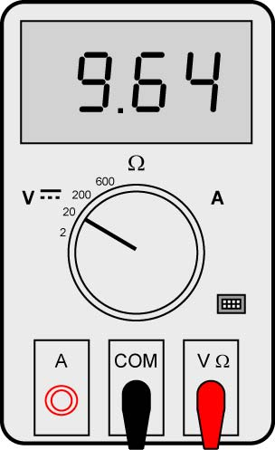

Figure 12: Sample Readings of Digital Meters

      - Read digital scale examples: calipers, micrometer, digital multimeter (DMM), and thermometer.
    - See: http://pioneer.netserv.chula.ac.th/~tarporn/311/HandOut/DmmPPT.pdf

  - Meter Probe Adapters: Attaches test probes to component leads.See:http://www.radioshack.com/product/index.jsp?productId=2062221 for Part #270-334. When removing the adapter from the test probe, push from the base of the adapter.

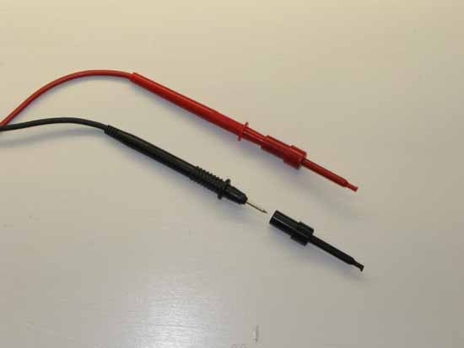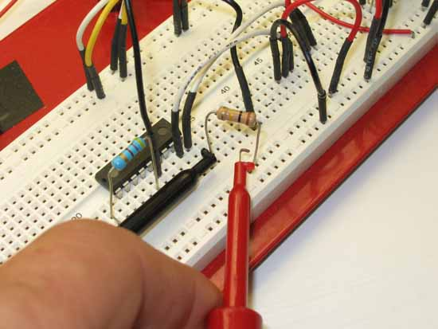

Attach Adapters to Test Probes Connect Adapter to Component Lead

- Ammeter: An ammeter measures electrical current in a circuit.
  - Using an ammeter to measure current:
    - An ammeter must always be connected in series (in line) with a circuit component. In other words, the circuit must be broken at the point of measurement and the ammeter inserted so that the electrons flowing through the circuit must also go through the meter (Figure 13).
    - When a current value is unknown, begin with the highest meter range.
    - Never connect an ammeter to a power source.
    - In dc circuits, the polarity of the meter must match the battery polarity; the positive (+) terminal of the ammeter connects toward the positive (+) side of the battery and the negative (-) terminal of the ammeter connects toward the negative (-) side of the battery.
    - Sample measurement:

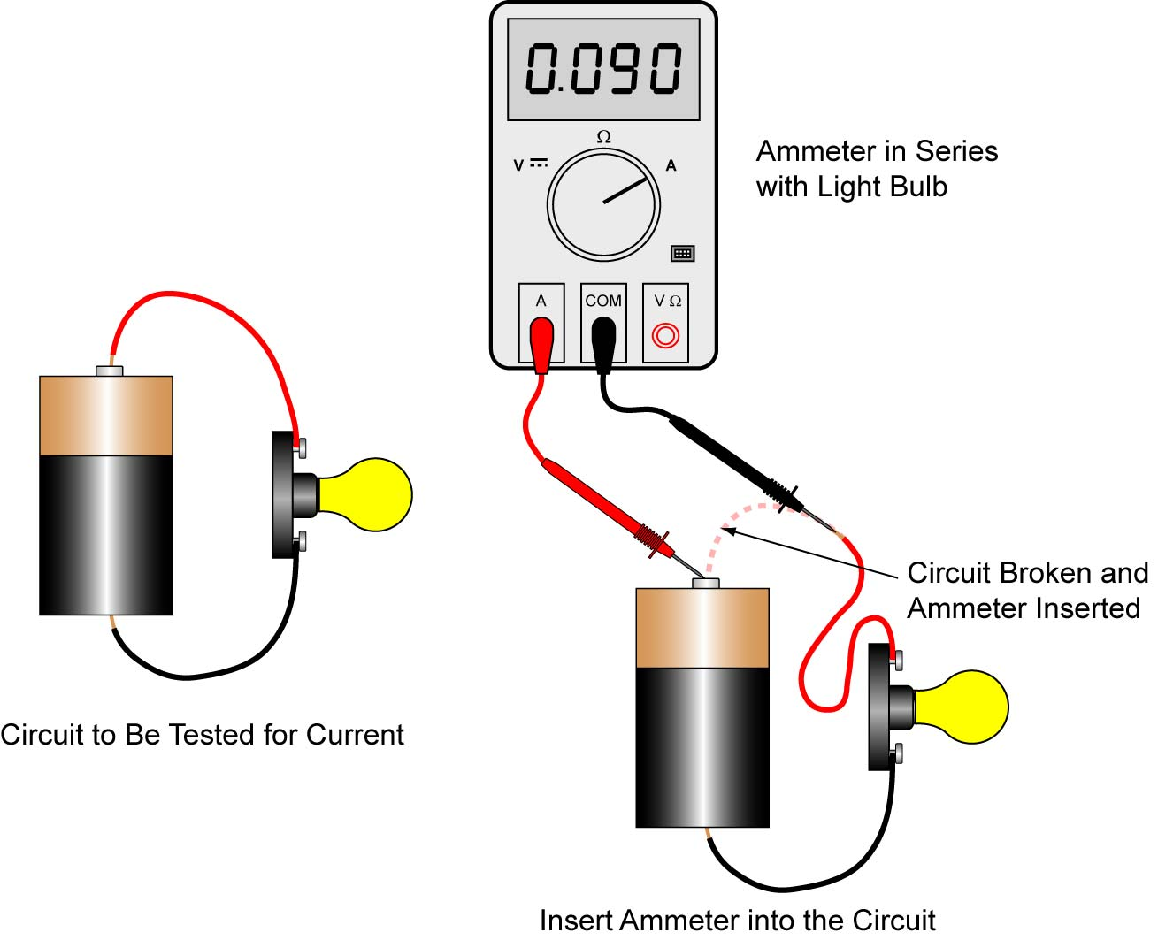

Figure 13: Measuring Current in a Circuit

  - Perform Electrical Meters Lab 1 – Ammeters
- Voltmeter: A voltmeter measures voltage in an electrical circuit. Voltage is always relative between two points. There is no such thing as voltage "on" or "at" a single point in the circuit. The voltage reading on a voltmeter is the voltage at one point in the circuit compared to another point in the circuit.
  - Using a voltmeter to measure voltage:
    - Voltmeters are always connected parallel with the component (across the component). The circuit is not broken as with the ammeter making the voltage measurements easier to make (Figure 14).
    - When the voltage is unknown, start with the highest meter range.
    - In dc circuits, the polarity of the meter must match the battery polarity; the positive (+) terminal of the voltmeter connects toward the positive (+) side of the battery and the negative (-) terminal of the voltmeter connects toward the negative (-) side of the battery.
    - Sample measurement:
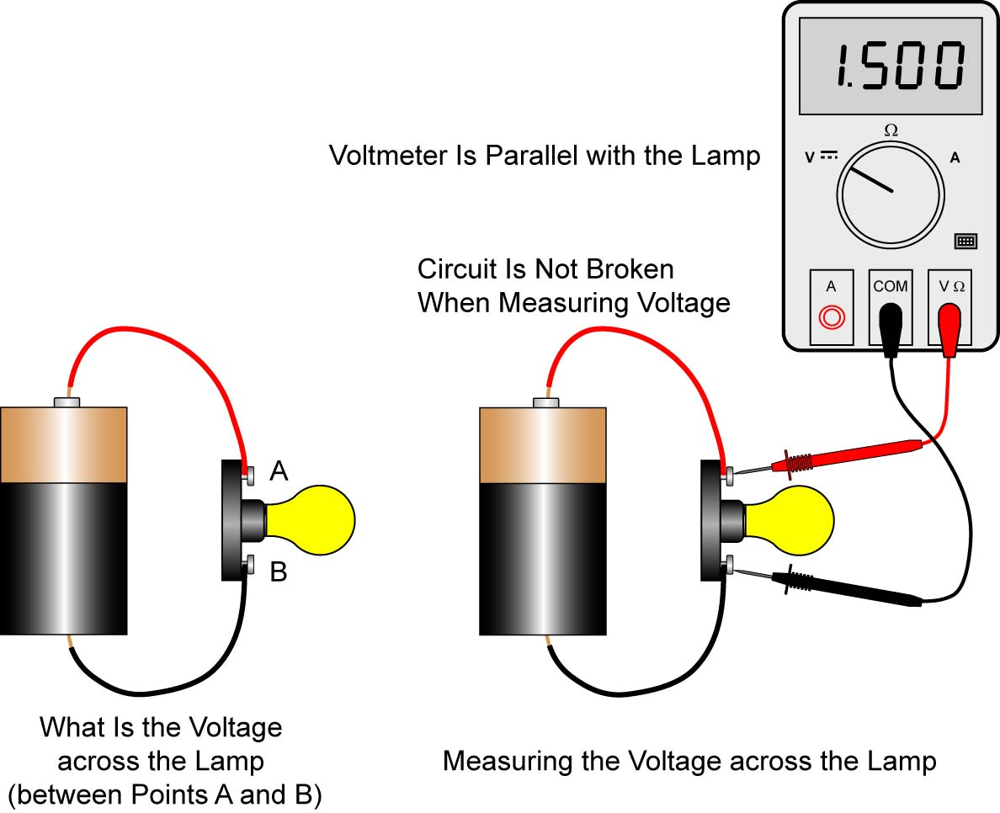

Figure 14: Measuring Voltage in a Circuit

  - Complete Electrical Meters Lab 2 – Voltmeters
  - See:
    - http://micro.magnet.fsu.edu/electromag/java/ohmslaw/
    - http://www.ngsir.netfirms.com/englishhtm/Circuit.htm
- Ohmmeter: An ohmmeter measures electrical resistance which is the opposition to the flow of an electric current.
  - Using a ohmmeter to measure resistance:
    - Always make sure that the power is off to the circuit and the component is de-energized.
    - When measuring resistance, the resistor must be disconnected from the circuit (Figure 15).
    - When the resistance is unknown, as usual, start with the highest meter range.

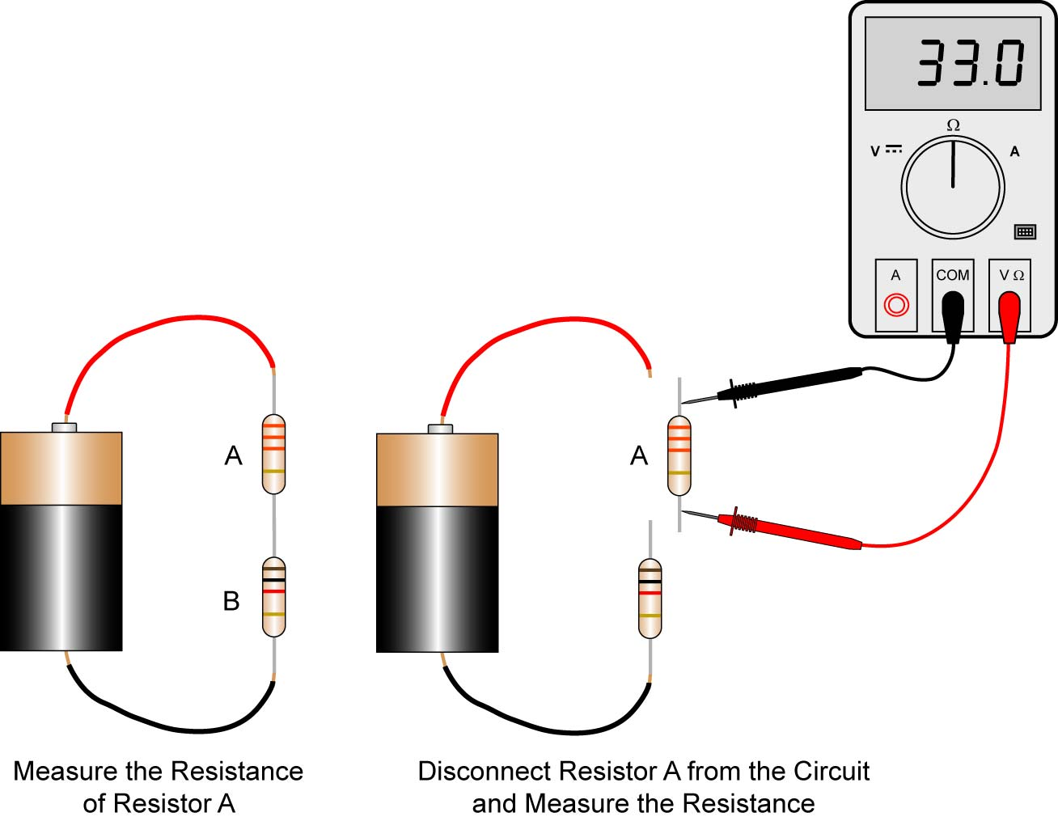

Figure 15: Measuring the Resistance in a Circuit

  - Special Readings for an Ohmmeter:
    - A reading of zero indicates a short circuit.
    - A reading of infinity indicates an open circuit.
  - Perform Electrical Meters Lab 3 – Ohmmeters

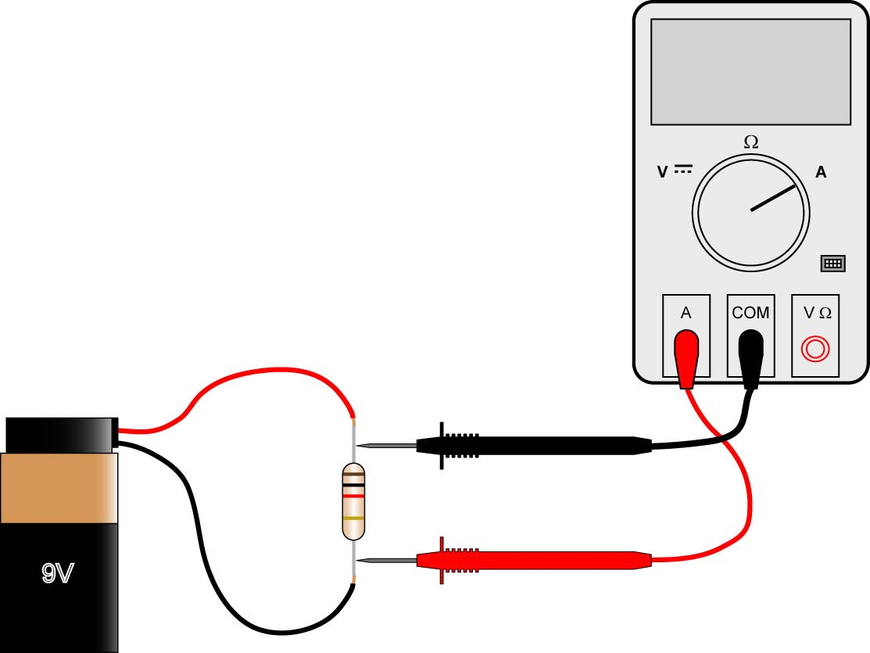

Figure 16: Is There Anything Incorrect with this Meter Setup?

- Review Relevant Algebra for Ohm’s Law:
  - Terms and Definitions:
    - Directly Related: Two terms, A and B, are directly related if as A is increased, B increases and B’s increase is proportional to A’s increase. For example, let’s say you are paid a wage of $5.00/hour. Then your earnings (E) are equal to your wage times your hours (H) worked, or E = 5.00 H. The terms E and H are directly related since E increases in proportion to an increase in H. If H is doubled, E is doubled; if H is tripled, E is tripled, etc. See the table and graph in Figure 17 below:

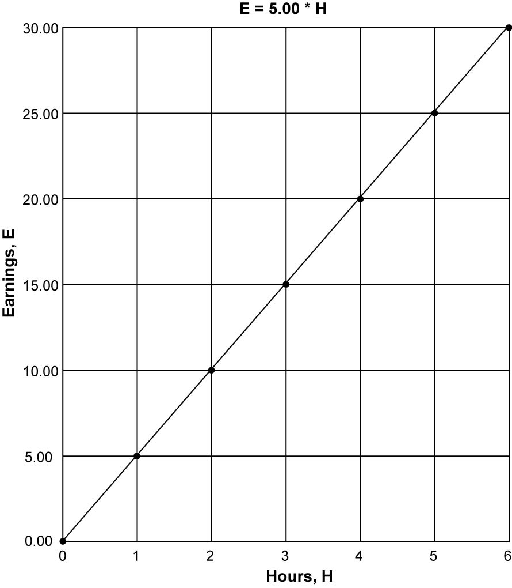

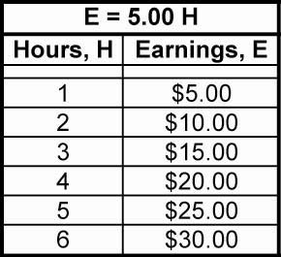

Figure 17: Two Terms that Are Directly Related
Inversely Related: Two terms, X and Y, are inversely related if as Y is increased, X decreases and X’s decrease is proportional to Y’s increase. For example, assume you have to travel a distance of 100 miles. Your speed (S) is equal to the distance divided by the time (T) it takes you to travel the 100 miles, S = 100 / T. So if your travel time, T, is 1 hour, then your speed, S, is 100 miles/hour. If you double T, (2 hours), then your speed is halved, (50 miles/hour), and if you triple T, (3 hours), then your speed is one third, (33.3 miles/hour), etc. The terms S and T are inversely related since S decreases in inverse proportion to an increase in T. See the table and graph in Figure 18 below:

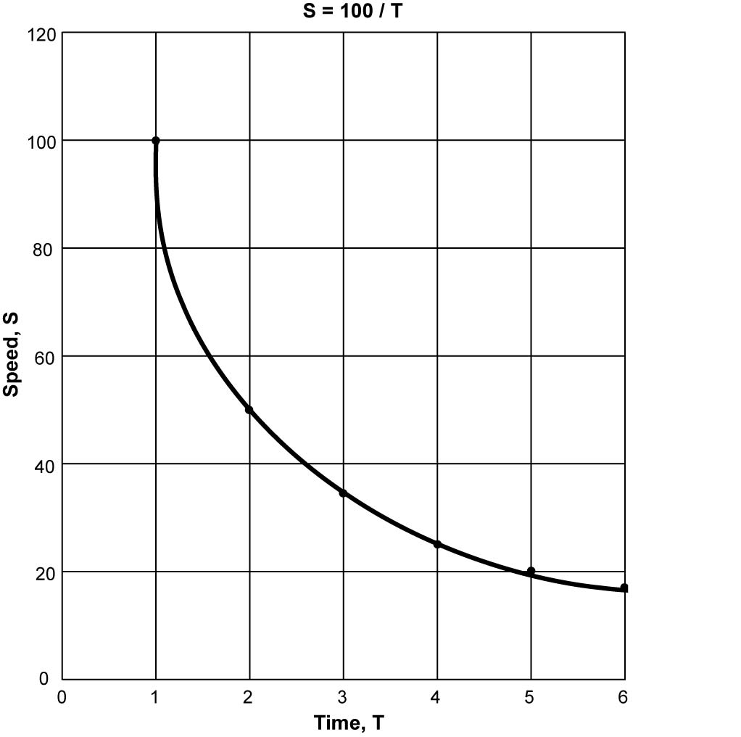

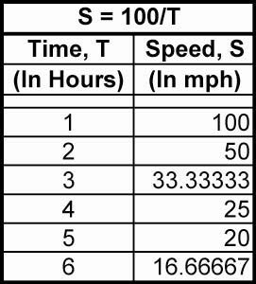

Figure 18: Two Inversely Related Terms

Electronics Technology and Robotics I Week 3
Electrical Meters Lab 1 – Ammeters

- Purpose: The purpose of this lab is to acquaint the student with measuring current using an ammeter and to become acquainted with current relationships in a series circuit.

- Apparatus and Materials:

  - 1 – Digital Multimeter (DMM)
  - 1 – Battery Holder and Battery
  - 1 – SPST Switch
  - 1 – 1 Ohm Resistor
  - 2 – Lamp Holders
  - 2 – 2.5 V Lamps
  - Alligator Clips

- Procedure:
  - Wire the following circuits and then use your ammeter to measure the current at each point labeled.
  - Record your results in the tables below.
  - Write your conclusions regarding your results.

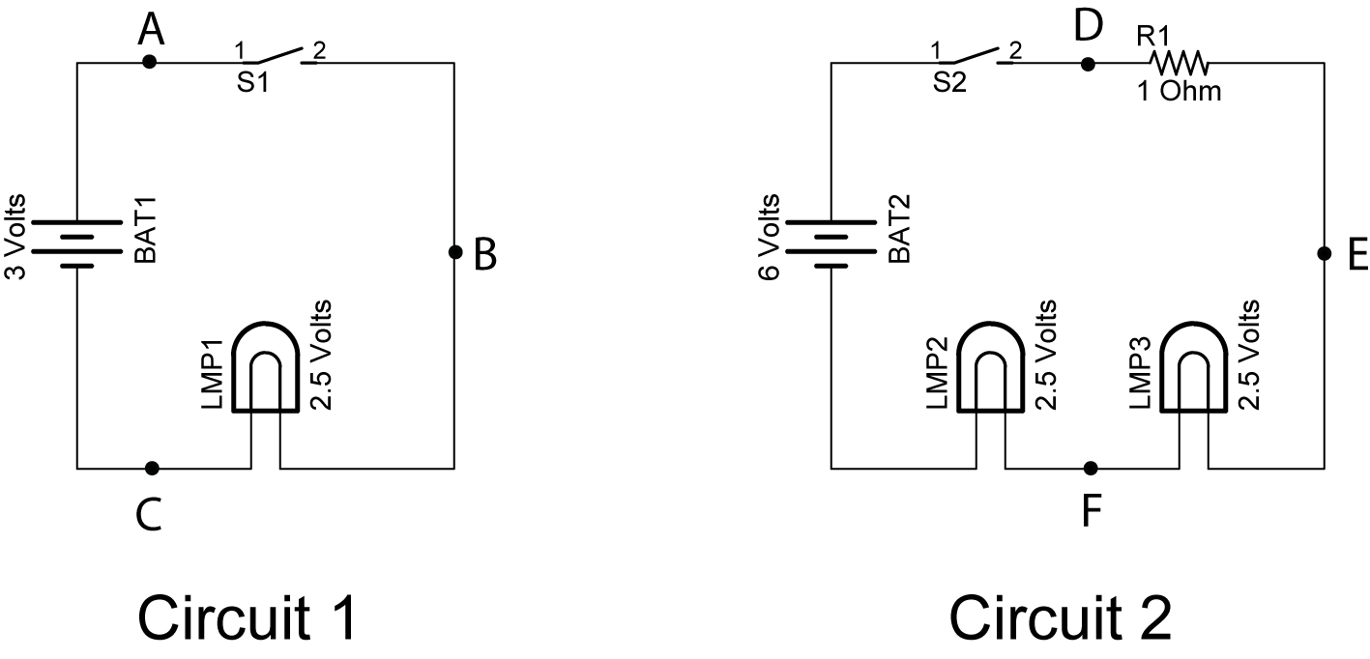

- Results:

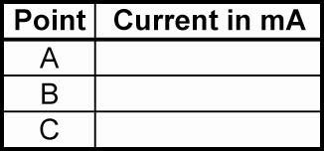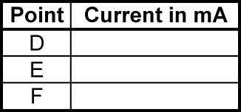

Circuit 1 Circuit 2

- Conclusions:
Electronics Technology and Robotics I Week 3
Electrical Meters Lab 2 – Voltmeters

- Purpose: The purpose of this lab is to acquaint the student with measuring voltage using a voltmeter.

- Apparatus and Materials:

  - 1 – Digital Multimeter (DMM)
  - 1 – Battery Snap and 9 V Battery
  - 1 – SPST Switch
  - 1 – 22 Ohm Resistor (Red, Red, Black)
  - 2 – Lamp Holders
  - 1 – 6 V Lamp and 1 – 7.5 V Lamp
  - Alligator Clips

- Procedure:
  - In the Circuit 3 below, close the switch then measure and record the voltage:
    - Across the battery terminals
    - Across the resistor
    - Across the 6 volt lamp. Add the voltage drops across the resistor and the 6 volt lamp, then compare the sum with the voltage drop across the battery.
    - Across the 7.5 volt lamp. Compare this reading with the voltage drop across the battery.
    - In the conclusions, describe how the sum of the voltage drops across the 6 V lamp and the resistor compare to the battery.

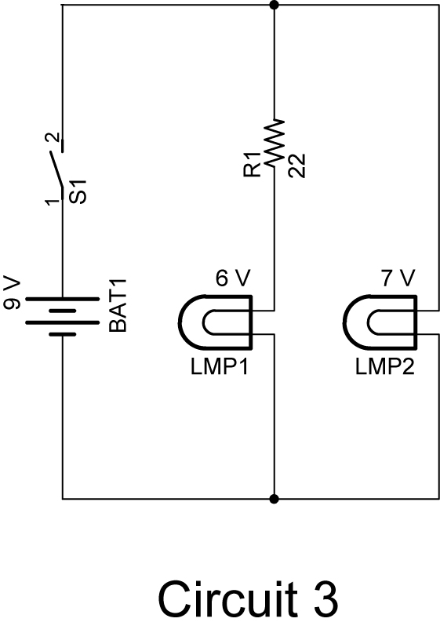
- Results:
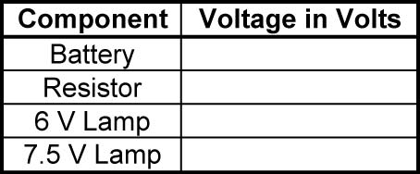

- Conclusions:
Electronics Technology and Robotics I Week 3
Electrical Meters Lab 3 – Ohmmeters

- Purpose: The purpose of this lab is to acquaint the student with measuring resistance using an ohmmeter.

- Apparatus and Materials:

  - 1 – Digital Multimeter (DMM)
  - Assortment of Resistors

- Procedure:

  - Measure and record the value of each resistor.

- Results:



