Cornerstone Electronics Technology and Robotics I Week 18
Magnetism

- Administration:
  - Prayer
  - Voltage Divider Review:
    - Divide +9 V source in half using 1K resistors. Solve for current.
- Electricity and Electronics, Section 9.1, Basic Magnetic Principles:
  - Magnetism: A magnet is defined as a material or substance that has the power to attract iron, steel and other magnetic materials.
  - Earth acts as a giant magnet. Scientists believe that the movement of the earth's liquid iron core and other factors are responsible for the magnetic field around the earth.

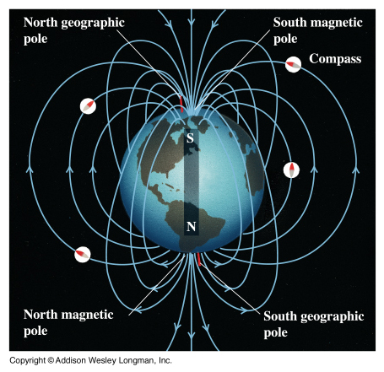
From: http://www.physics.sjsu.edu/becker/physics51/images/28_03_Earth_magnetic_field.jpg

    - Magnetic Declination: The magnetic declination at any point on the earth is the angle between the local magnetic field -- the direction the north end of a compass points -- and true north.

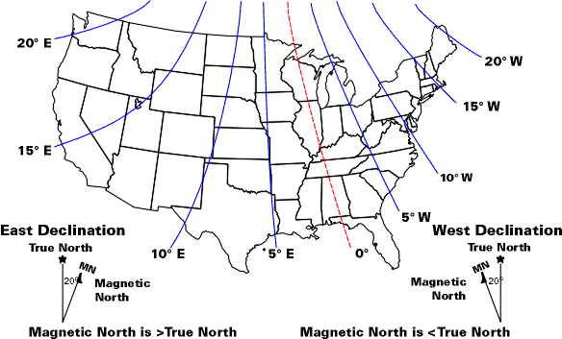
From: http://www.ussartf.org/compass_basics.htm
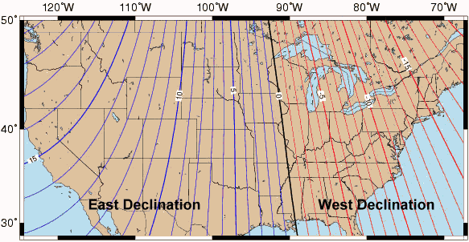
Magnetic Declination across the Continental US

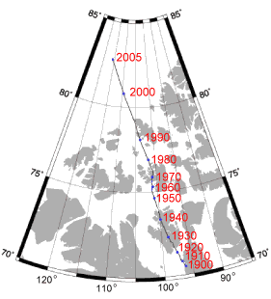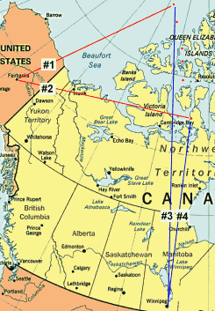

North Magnetic Pole Drift 1900–2005 Changes in Magnetic Declination 1900–2005
From: http://www.compassdude.com/compass-declination.shtml

    - The magnetic north pole is now moving about 25 miles per year on its way out of Canada and heading to Russia.
    - Perform Magnetism Lab 1 – Floating Compass Pin
    - Related sites:
      - http://geomag.usgs.gov/movies/movies/index.php?type=declination&format=flash
      - http://geomag.usgs.gov/movies/movies/index.php?type=tintensity&format=flash
    - Digital Compass Car: http://www.youtube.com/watch?v=KIw6lMg0o3s
  - How is a magnetic field created:
    - As Ampere suggested, a magnetic field is produced whenever an electrical charge is in motion. The motion of an electric charge producing a magnetic field is an essential concept in understanding magnetism.
  - First Two Laws of Magnetism:
    - Law 1: Like poles repel each other.
    - Law 2: Unlike poles attract each other.
    - Demonstrate floating magnets.
  - Causes of Magnetism in Materials:
    - Materials with a strong magnetic attraction are called ferromagnetic materials. Alignment of the magnetic poles of the molecules in ferromagnetic materials creates a magnetic. Ferromagnetic materials include iron, nickel, and cobalt.
    - Permanent magnets are created by placing ferromagnetic material in a very strong magnetic field. See the illustration below.

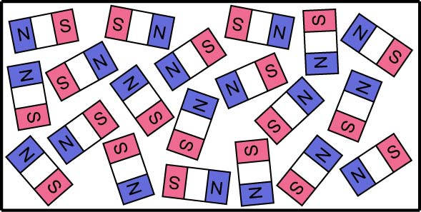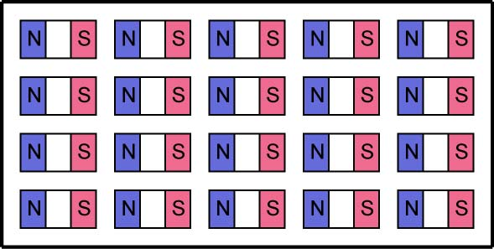

Unmagnetized Molecules Magnetized Molecules

    - Every magnetic has a north pole and a south pole.
    - Break long magnet into parts. See applet: http://www.ndt-ed.org/EducationResources/HighSchool/Magnetism/magneticproperties.htm
    - Heat will destroy a magnet. Heat energy causes an increase in molecular activity which permits the molecules to return to their random positions.
  - Magnetic Flux:
    - A magnet has a magnetic field surrounding it that is made up with lines of force or magnetic flux lines.

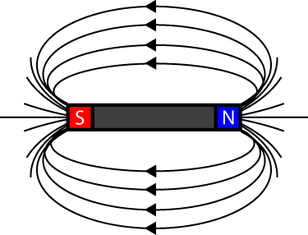

Magnetic Lines of Flux around a Bar Magnet
    - The concentration of the lines of force shows the strength of the magnetic field at that place. The strength of a magnetic field is determined by the field’s flux density or the number of lines per in² or lines per cm². The higher the number of lines per in² the higher the magnetic flux.
    - Demonstrate magnetic lines of force. Lines of filings reflect lines of magnetic force. Experiment 9-1 from Electricity and Electronics.
    - Demonstration using magnetic field compass demonstrator.
    - Demonstration with the iron rod field demonstrator.
    - See lines of force demonstration setup at: http://blog.teachersource.com/tag/magnetic-fields/
    - See applet: http://www.ndt-ed.org/EducationResources/HighSchool/Magnetism/magneticfields.htm
    - See applet: http://falstad.com/vector3dm/
      - Change current line to magnetic sphere
      - Display: Field Lines
    - Formula for magnetic flux density:

B = φ / A
Where:

B = magnetic flux density (in tesla, T)
φ (the Greek letter phi) = number of lines (flux) (in weber, Wb)
A = cross-sectional area (in square meters, m²)

    - Strength of Magnetic fields:
      - The strength of the field at the Earth's surface ranges from less than 30 microteslas (0.00003 T) in an area including most of South America and South Africa to over 60 microteslas around the magnetic poles in northern Canada and south of Australia, and in part of Siberia. Internet site: http://geomag.usgs.gov/charts/
      - The strongest continuous magnetic field,(45 T), yet produced in a laboratory is at Florida State University’s National High Magnetic Field Laboratory. See: http://www.magnet.fsu.edu/mediacenter/features/meetthemagnets/hybrid.html
      - In medical magnetic resonance imaging, flux densities reach up to 7 T
    - Perform Magnetism Lab 2 – Reed Switch and Reed Relay
  - Permeability:
    - Definition: Permeability is the ability of a material to conduct magnetic lines of force. Permeability is to magnetic circuits as conductance is to electrical circuits.
    - The permeability of air is defined as 1. The higher the value of permeability for a material, the better that material will conduct lines of force (magnetic flux). Other maximum permeability values:
      - Iron 5,000
      - Nickel 60
      - Supermalloy 1,000,000

Reference: http://www.ee.surrey.ac.uk/Workshop/advice/coils/mu/#mur

  - Reluctance:
    - Definition: Reluctance is the resistance to magnetic flux or the magnetic lines of force.
    - Remember that there are four factors affecting conductor resistance. Some of these same four factors also affect the conductor reluctance. The factors that affect conductor reluctance are:
      - Cross section area of a conductor; the larger the cross-section area, the lower the reluctance (inversely related).
      - Type of material; reluctance varies for different conductor materials.
      - Length of the conductor; the longer the conductor, the higher the reluctance (directly related).
  - Retentivity: The ability of a material to retain its magnetism after the magnetizing field has been removed.
  - Types of Magnets:
    - Permanent: A piece of magnetic material that retains its magnetism.
    - Electromagnet: Covered in the next section.
- Electricity and Electronics, Section 9.2, Electric Current and Magnetism:
  - The Danish physicist Hans Christian Oersted was lecturing one day in 1820 on the possibility of electricity and magnetism being related to one another, and in the process demonstrated it conclusively by experiment in front of his whole class.
  - Electromagnetism: When current flows in a conductor, a magnetic field is produced around the conductor. This magnetic field is called electromagnetism.

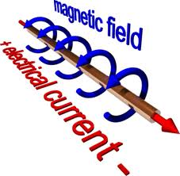

  - Electromagnet: An electromagnet is a coil wound around typically an iron or steel core. When current flows through it, the core becomes magnetized.
  - Demonstration running current through a conductor in one direction then in the opposite direction using small compasses.
  - Demonstrate “U” magnet.
  - See: http://www.ndt-ed.org/EducationResources/HighSchool/Magnetism/electromagnets.htm
  - The right-hand rule:
    - Using your right-hand, point your thumb in the direction of the conventional current in a conductor and curl your fingers into a half-circle around the conductor. Your fingers point in the direction of the magnetic field B.
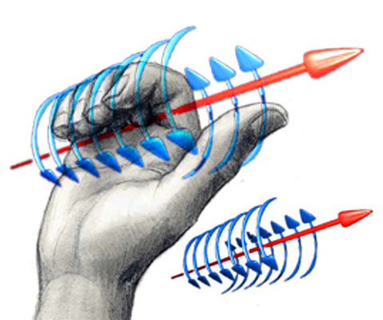

Right-hand Rule Illustrated
From: http://www.ovalecotech.ca/philyexp.html

  - Conductors carrying alternating current are grouped in pairs to eliminate the effects of the magnetic field around a single conductor. Alternating current will be covered in Week 19.
  - Solenoids:
    - The basic definition of a solenoid is a conductor wound into a coil.
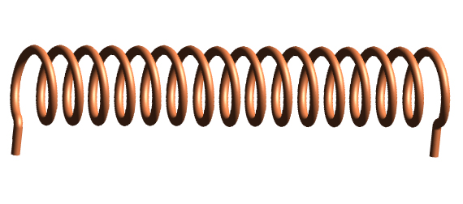
A Basic Solenoid

From: http://en.wikipedia.org/wiki/Solenoid

    - When a current is run through a solenoid, the magnetic lines of force of each wire join with the lines of force of the other wires to form a composite magnetic field.

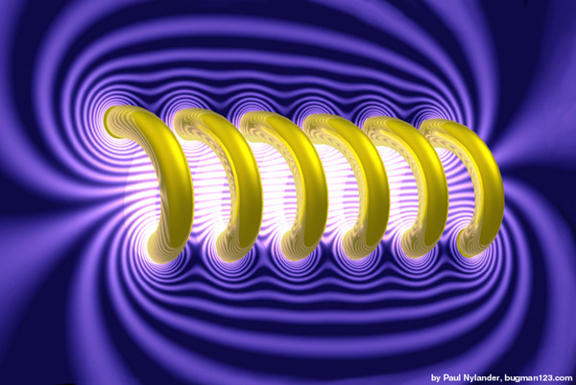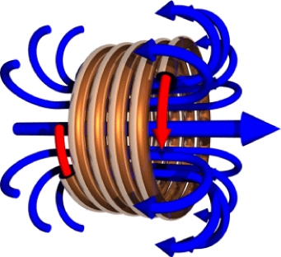

Two Illustrations of Lines of Force around a Solenoid

From: http://members.wolfram.com/jeffb/visualization/solenoid.shtml and
http://www.ovalecotech.ca/philyexp.html

    - Review the right-hand rule for a coil.
    - Strength of a magnetic field: The strength of a magnetic field depends upon:
      - The number of turns in a coil, directly related
      - The size of the current, directly related
      - Type of core material
      - Length of the coil, inversely related
      - The formula for the magnetic field inside the solenoid is:

B = μ₀(N / L) I

Where: B = Magnetic Field
μ₀ = Magnetic Constant
I = Current
N = Number of Turns in the Solenoid
L = Length of Solenoid
There is no dependence on the diameter of the solenoid, and the field strength doesn't depend on the position inside the solenoid, i.e., the field inside is constant.
    - Another definition is that a solenoid is a coil and a moveable iron core used to convert electrical energy into mechanical energy. It is a coil of wire commonly in the form of a long cylinder that when carrying a current resembles a bar magnet so that a moveable core is drawn into the coil when a current flows.
    - They range in size from less than one-quarter of an inch to more than 15 inches in diameter with force outputs of less than an ounce to a ton.

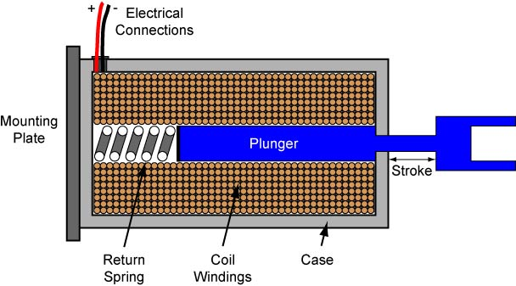

Cross Section of a Linear Solenoid

    - See: http://www.electronics-tutorials.ws/io/io_6.html and
http://www.societyofrobots.com/actuators_solenoids.shtml
    - Experiments 9-2 and 9-3 from Electricity and Electronics.
  - Hall-Effect:
    - Named after E.H. Hall of Johns Hopkins University who discovered the effect on 1879.
    - The generation of a voltage perpendicular to both an electric current flowing along a conducting material and an external magnetic field applied at right angles to the current upon application of the magnetic field. See the illustrations below.
    - The Hall voltage is much higher in semiconductors than in conductors.
    - The Hall voltage is so small that the sensors are normally manufactured with a built-in amplifier circuit.

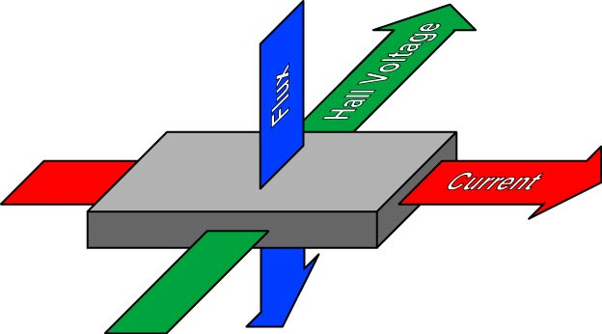

First Illustration of the Hall Effect

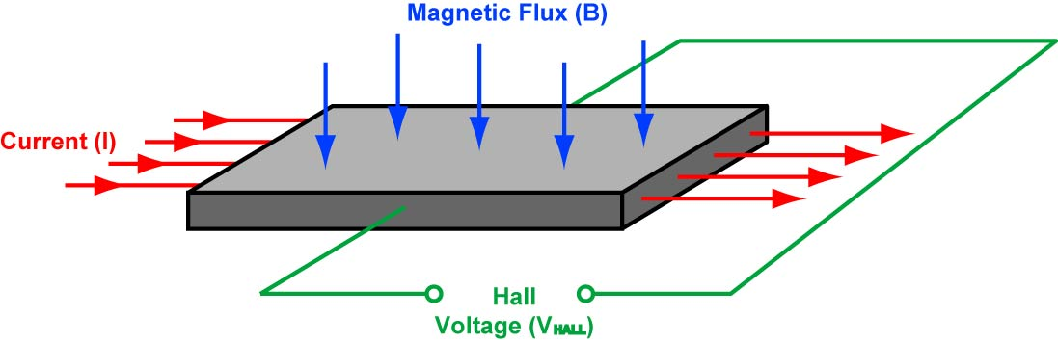

Second Illustration of the Hall Effect

    - Perform Magnetism Lab 3 – Digital Hall-Effect Sensor
    - Perform Magnetism Lab 4 – Linear Hall-Effect Sensor
    - For additional information on Hall-Effect sensors see http://www.allegromicro.com/hall/
    - Review lesson and overview of each activity.

Electronics Technology and Robotics I Week 18
Magnetism LAB 1 – Floating Compass Pin

- Purpose: The purpose of this lab is to have the student build a simple compass.

- Apparatus and Materials:

  - 1 – Straight Pin
  - 1 – Dish of Water
  - 1 – Permanent Magnet
  - Paper Towels

- Procedure:
  - Snip off the head of a straight pin using wire cutters.
  - Drop the pin into a dish of water. Hold it horizontally at its middle between two fingers, just above the water, then let go. Make sure the pin is floating. Observe the pin’s alignment. Rotate the pin while still in the water by using a pencil and observe the pin’s alignment. Make sure that the magnet is not in close proximity to the dish of water. Record the results.
  - Magnetize the pin by placing it on the permanent magnet.
  - Once again, drop the pin into the dish of water. Observe the pin’s alignment. Rotate the pin by using a pencil and observe the pin’s alignment. Record the results.

- Results:
  - Alignment of unmagnetized pin:

  - Alignment of magnetized pin:

- Conclusions:
  - What conclusion can be made about the earth and magnetism?

Electronics Technology and Robotics I Week 18
Magnetism LAB 2 – Reed Switch and Reed Relay

- Purpose: The purpose of this lab is to acquaint the student with a magnetic sensor switch and a reed relay.

- Apparatus and Materials:

  - 1 – Breadboard with a +9 V Power Supply
  - 1 – SPST Switch
  - 1 – Bar Magnet
  - 1 – Reed Switch
  - 1 – Reed Relay (Radio Shack #275-233) See: http://www.radioshack.com/product/index.jsp?productId=2062479&cp=
  - 1 – 470 Resistor
  - 1 – 1K Resistor
  - 1 – 47K Resistor
  - 1 – 2N2222A NPN Transistor
  - 2 - LEDs

- Procedure:
  - Magnetic switches: A reed switch is a magnetic switch that will open or close depending upon the strength of the magnetic field acting upon it.
  - Wire the following circuit then use a magnet to activate the switch:
  - Replace the switch with a reed relay as shown in the reed relay circuit. The reed relay wiring diagram shows the connections.
  - Use the switch S1 to activate the reed relay.

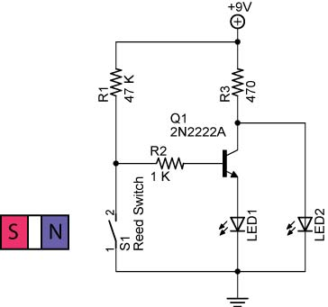

Reed Switch Circuit

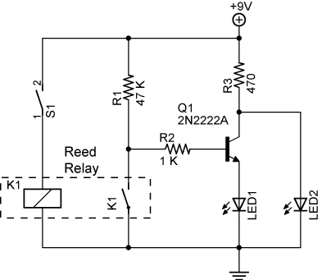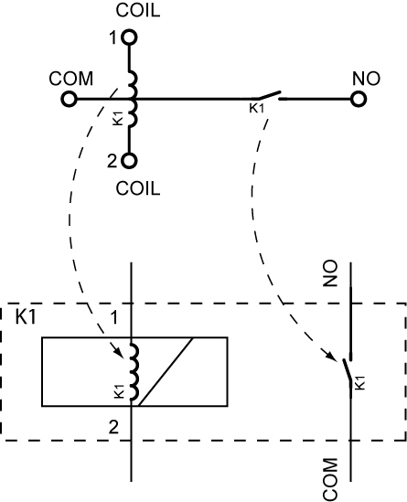

Reed Relay Circuit Reed Relay (K1) Wiring Diagram

- Conclusions:
  - How is the magnetic force generated to close the switch in the reed relay K1?

Electronics Technology and Robotics I Week 18
Magnetism LAB 3 – Digital Hall-Effect Sensor

- Purpose: The purpose of this lab is to acquaint the student with a digital Hall-Effect sensor.

- Apparatus and Materials:

  - 1 – Breadboard with a +5 V Power Supply
  - 3 – Hall-Effect Digital Sensors (#402 LESSEMF.com, http://www.lessemf.com/dcgauss.html)
  - 3 – 220 Ohm Resistors
  - 3 - LEDs

- Procedure:
  - Wire the Hall-effect bargraph circuit below. Use a magnet to approach the Hall-effect switch sensors from one side then the other side.
  - Leave enough room between the sensors and the LEDs to insert the magnet. See photos of spacing below.

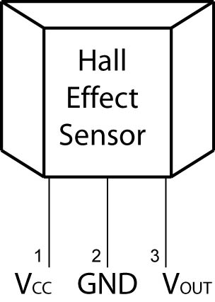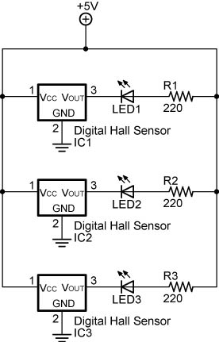

Sensor Pin Layout Hall Effect Bargraph Circuit

From Electronic Sensor Circuits & Projects
By Forrest M. Mims

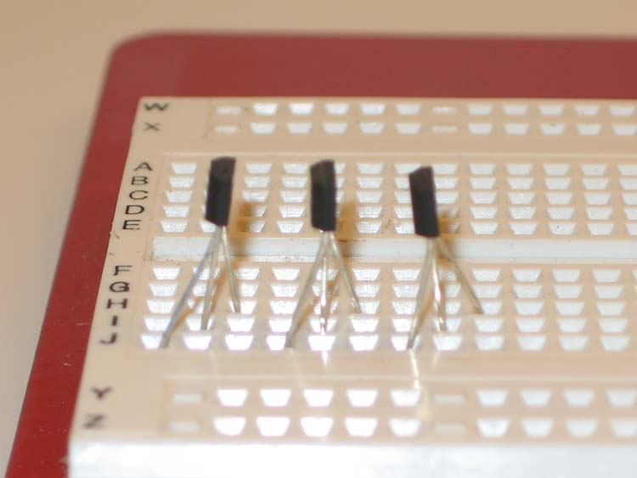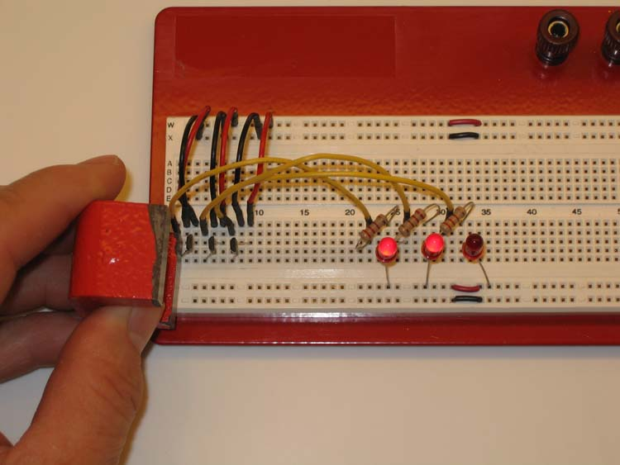

Sensor Pin Insertion into Breadboard Final Hall Effect Circuit

Electronics Technology and Robotics I Week 18
Magnetism LAB 4 – Linear Hall-Effect Sensor

- Purpose: The purpose of this lab is to acquaint the student with a linear Hall-Effect sensor.

- Apparatus and Materials:

  - 1 – Breadboard with a +5 V Power Supply
  - 1 – Linear Hall-Effect Sensor (#400 LESSEMF.com, http://www.lessemf.com/dcgauss.html)
  - 1 – 555 Timer IC
  - 1 – 220 Ohm Resistor
  - 1 – 1K Ohm Resistor
  - 1 – 100K Ohm Potentiometer
  - 1 – 0.1 Micro-Farad Capacitor
  - 1 – 8 Ohm Speaker

- Procedure:
  - Wire the Hall effect tone generator below. Use a magnet to change the output of the linear Hall effect sensor.

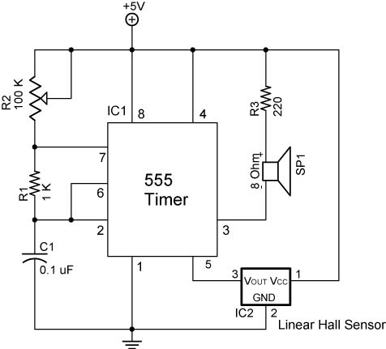

Sensor Pin Layout Magnetic Tone Generator

From Electronic Sensor Circuits & Projects
By Forrest M. Mims

