Cornerstone Electronics Technology and Robotics I Week 15
Combination Circuits (Series-Parallel Circuits)

- Administration:
  - Prayer
  - Turn in quiz
- Electricity and Electronics, Chapter 8, Introduction:
  - In this lesson, we will learn to analyze circuits with resistors in both series and parallel together and compute the total resistance (equivalent resistance) for those circuits. From there, we can calculate the voltage drop and current for each resistor in the circuit.
  - Series-parallel circuits are also called combination circuits.
  - Examples:

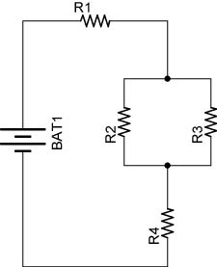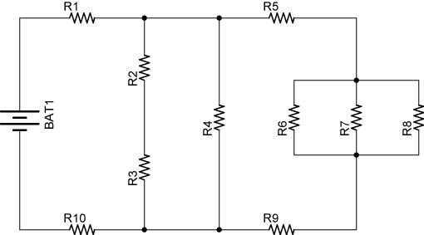

Figure 1 – Examples of Combination Circuits

  - See applets:
    - http://www.falstad.com/circuit/e-resistors.html
    - http://webphysics.davidson.edu/physlet_resources/bu_semester2/c10_combo.html
  - Regardless of the complexity of a series-parallel circuit, it can be solved when broken down into steps of individual series and parallel circuits.
  - Review:
    - Four equations are used to solve series resistor circuits. They are:

R_{T} = R₁ + R₂ + R₃ + … + R_{N}
V_{T} = V₁ + V₂ + V₃ + …+ V_{N}
I_{T} = I₁ = I₂ = I₃ =…I_{N}
V = I x R

V = I x R can be applied to the total circuit (V_{T} = I_{T} x R_{T}) and to individual resistors (V₁ = I₁ x R₁).

See Lesson 13, Series Circuits for details. Link: http://cornerstonerobotics.org/curriculum/lessons_year1/ER%20Week13,%20Series%20Circuits.pdf

    - Four equations are used to solve parallel resistor circuits. They are:
1/R_{T} = 1/R₁ + 1/R₂ + 1/R₃ +………..+1/R_{N}
V_{T} = V₁ = V₂ = V₃ = ….. V_{N}
I_{T} = I₁ + I₂ + I₃ + …+ I_{N}
V = I x R

See Lesson 14, Parallel Circuits for details. Link: http://cornerstonerobotics.org/curriculum/lessons_year1/ER%20Week14,%20Parallel%20Circuits.pdf

  - Power in Combination Circuits: The total power in a combination circuit is equal to the sum of the individual powers.
  - The variables used in Ohm's Law equations must be common to the same two points in the circuit under consideration. This rule cannot be overemphasized. This is especially important in series-parallel combination circuits where nearby components may have different values for both voltage drop and current.
- Electricity and Electronics, Section 8.1, Solving a Complex Circuit:
  - The goal of series-parallel resistor circuit analysis is to be able to determine all voltage drops, currents, and power dissipations in a circuit.
  - Contracting the Circuit: Finding the total resistance and total current: In this section, you will combine series and parallel resistors in a step by step process until the entire circuit is reduced to one equivalent resistor.
    - Step 1: Assess which resistors in a circuit are connected together in simple series or simple parallel.
    - Step 2: Re-draw the circuit, replacing each of those series or parallel resistor combinations identified in step 1 with a single, equivalent-value resistor.
    - Step 3: Repeat Steps 1 and 2 until the entire circuit is reduced to one equivalent resistor.
    - Step 4: Find the total current for the circuit.
  - Expanding the Circuit: In this section, you will proceed step-by-step from the simplified version of the circuit back to its original form, plugging in values of voltage and current where appropriate until all values of voltage and current are known.
    - Step 5: Taking total voltage and total current values, go back to last step in the circuit reduction process and insert those values where applicable.
    - Step 6: From known resistances, total voltage, and total current values from step 5, use Ohm's Law to calculate unknown values (voltage or current)
    - Step 7: Repeat steps 5 and 6 until all values for voltage and current are known in the original circuit configuration. Essentially, you will proceed step-by-step from the simplified version of the circuit back to its original, complex form, plugging in values of voltage and current where appropriate until all values of voltage and current are known.
    - Step 8: Calculate power dissipations from known voltage, current, and/or resistance values.
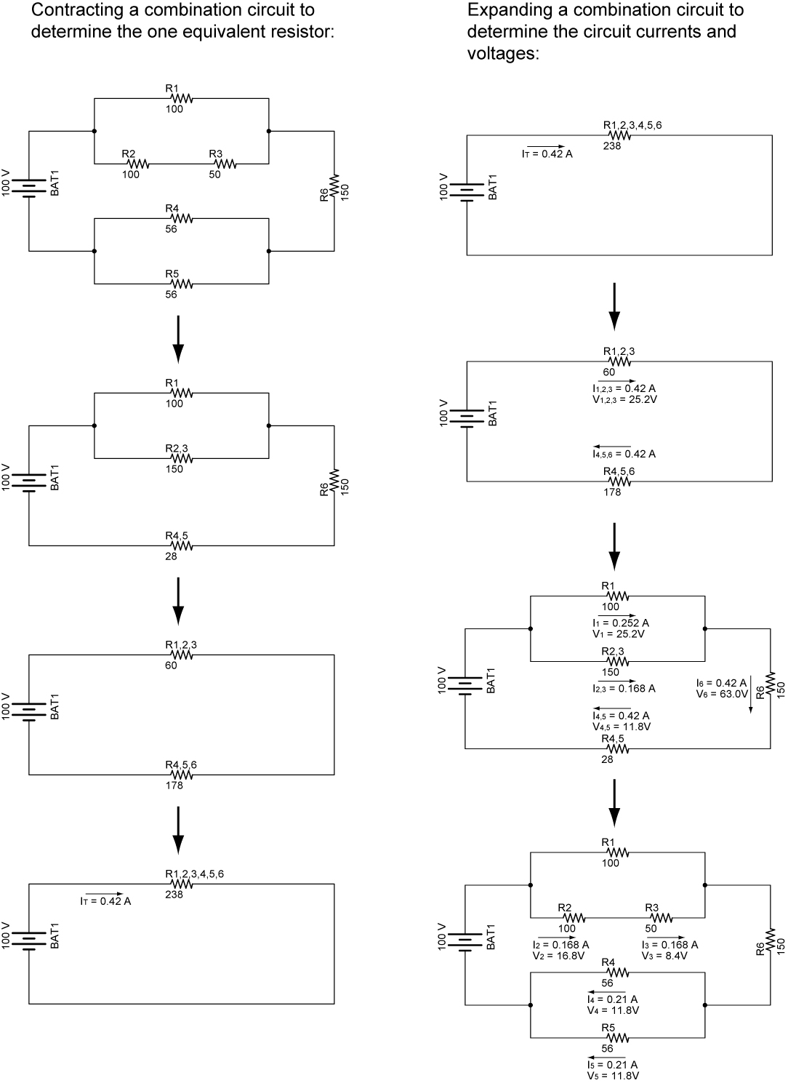

Figure 2 – Example of Contracting and Expanding a Combination Circuit
Example 1: Parallel resistors R₁ and R₂ are in series with resistor R₃. See Figure 3.
(Note: In the following examples, when you encounter a resistor labeled R_{1,2}, it is an equivalent resistor for resistors R₁ and R₂. R_{1,2,3,4,5} is the equivalent resistor for resistors R₁, R₂, R₃, R₄, and R₅. Similarly, V_{4,5} is the voltage drop across the equivalent resistor R_{4,5}.)

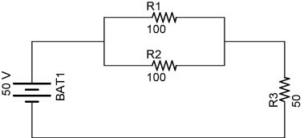

Figure 3

Solve for the all of the unknowns in Table 1.

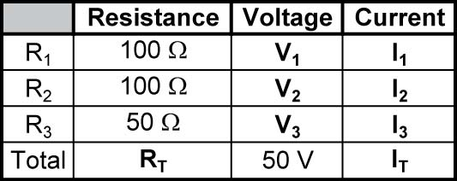

Table 1

  - Contracting the Circuit: Finding the Total Resistance, R_{T} and Total Current, I_{T} :
    - Step 1: Assess which resistors in a circuit are connected together in simple series or simple parallel. In our circuit, R₁ and R₂ are in a simple parallel configuration.
    - Step 2: Re-draw the circuit, (Figure 4), replacing each of those series or parallel resistor combinations identified in Step 1 with a single, equivalent-value resistor. In this circuit, R₁ and R₂ are replaced with R_{1,2}.
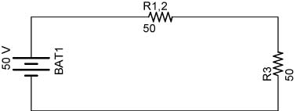

Figure 4

R_{1,2} = R/N
R_{1,2} = 100 Ω / 2
R_{1,2} = 50 Ω
    - Step 3: Repeat Steps 1 and 2 until the entire circuit is reduced to one equivalent resistor. (Step 1) - R_{1,2} and R₃ are in a simple series configuration. (Step 2) - Re-draw the circuit, (Figure 5), with R_{1,2,3} replacing R_{1,2} and R₃. Enter R_{T}, (R_{1,2,3}), into the solution table (Table 2).
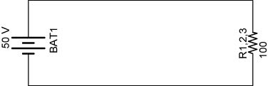

Figure 5

R_{T} = R_{1,2,3}
R_{T} = R_{1,2} + R₃
R_{T} = 50 Ω + 50 Ω
R_{T} = 100 Ω

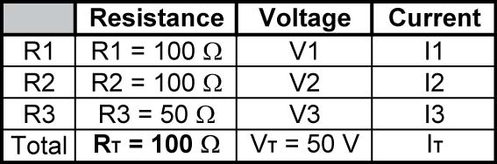

Table 2

    - Step 4: Find the total current for the circuit.

I_{T} = V_{T} / R_{T}
I_{T} = 50 V / 100 Ω
I_{T} = 0.5 A

See Table 3:

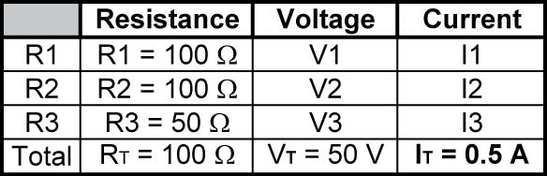

Table 3
  - Expanding the Circuit: Find all remaining values of voltage and current.
    - Step 5: Taking total voltage and total current values, go back to last step in the circuit reduction process, (Figure 6), and insert those values where applicable. We can now determine the current through each series resistor in the equivalent circuit in Figure 8.4.

Figure 6

I_{T} = I_{1,2} = I₃ = 0.5 A

Enter the value of I₃ into the solution table (Table 4).

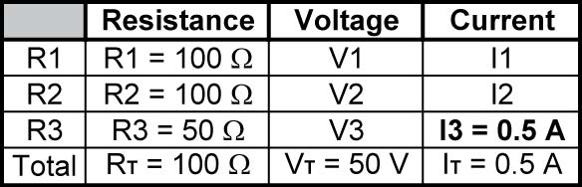

Table 4

- Step 6: From known resistances, total voltage, and total current values from Step 5, use Ohm’s Law to calculate unknown values (voltage or current). In our example, calculate the voltage drop V₃ across the series resistor R₃ and the voltage drop V_{1,2} across the parallel combination (equivalent resistor, R_{1,2}).

Figure 7

V₃ = I₃ x R₃
V₃ = 0.5 A x 50 Ω
V₃ = 25 V
V_{1,2} = I_{1,2} x R_{1,2}
V_{1,2} = 0.5 A x 50 Ω
V_{1,2} = 25 V
Since R₁ and R₂ are parallel resistors, the voltage drops V₁ and V₂ are the same value and equal to V_{1,2}.

V₁ = V₂ = V_{1,2} = 25 V

We can now enter V₁, V₂, and V₃ into the solution table (Table 5).

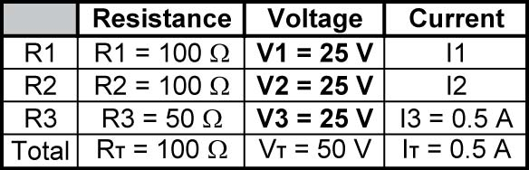

Table 5
    - Step 7: Repeat steps 5 and 6 until all values for voltage and current are known in the original circuit configuration. Essentially, you will proceed step-by-step from the simplified version of the circuit back into its original, complex form, plugging in values of voltage and current where appropriate until all values of voltage and current are known. Here, calculate the current through each parallel resistor (R₁ and R₂) in the parallel resistor combination. Use Ohm’s Law.
Figure 8
I₁ = V₁ / R₁
I₁ = 25 V / 100 Ω
I₁ = 0.25 A

I₂ = V₂ / R₂
I₂ = 25 V / 100 Ω
I₂ = 0.25 A

Enter I₁ and I₂ into the solution table (Table 6).

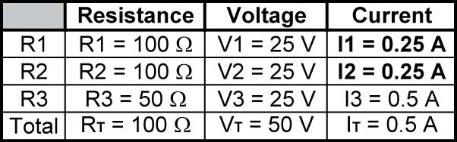

Table 6
    - Step 8: Calculate power dissipations from known voltage, current, and/or resistance values.
P₁ = V₁ x I₁
P₁ = 25 V x 0.25 A
P₁ = 6.25 W

P₂ = V₂ x I₂
P₂ = 25 V x 0.25 A
P₂ = 6.25 W

P₃ = V₃ x I₃
P₃ = 25 V x 0.5 A
P₃ = 12.5 W

P_{T} = V_{T} x I_{T}
P_{T} = 50 V x 0.5 A
P_{T} = 25 W

The final solution table (Table 7):

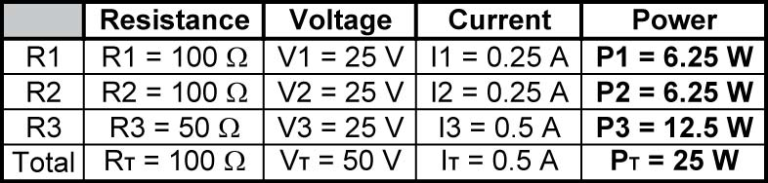

Table 7

Summary of Values:

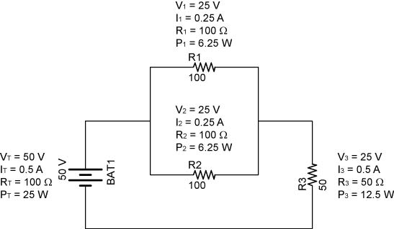

Figure 9

  - Example 2: This combination circuit is a more complicated set of series and parallel resistors. See Figure 10.

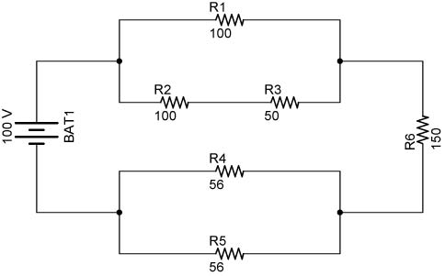

Figure 10

Solve for the all of the unknowns in Table 8.

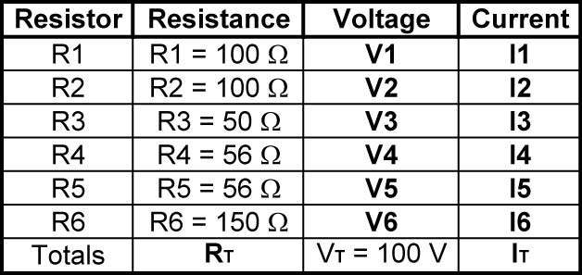

Table 8

  - Contracting the Circuit: Finding the Total Resistance, R_{T} and Total Current, I_{T} :
    - Step 1: Assess which resistors in a circuit are connected together in simple series or simple parallel. In this circuit, R₂ and R₃ are in simple series in a parallel branch. Also, R₄ and R₅ are in simple parallel configuration.
    - Step 2: Re-draw the circuit, (Figure 11), replacing each of those series or parallel resistor combinations identified in Step 1 with a single, equivalent-value resistor.

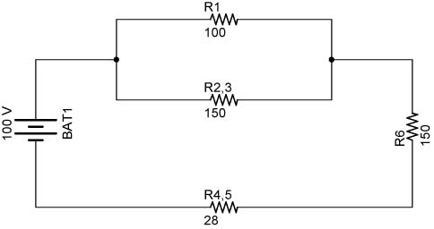

Figure 11

To determine the equivalent resistance R_{2,3}, add the series resistors R₂ and R₃ together.

R_{2,3}:
R_{2,3} = R₂ + R₃
R_{2,3} = 100 Ω + 50 Ω
R_{2,3} = 150 Ω

Also determine the equivalent resistor R_{4,5} for the parallel resistors, R₄ and R₅, using the formula for parallel resistors of equal value.

R_{4,5}:
R_{4,5} = R/N
R_{4,5} = 56 Ω / 2
R_{4,5} = 28 Ω
    - Step 3: Repeat Steps 1 and 2 until the entire circuit is reduced to one equivalent resistor. (Step 1) - R₁ and R_{2,3} are in a simple parallel configuration. R_{4,5} and R₆ are in a simple series configuration. (Step 2) - Re-draw the circuit, (Figure 12), with R_{1,2,3} replacing R₁ and R_{2,3} and R_{4,5,6} replacing R_{4,5} and R₆. 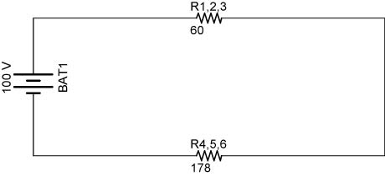
Figure 12
Determine the equivalent resistor R_{1,2},₃ for the parallel resistors, R₁ and R_{2,3}, using the formula for two parallel resistors.
R_{1,2},₃:
R_{1,2},₃ = R₁ x R_{2,3} / R₁ + R_{2,3}
R_{1,2},₃ = 100 Ω x 150 Ω / 100 Ω + 150 Ω
R_{1,2},₃ = 15,000 Ω² / 250 Ω R_{1,2},₃ = 60 Ω

Determine the equivalent resistor R_{4,5,6} for the series resistors, R_{4,5} and R₆, using the formula series resistor formula.

R_{4,5,6}:
R_{4,5,6} = R_{4,5} + R₆
R_{4,5,6} = 28 Ω + 150 Ω
R_{4,5,6} = 178 Ω

    - Step 3 again: Repeat Steps 1 and 2 until the entire circuit is reduced to one equivalent resistor. (Step 1) - R_{1,2,3} and R_{4,5,6} are in a simple series configuration. (Step 2) - Re-draw the circuit, (Figure 13), with R_{1,2,3,4,5,6} replacing R_{1,2,3} and R_{4.5.6}.

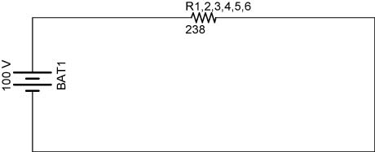

Figure 13

Determine the equivalent resistor R_{1,2,3,4,5,6} for the series resistors R_{1,2,3} and R_{4,5,6} using the formula series resistor formula.

R_{1,2,3,4,5,6} = R_{1,2,3} + R_{4,5,6}
R_{1,2,3,4,5,6} = 60 Ω + 178Ω
R_{1,2,3,4,5,6} = 238 Ω
R_{1,2,3,4,5,6} = R_{T}

Enter R_{T}, (R_{1,2,3,4,5,6}), into the solution table (Table 9).

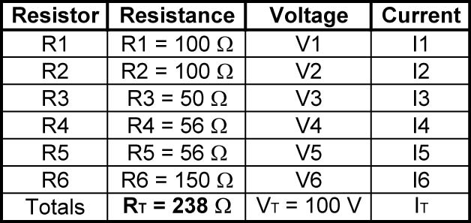

Table 9

    - Step 4: Find the total current for the circuit.

I_{T} = V_{T} / R_{T}
I_{T} = 100 V / 238 Ω
I_{T} = 0.42 A

See Table 10:

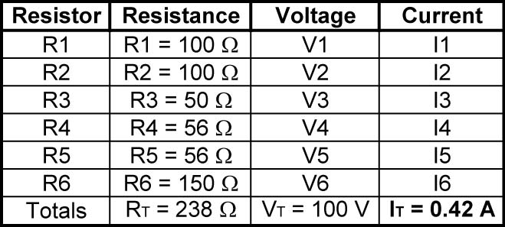

Table 10

  - Expanding the Circuit: Find all remaining values of voltage and current.
    - Step 5: Taking total voltage and total current values, go back to last step in the circuit reduction process, (Figure 8.12), and insert those values where applicable.

Figure 14

Determine the current through each series resistor in the equivalent circuit in Figure 14.

I_{T} = I_{1,2,3} = I_{4,5,6} = 0.42 A

Also, we can calculate the voltage drop V_{1,2,3} across resistor R_{1,2,3}.

V_{1,2,3} = I_{1,2,3} x R_{1,2,3}
V_{1,2,3} = 0.42 A x 60 Ω
V_{1,2,3} = 25.2 V

- Step 6: From known resistances and total voltage / total current values from Step 5, use Ohm’s Law to calculate unknown values (voltage or current). See Figure 15.

Figure 15

R₁ and R_{2,3}:

Since R₁ and R_{2,3} are parallel resistors, the voltage drops V₁ and V_{2,3} are the same value and equal to V_{1,2,3}.

V₁ = V_{2,3} = V_{1,2,3} = 25.2 V

Knowing V₁ and R₁, solve for I₁:

I₁ = V₁ / R₁
I₁ = 25.2 V / 100 Ω
I₁ = 0.25 A

The current through R_{2,3} is the total current I_{T} less I₁.

I_{2,3} = I_{T} - I₁
I_{2,3} = 0.42 A – 0.252 A
I_{2,3} = 0.168 A

I_{2,3} could have been solved using Ohm’s Law, I_{2,3} = V_{2,3} / R_{2,3}

R_{4,5} and R₆:

R_{4,5} and R₆ are in series so they have the same current through them as R_{4,5,6}.

I_{4,5,6} = I_{4,5} = I₆ = 0.42 A

Knowing I₆ and R₆, solve for V₆:

V₆ = I₆ x R₆
V₆ = 0.42 A x 150 Ω
V₆ = 63 V

Knowing I_{4,5} and R_{4,5}, solve for V_{4,5}:

V_{4,5} = I_{4,5} x R_{4,5}
V_{4,5} = 0.42 A x 28 Ω
V_{4,5} = 11.8 V

Update the solutions table with the values of V₁, I₁, V₆ and I₆ (Table 11).

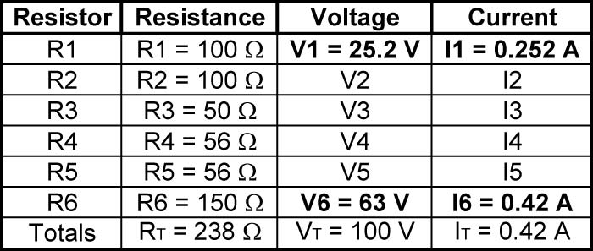

Table 11
- Step 7: Repeat steps 5 and 6 until all values for voltage and current are known in the original circuit configuration.

Figure 16

R₂ and R₃:

R₂ and R₃ are in series so they have the same current through them as R_{2,3}.

I_{2,3} = I₂ = I₃ = 0.168 A

Knowing I₂ and R₂, solve for V₂:

V₂ = I₂ x R₂
V₂ = 0.168 A x 100 Ω
V₂ = 16.8 V

Knowing I₃ and R₃, solve for V₃:

V₃ = I₃ x R₃
V₃ = 0.168 A x 50 Ω
V₃ = 8.4 V

R₄ and R₅:

Since R₄ and R₅ are parallel resistors, the voltage drops V₄ and V₅ are the same value and equal to V_{4,5}.

V₄ = V₅ = V_{4,5} = 11.8 V

Knowing V₄ and R₄, solve for I₄:

I₄ = V₄ / R₄
I₄ = 11.8 V / 56 Ω
I₄ = 0.21 A

Since R₄ and R₅ are equal,

I₄ = I₅

Record voltages and currents into the solution table (Table 12).

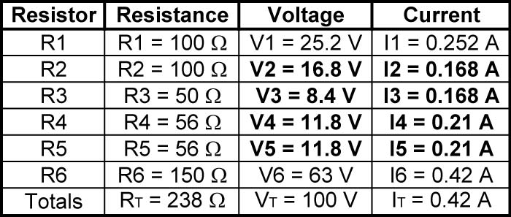

Table 12
    - Step 8: Calculate power dissipations from known voltage, current, and/or resistance values.
P₁ = V₁ x I₁
P₁ = 25.2 V x 0.252 A
P₁ = 6.3 W

P₂ = V₂ x I₂
P₂ = 16.8 V x 0.168 A
P₂ = 2.8 W

P₃ = V₃ x I₃
P₃ = 8.4 V x 0.168 A
P₃ = 1.4 W

P₄ = V₄ x I₄
P₄ = 11.8 V x 0.21 A
P₄ = 2.5 W

P₅ = V₅ x I₅
P₅ = 11.8 V x 0.21 A
P₅ = 2.5 W

P₆ = V₆ x I₆
P₆ = 63 V x 0.42 A
P₆ = 26.5 W

P_{T} = V_{T} x I_{T}
P_{T} = 100 V x 0.42 A
P_{T} = 42 W

Check power total:

P_{T} = P₁ + P₂ + P₃ + P₄ + P₅ + P₆
P_{T} = 6.3 W + 2.8 W + 1.4 W + 2.5 W + 2.5 W + 26.5 W
P_{T} = 42.0 W

The final solution table (Table 13):

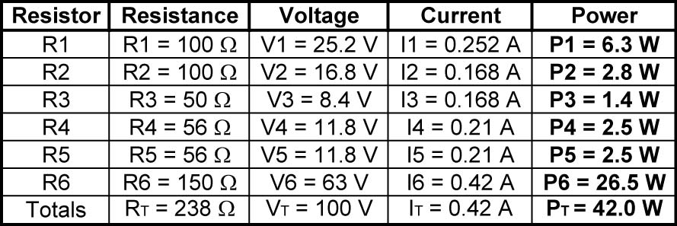

Table 13

Summary of Values:

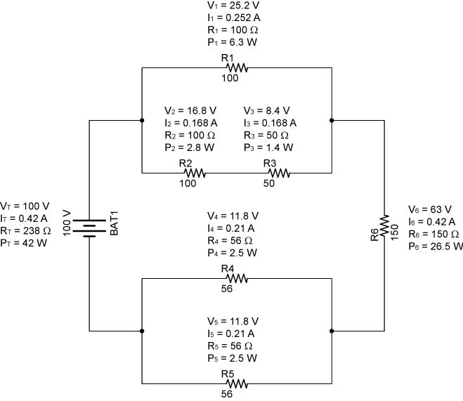

Figure 17

  - Example Problem 1:
    - Solve for all of the unknowns in the following circuit. Fill in each unknown in the table below the circuit.

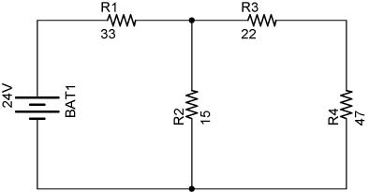

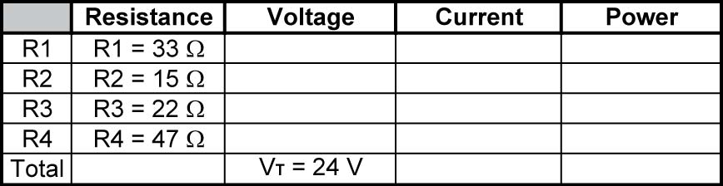

  - Remember, to solve series circuit problems, you can use any or all of the following equations:

R_{T} = R₁ + R₂ + R₃ + … + R_{N}
V_{T} = V₁ + V₂ + V₃ + …+ V_{N}
I_{T} = I₁ = I₂ = I₃ =…I_{N}
V = I x R

  - Remember, to solve parallel circuit problems, you can use any or all of the following equations:

1/R_{T} = 1/R₁ + 1/R₂ + 1/R₃ +………..+1/R_{N}
V_{T} = V₁ = V₂ = V₃ = ….. V_{N}
I_{T} = I₁ + I₂ + I₃ + …+ I_{N}
V = I x R

  - Example Problem 2:
    - Fill in the known values then solve for all of the unknowns in the following circuit.

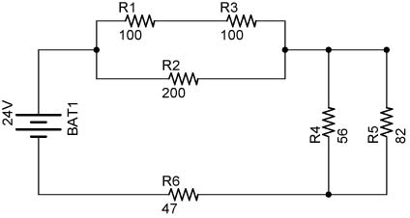

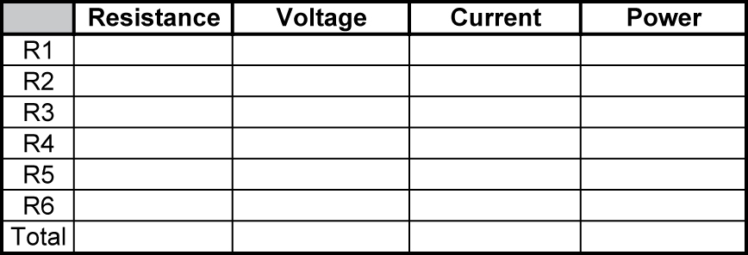

  - Remember, to solve series circuit problems, you can use any or all of the following equations:

R_{T} = R₁ + R₂ + R₃ + … + R_{N}
V_{T} = V₁ + V₂ + V₃ + …+ V_{N}
I_{T} = I₁ = I₂ = I₃ =…I_{N}
V = I x R

  - Remember, to solve parallel circuit problems, you can use any or all of the following equations:

1/R_{T} = 1/R₁ + 1/R₂ + 1/R₃ +………..+1/R_{N}
V_{T} = V₁ = V₂ = V₃ = ….. V_{N}
I_{T} = I₁ + I₂ + I₃ + …+ I_{N}
V = I x R

- You are given a black box with two terminals. The box is known to contain six 1-ohm resistors. Using ohm-meter, you measure the resistance between the terminals to be the following:

      - 0.75 Ohms
      - 1.5 Ohms
      - 2.25 Ohms
      - 3 Ohms
      - 4.5 Ohms
      - 6 Ohms

Determine the configurations of the six resistors inside the box that create each resistance value.

- Example Problem Solutions:

  - Example Problem 1:

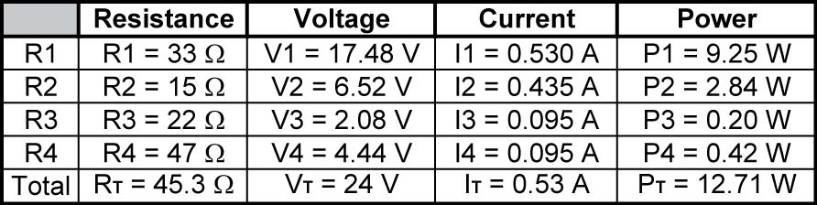

  - Example Problem 2:



