Cornerstone Electronics Technology and Robotics I Week 14
Parallel Circuits
- Administration:
  - Prayer
- Electricity and Electronics, Section 7.1, Parallel Circuits:
  - A parallel circuit is one that has more than one pathway for the electrons to flow. Unlike series circuit, when you remove a resistor in a parallel circuit, electrons continue to flow.
  - Identifying parallel circuits: Each example below is a circuit with two parallel paths; all of the circuit configurations are electrically equivalent to each other.

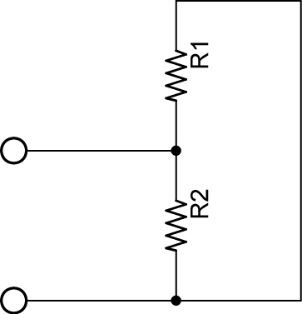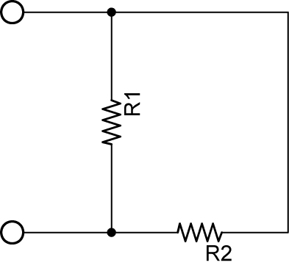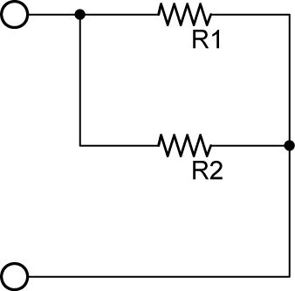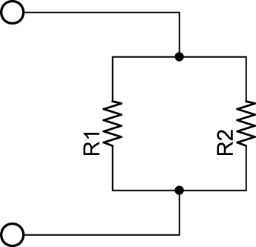

Circuit 1 Circuit 2 Circuit 3 Circuit 4

  - Everyday examples of parallel circuits:
    - Electrical outlets in a home See: http://sol.sci.uop.edu/~jfalward/seriesparallelcircuits/seriesparallelcircuits.html (House wiring diagram)
    - Lights in a home
    - Electrical car functions, such as the radio, horn, starter, lights, etc.
  - Voltage in a Parallel Circuit:
    - If components are connected in parallel to the source, the voltage drop across each component is the same as the source voltage.
    - Mathematically:

V_{T} = V₁ = V₂ = V₃ = ….. = V_{N}

Where:

V_{T} = Total voltage applied to the series circuit
V₁ = Voltage drop across R₁
V₂ = Voltage drop across R₂
V₃ = Voltage drop across R₃
V_{N} = Voltage drop across R_{N}
N = The number of resistors in the parallel

For example, if N = 2, then the 2 resistor parallel circuit and voltmeter setup is as follows:

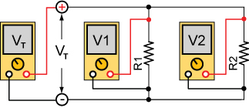

And the corresponding voltage drop equation is:

V_{T} = V₁ = V₂

If N = 5, then the 5 resistor parallel circuit is:

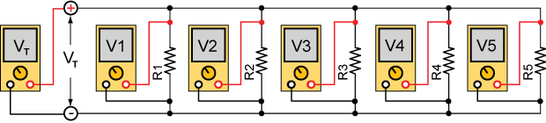

And the corresponding voltage drop equation is:

V_{T} = V₁ = V₂ = V₃ = V₄ = V₅

    - In the two circuits below, the connections in Figure 1 and Figure 2 are electrically equivalent.

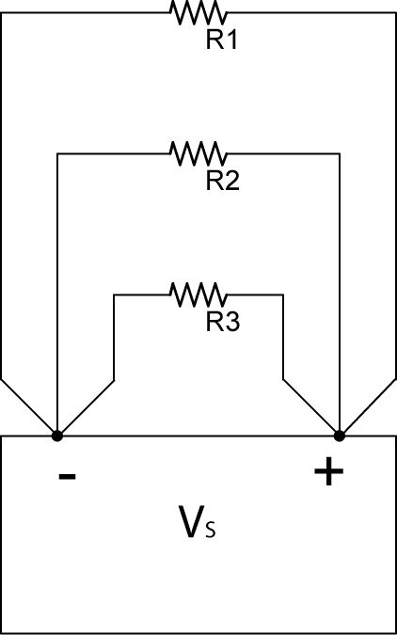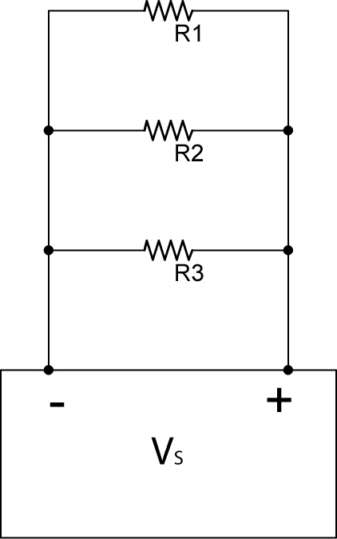

Figure 1 Figure 2

    - Perform Parallel Circuits Lab 1 – Voltage Drop in a Parallel Circuit
  - Current in a Parallel Circuit:
    - Kirchhoff’s Current Law: The sum of the currents into a junction is equal to the sum of the currents out of that junction.
    - Mathematically:

I_{TOTAL in} = I_{TOTAL out}

Where:

I_{TOTAL in} = the sum of currents into a junction
I_{TOTAL out} = the sum of currents out of a junction

For Example:

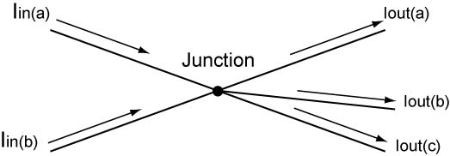

Figure 3

I_{in(a)} + I_{in(b)} = I_{out(a)} + I_{out(b)} + I_{out(c)}

Another way of expressing Kirchhoff’s Current Law (see Figure 4):

I_{T} = I₁ + I₂ + I₃ + …+ I_{N}

Where:

I_{T} = Total current into a parallel resistor circuit
I₁ = Current through R₁
I₂ = Current through R₂
I₃ = Current through R₃
I_{N} = Current through R_{N}

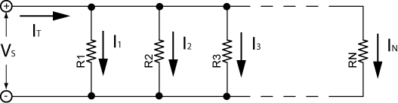

Figure 4

Draw a parallel resistor circuit where N = 4 and show the total current and the currents through each resistor. Assume conventional current flow.

    - See applets:
      - http://www.falstad.com/circuit/e-ohms.html
      - http://media.pearsoncmg.com/bc/aw_young_physics_11/pt2a/Media/DCCircuits/1202DCParallel/Main.html (#3, junction law)
    - Parallel circuits act as current dividers. See the two examples below.

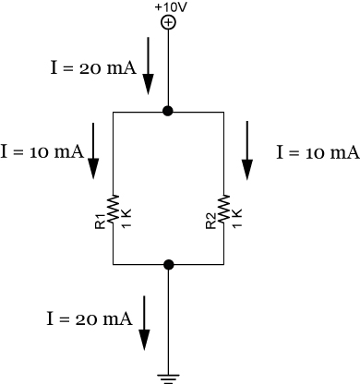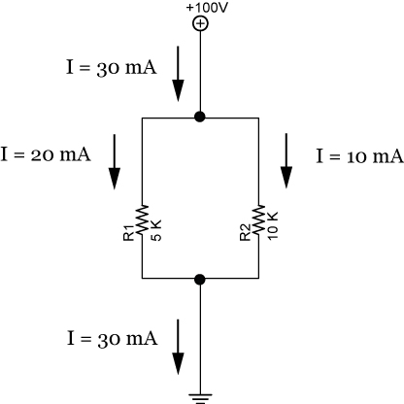

Example 1 Example 2

    - Perform Parallel Circuits Lab 2 – Kirchhoff’s Current Law
  - Resistance in Parallel Circuits:
    - When resistors are connected in parallel circuits, the total resistance is always less than the value of the smallest resistor.
    - Reciprocal Rule:
      - The reciprocal of a number is equal to 1 divided by that number, e.g., the reciprocal of 4 is ¼, and the reciprocal of 87 is 1/87.
      - The total resistance of a parallel circuit is:

1/R_{T} = 1/R₁ + 1/R₂ + 1/R₃ +………..+1/R_{N}

Where R_{T} is the total resistance and
N is the total number of resistors in parallel.

      - Proof: Since I_{T} = I₁ + I₂ + I₃ + …+ I_{N}:

And I_{T} = V_{S}/R_{T} and I₁ = V_{S}/R₁, I₂ = V_{S}/R₂, etc., then:

V_{S}/R_{T} = V_{S}/R₁ + V_{S}/R₂ + V_{S}/R₃ +…..+ V_{S}/R_{N}

Now factor out V_{S} by dividing both sides of the equation by V_{S} and you arrive at:

1/R_{T} = 1/R₁ + 1/R₂ + 1/R₃ +…..+1/R_{N}

      - Example: Find the total resistance in Circuit 5:

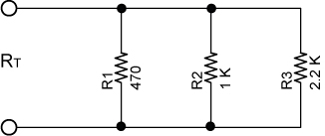

Circuit 5

1/R_{T} = 1/R₁ + 1/R₂ + 1/R₃
1/R_{T} = 1/470 + 1/1000 + 1/2200
1/R_{T} = 0.0021 + 0.001 + 0.0004
1/R_{T} = 0.0035
R_{T} = 1/0.0035
R_{T} = 286 Ω

    - Special Case 1: Two resistor parallel circuit: Since 1/R_{T} = 1/R₁ + 1/R₂, then

R_{T} = R₁R₂/R₁+R₂
    - Special Case 2: Resistors of equal value:

R_{T} = R/N

Where:

R = the value of each resistor (all being the same) N = the number of resistors

For Example:

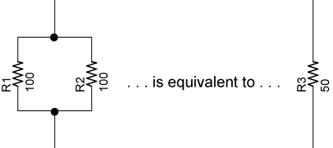

R_{T} = R/N
R_{T} = 100/2
R_{T} = 50 Ω

How many 1 K resistors in parallel would you need to create a total resistance of 1 ohm?

    - In a parallel circuit, a resistor that is much smaller than the other resistors dominates.
    - Applet: http://www.lon-capa.org/~mmp/kap20/RR506a.htm
    - Perform Parallel Circuits Lab 3 – Total Resistance in a Parallel Circuit
  - Power in a Parallel Circuit:
    - The total power is equal to the sum of all the power of each resistor in the parallel circuit.

P_{T} = P₁ + P₂ + P₃ +…….+P_{N}

Where P_{T} is the total power consumed in the circuit and
N is the total number of resistors in parallel.

    - Power is also equal to the source voltage times the total current.

P_{T} = V_{T} x I_{T}

Where P_{T} is the total power consumed in the circuit,
V_{T} is the source voltage, and
I_{T} is the total current

- Electricity and Electronics, Section 7.2, Applications and Troubleshooting Parallel Circuits:
  - Solving for Resistance, Voltage, and Current in a Parallel Resistor Circuits:
    - Four equations are used to solve parallel resistor circuits. They are:

1/R_{T} = 1/R₁ + 1/R₂ + 1/R₃ +………..+1/R_{N}
V_{T} = V₁ = V₂ = V₃ = ….. V_{N}
I_{T} = I₁ + I₂ + I₃ + …+ I_{N}
V = I x R

V = I x R can be applied to the total circuit (V_{T} = I_{T} x R_{T}) and to individual resistors (V₁ = I₁ x R₁).

    - A table will be used to help solve our circuits. To begin, a table as shown in Table 1 corresponds to the circuit in Figure 5:

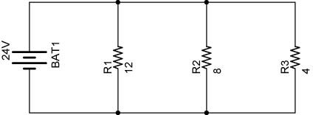

Figure 5

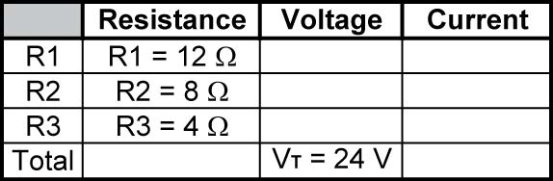

Table 1

    - Table 2 lists all of the unknowns that will be solved.

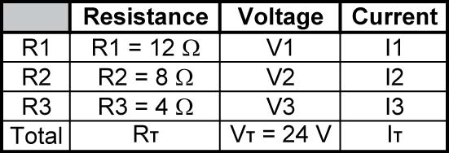

Table 2

    - Step 1: Find V₁, V₂, and V₃.

V_{T} = V₁ = V₂ = V₃ = 24 V

See Table 3:

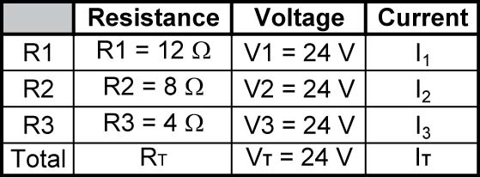

Table 3

    - Step 2: Find I₁, I₂, and I₃.

V₁ = I₁ x R₁, therefore,
I₁ = V₁ / R₁
I₁ = 24 V / 12 Ω
I₁ = 2 A

I₂ = V₂ / R₂
I₂ = 24 V / 8 Ω
I₂ = 3 A

I₃ = V₃ / R₃
I₃ = 24 V / 4 Ω
I₃ = 6 A

See Table 4:

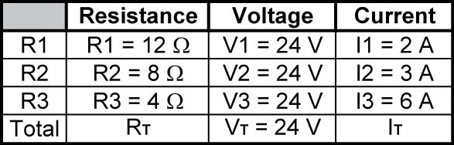

Table 4

    - Step 3: Find I_{T}.

I_{T} = I₁ + I₂ + I₃
I_{T} = 2 A + 3 A + 6 A
I_{T} = 11 A

See Table 5:

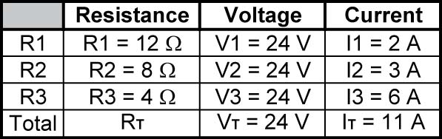

Table 5

    - Step 5: Find R_{T}.

1/R_{T} = 1/R₁ + 1/R₂ + 1/R₃
1/R_{T} = 1/12 + 1/8 + 1/4
1/R_{T} = 0.083 + 0.125 + 0.25
1/R_{T} = 0.458
R_{T} = 1/0.458
R_{T} = 2.18 Ω

Or an alternate way:

V_{T} = I_{T} x R_{T}, therefore,
R_{T} = V_{T} / I_{T}
R_{T} = 24 V / 11 A
R_{T} = 2.18 Ω

See Table 6:

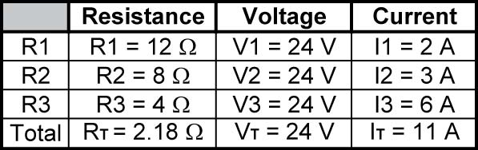

Table 6

    - Since all of the resistances, voltages, and currents are solved in the present problem, the power can now be calculated.
  - Solving for Power in a Parallel Resistor Circuits:
    - Two equations are used to solve for power in a parallel resistor circuit. They are:

P_{T} = P₁ + P₂ + P₃ + …. + P_{N}
P = V x I

P = V x I can be applied to the total circuit (P_{T} = V_{T} x I_{T}) and to individual resistors (P₁ = V₁ x I₁).
    - A column for power will be added to the table already used to solve our circuit. See Table 7.

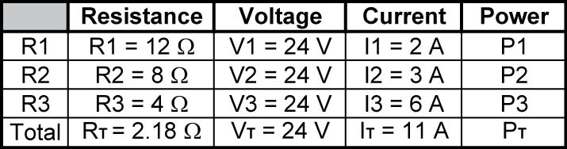

Table 7

    - Step 5: Solve for P₁, P₂, P₃, and P_{T}.

P₁ = V₁ x I₁
P₁ = 24 V x 2 A
P₁ = 48 W

P₂ = V₂ x I₂
P₂ = 24 V x 3 A
P₂ = 72 W

P₃ = V₃ x I₃
P₃ = 24 V x 6 A
P₃ = 144 W

P_{T} = P₁ + P₂ + P₃
P_{T} = 48 W + 72 W + 144 W
P_{T} = 264 W

See Table 8:

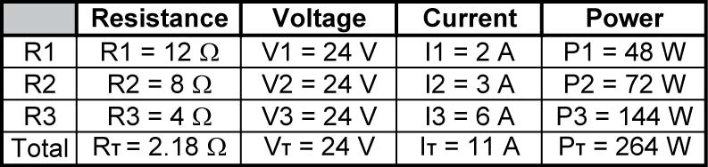

Table 8
  - Example Problem 1:
    - In following example problems, insert the known values into the tables and solve for all of the unknowns for the corresponding circuits.

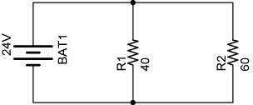

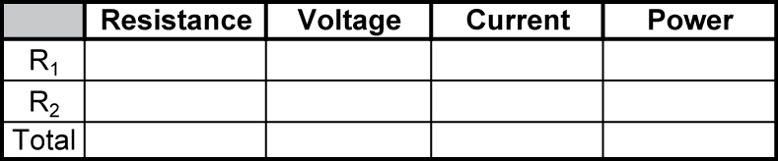

  - Remember:

1/R_{T} = 1/R₁ + 1/R₂ + 1/R₃ +………..+ 1/R_{N}
V_{T} = V₁ = V₂ = V₃ = ….. V_{N}
I_{T} = I₁ + I₂ + I₃ + …+ I_{N}
V = I x R
P = V x I

  - Example Problem 2:

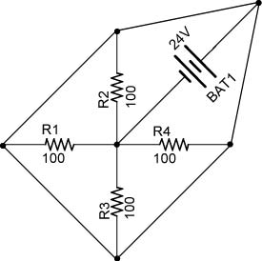

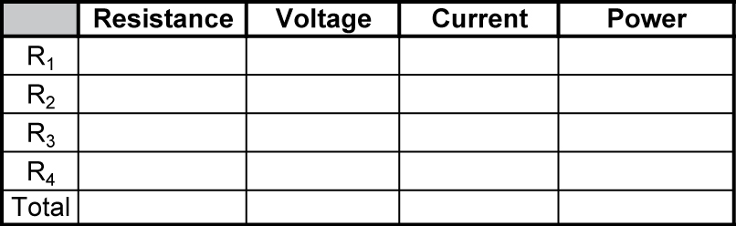

  - Example Problem 3:

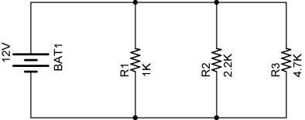

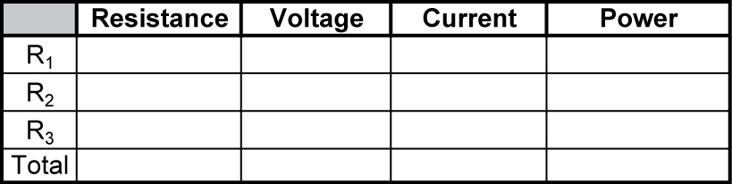
  - Example Problem 4:

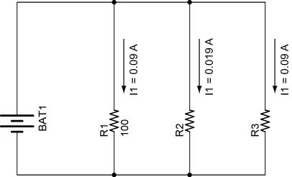

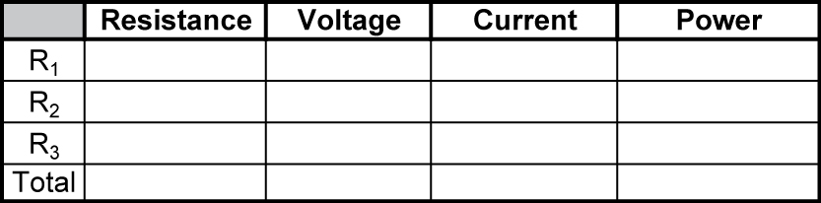

  - Example Problem 5:

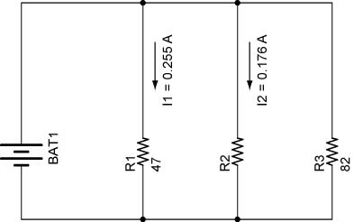

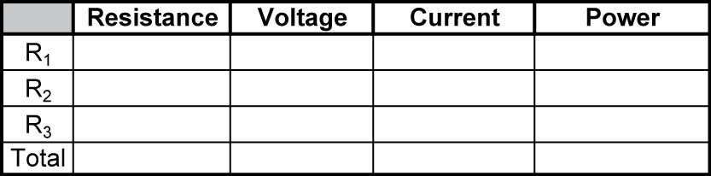

  - Solve problems 1, 2, 4, and 7 in Student Activity Sheet 7-2.
- Related Web Sites:
  - http://www.physics247.com/solved_problems/basic_circuits.php
  - http://www.acs.ryerson.ca/~kantorek/EES512/tutor2.html
  - http://people.clarkson.edu/~svoboda/eta/designLab/ParallelRDesign.html
  - http://www.glenbrook.k12.il.us/gbssci/phys/Class/circuits/u9l4d.html
  - http://www.allaboutcircuits.com/vol_1/chpt_5/3.html
- Suggested Home-Study Student Activity Sheets 7.1 and 7.2
- Example Problem Solutions:
  - Example Problem 1:

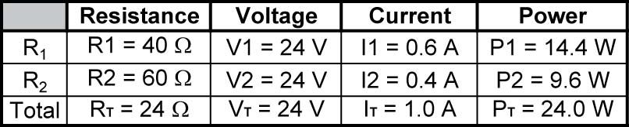

  - Example Problem 2:

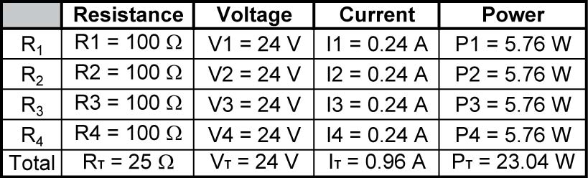

  - Example Problem 3:

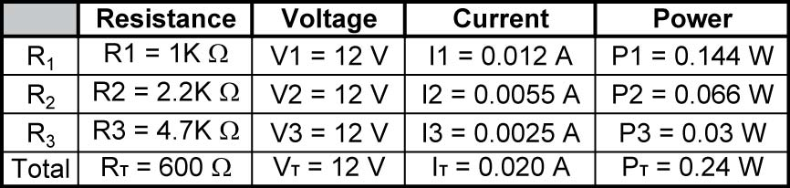

  - Example Problem 4:

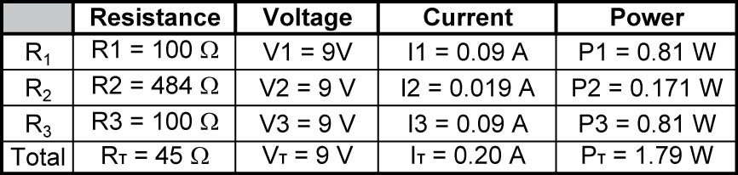

  - Example Problem 5:

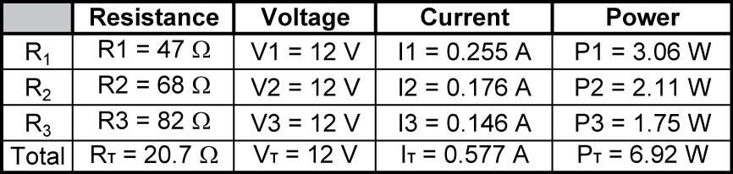
Electronics Technology and Robotics I Week 14
Parallel Circuits Lab 1 – Voltage Drop in a Parallel Circuit

- Purpose: The purpose of this lab is to experimentally verify that the voltage drops across parallel resistors are equal.

- Apparatus and Materials:

  - 1 – Solderless Breadboard with 9 V Power Supply
  - 1 – Digital Multimeter
  - 1 – 1 K Ohm Resistor
  - 2 – 2.2 K Ohm Resistors
  - 1 – 4.7 K Ohm Resistor

- Procedure:
  - Wire the following circuit
  - Measure and record V_{AE}, V_{BF}, V_{CG}, and V_{DH}.

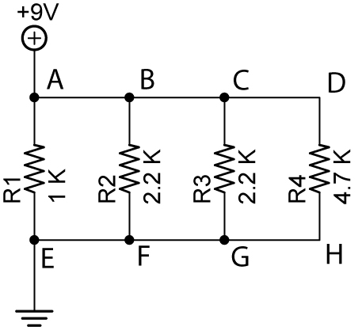

- Results:

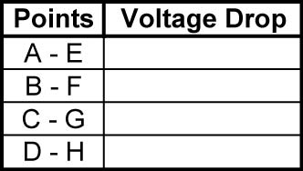

- Conclusions:
  - How do the voltage drops V_{AE}, V_{BF}, V_{CG}, and V_{DH} relate to each other?

Electronics Technology and Robotics I Week 14
Parallel Circuits Lab 2 – Kirchhoff’s Current Law

- Purpose: The purpose of this lab is to experimentally verify Kirchhoff’s Current Law.

- Apparatus and Materials:

  - 1 – Solderless Breadboard with 9 V Power Supply
  - 4 – Digital Multimeters
  - 4 - Switches
  - 2 – 220 Ohm Resistors
  - 1 – 330 Ohm Resistor
  - 1 – 470 Ohm Resistor

- Procedure:
    - In the following circuit, simultaneously measure the current at points A, B, C, and D. With all switches closed, see if I_{A} = I_{B} + I_{C} + I_{D}. Record the results. Measure and record the currents of the other combinations in the table using open and closed switches.
    - Verify Kirchhoff’s Current Law for each case.

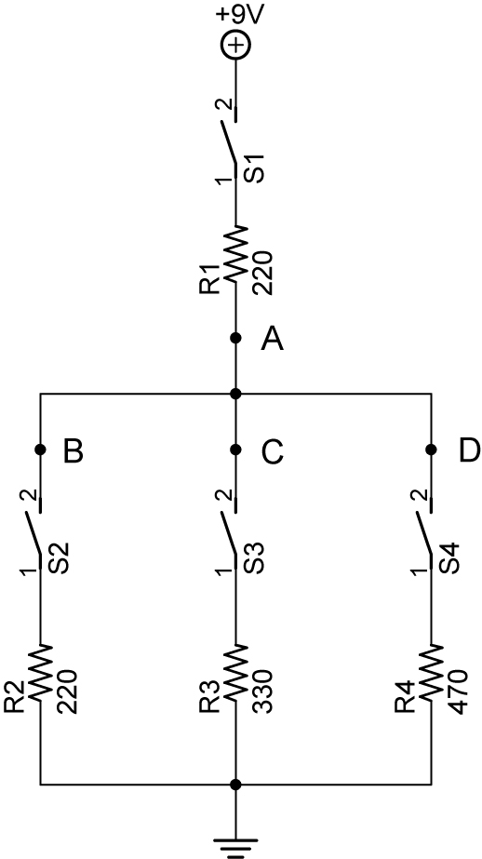

Note how the current through R₁ changes as resistors R₂, R₃, and R₄ are added or removed from the circuit.

- Results:

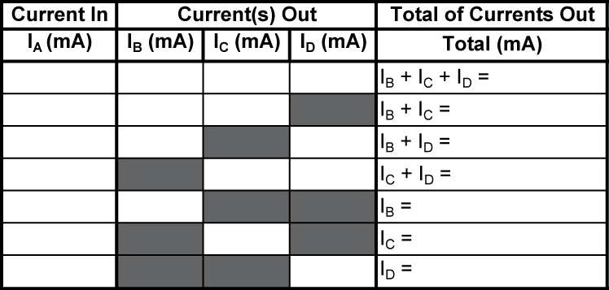

- Conclusions:
  - Does the experiment verify Kirchhoff’s Current Law? Explain.

Electronics Technology and Robotics I Week 14
Parallel Circuits Lab 3 – Total Resistance in a Parallel Circuit

- Purpose: The purpose of this lab is to experimentally verify the reciprocal rule for total resistance of a parallel circuit.

- Apparatus and Materials:

  - 1 – Solderless Breadboard
  - 1 – Digital Multimeter
  - 1 – 100 Ohm Resistor
  - 1 – 220 Ohm Resistor
  - 1 – 1K Resistor
  - 3 – 1.5K Resistor

- Procedure:
  - Resistors in Parallel:
    - Wire the following circuit below then calculate and measure/record R_{T}.

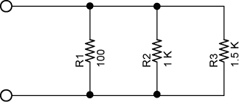

  - Two Parallel Resistors:
    - Wire the following circuit below then calculate and measure/record R_{T}.

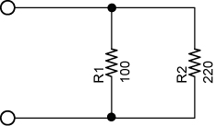

  - Equal Resistors:
    - Wire the following circuit below then calculate and measure/record R_{T}.

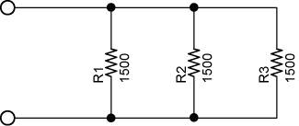

- Results:
  - Resistors in Parallel:

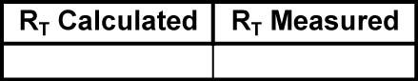

  - Two Parallel Resistors:

  - Equal Resistors:

- Conclusions: In each case, evaluate how well the R_{T} calculated matched the R_{T} measured. Explain any discrepancies.

  - Resistors in Parallel:

1/R_{T} = 1/R₁ + 1/R₂ + 1/R₃ +………..+1/R_{N}

  - Two Parallel Resistors:

R_{T} = R₁R₂/R₁+R₂

  - Equal Resistors:

R_{T} = R/N

