Cornerstone Electronics Technology and Robotics I Week 13
Series Circuits
- Administration:
  - Prayer
- Electricity and Electronics, Section 6.1, Series Circuit Principles and Equations:
  - A series circuit is one with all the loads in a row, like links in a chain. In this lesson, the loads are resistors. There is only one path for the electrons to flow. If one of the resistors is removed, the current stops.
  - Resistance in a Series Circuits:
    - The total resistance in a series circuit is equal to the sum of all of the resistors.

R_{T} = R₁ + R₂ + R₃ + … + R_{N}

Where:

R_{T} = Total resistance
R₁ = Resistance of R₁
R₂ = Resistance of R₂
R₃ = Resistance of R₃
R_{N} = Resistance of R_{N}
N = The number of resistors in the series circuit.

Figure 1A

For example, if N = 2 then the series resistor circuit appears like this:

And the corresponding total resistance equation is:

R_{T} = R₁ + R₂

Figure 1B

If N = 7 then the series resistor circuit is:

And the corresponding total resistance equation is:

R_{T} = R₁ + R₂ + R₃ + R₄ + R₅ + R₆ + R₇

Figure 1C

    - More than one resistor in series can substitute for a resistor value that is unavailable.
    - In a series circuit, the large resistor dominates if it is series with a small resistor.
    - Complete Series Circuits Lab 1 – Series Resistors
  - Voltage in a Series Circuit:
    - Kirchhoff’s Voltage Law: The total voltage applied to a series circuit is equal to the total of the individual voltage drops across each resistor in the series circuit. (In more general terms, the algebraic sum of all voltages, both source and drops, around a closed loop is equal to zero.)
    - Mathematically:

V_{T} = V₁ + V₂ + V₃ + …+ V_{N,} or

V_{T} - V₁ - V₂ - V₃ - …- V_{N} = 0
Where:
V_{T} = Total voltage applied to the series circuit
V₁ = Voltage drop across R₁
V₂ = Voltage drop across R₂
V₃ = Voltage drop across R₃
V_{N} = Voltage drop across R_{N}
N = The number of resistors in the series

    - Example of Voltage in a Series Circuit (Figure 2):
      - The voltage at Point D is 0 volts when both multimeter leads are connected to the same point.
      - Leaving the common lead at Point D, the voltage jumps to +10 V at Point A because the battery supplies the energy to increase the potential by +10 V.
      - There is a 2 V drop across R₁ (-2 V) causing the voltage at Point B to drop to +8 V.
      - Likewise, R₂ causes a further 3 V drop (-3 V) in the voltage bringing the voltage at Point C to +5 V.
      - Finally, R₃ drops the voltage 5 more volts (-5 V) to return the voltage back to 0 V at Point D.

V_{T} - V₁ - V₂ - V₃ = 0

10 V – 2 V – 3 V – 5 V = 0

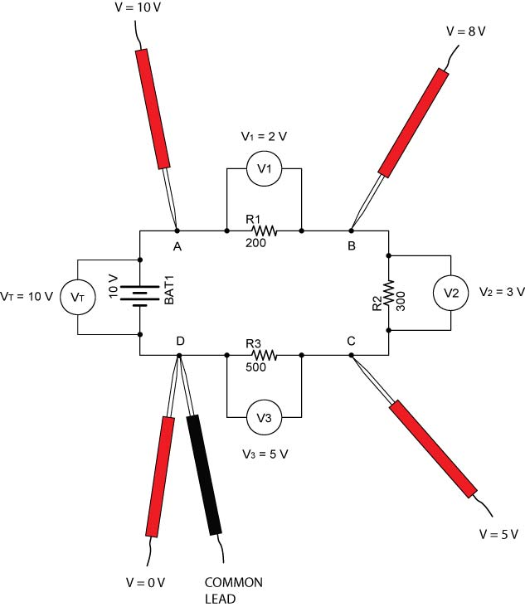

Figure 2

    - Complete Series Circuits Lab 2 – Kirchhoff’s Voltage Law
  - Current in a Series Circuit:
    - A series circuit provides only one path for the current so it must have the same value at any point in the circuit.
    - Mathematically:

I_{T} = I₁ = I₂ = I₃ =…I_{N}

Where:

I_{T} = Total current
I₁ = Current through R₁
I₂ = Current through R₂
I₃ = Current through R₃
I_{N} = Current through R_{N}
N = The number of resistors in the series

    - Example of Current in a Series Circuit (Figure 3):

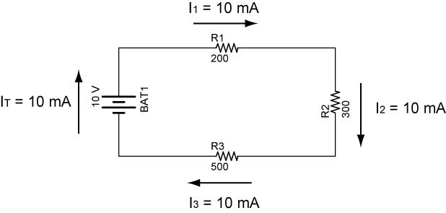

Figure 3

    - Complete Series Circuits Lab 3 – Current in Series Circuits
  - Power in a Series Circuit:
    - The total amount of power consumed in a series circuit is equal to the source voltage multiplied by the circuit current. The total power consumed is also equal to the sum of the power consumed by each resistor.
    - Mathematically:

P_{T} = P₁ + P₂ + P₃ + …. + P_{N}

Where:

P_{T} = Total power consumed
P₁ = Power consumed by R₁
P₂ = Power consumed by R₂
P₃ = Power consumed by R₃
P_{N} = Power consumed by R_{N}
N = The number of resistors in the series circuit.
    - Power also equals the product of the total voltage and the total current.

P_{T} = V_{T} x I_{T}

Where:

P_{T} = Total power consumed
V_{T} = Total voltage applied to the series circuit
I_{T} = Total current

    - Example of Power in a Series Circuit (Figure 4):

P_{T} = P₁ + P₂ + P₃
P_{T} = V₁ x I₁ + V₂ x I₂ + V₃ x I₃
P_{T} = 2 V x 0.01 A + 3 V x 0.01 A + 5 V x 0.01 A
P_{T} = 0.02 W + 0.03 W + 0.05 W
P_{T} = 0.10 W

Also,
P_{T} = V_{T} x I_{T}
P_{T} = 10 V x 0.01 A
P_{T} = 0.10 W

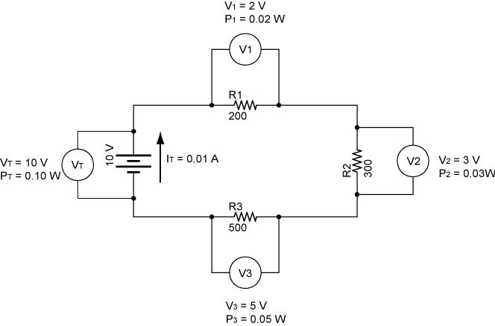

Figure 4

    - Complete Series Circuits Lab 4 – Power in Series Circuits
- Electricity and Electronics, Section 6.2, Applications and Troubleshooting Series Circuits:
  - Solving for Resistance, Voltage, and Current in a Series Resistor Circuits:
    - Four equations are used to solve series resistor circuits. They are:

R_{T} = R₁ + R₂ + R₃ + … + R_{N}
V_{T} = V₁ + V₂ + V₃ + …+ V_{N}
I_{T} = I₁ = I₂ = I₃ =…I_{N}
V = I x R

V = I x R can be applied to the total circuit (V_{T} = I_{T} x R_{T}) and to individual resistors (V₁ = I₁ x R₁).

    - A table will be used to help solve our circuits. Table 1 corresponds to the circuit in Figure 5. All of the known values for resistance, voltage, and current in the circuit in Figure 5 are entered into Table 1.

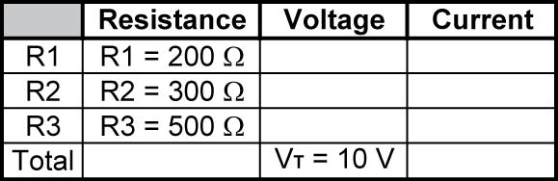

Table 1

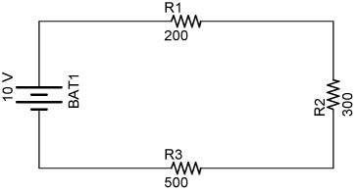

Figure 5

    - Table 2 lists all of the unknowns that will be solved.

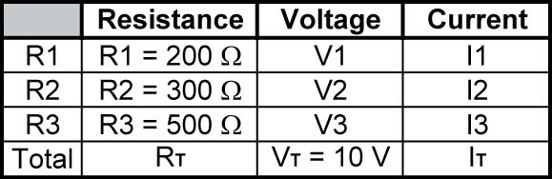

Table 2

    - Step 1: Find R_{T}:

R_{T} = R₁ + R₂ + R₃
R_{T} = 200 Ω + 300 Ω + 500 Ω
R_{T} = 1000 Ω

See Table 3:

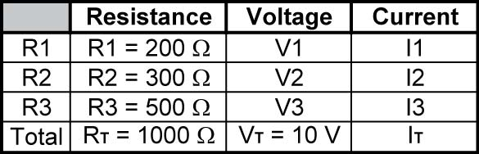

Table 3

    - Step 2: Solve for I_{T}:

I_{T} = V_{T} / R_{T}
I_{T} = 10 V / 1000 Ω
I_{T} = 0.010 A or 10 mA

See Table 4:

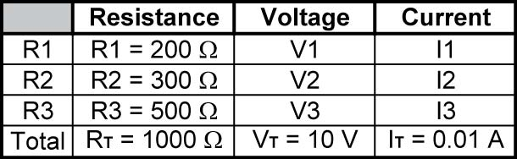

Table 4

    - Step 3: Find I₁, I₂, and I₃.

I_{T} = I₁ = I₂ = I₃ = 0.010 A

See Table 5:

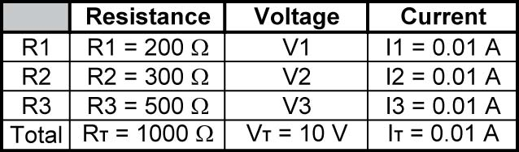

Table 5

    - Step 4: Solve for V₁, V₂, and V₃.

V₁ = I₁ x R₁
V₁ = 0.010 A x 200 Ω
V₁ = 2 V

V₂ = I₂ x R₂
V₂ = 0.010 A x 300 Ω
V₂ = 3 V

V₃ = I₃ x R₃
V₃ = 0.010 A x 500 Ω
V₃ = 5 V

See Table 6:

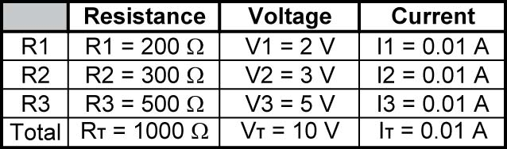

Table 6

    - Not every series circuit to be solved will have the source voltage and all of the resistor values. To solve the unknowns for each circuit, use the four equations in bold above in whatever the order is necessary for the solution.
    - Since all of the resistances, voltages, and currents are solved in the present problem, the power can now be calculated.
  - Solving for Power in a Series Resistor Circuits:
    - Two equations are used to solve for power in a series resistor circuit. They are:

P_{T} = P₁ + P₂ + P₃ + …. + P_{N}
P = V x I

P = V x I can be applied to the total circuit (P_{T} = V_{T} x I_{T}) and to individual resistors (P₁ = V₁ x I₁).
    - A column for power will be added to the table already used to solve our circuit.

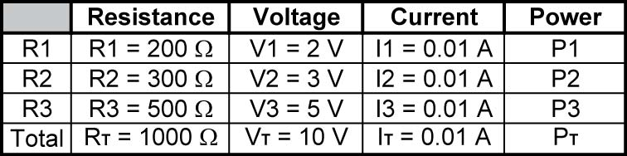

Table 7

    - Step 5: Solve for P₁, P₂, P₃, and P_{T}.

P₁ = V₁ x I₁
P₁ = 2 V x 0.010 A
P₁ = 0.020 W

P₂ = V₂ x I₂
P₂ = 3 V x 0.010 A
P₂ = 0.030 W

P₃ = V₃ x I₃
P₃ = 5 V x 0.010 A
P₃ = 0.050 W

P_{T} = P₁ + P₂ + P₃
P_{T} = 0.020 W + 0.030 W + 0.050 W
P_{T} = 0.100 W

See Table 8:

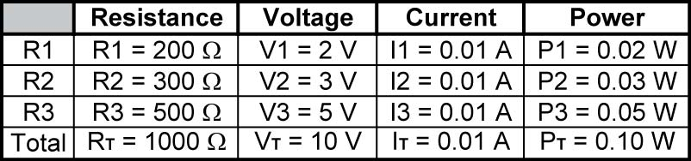

Table 8

  - Example Problem 1:
    - Solve for all of the unknowns in the following circuit. Fill in each unknown in the table below the circuit.

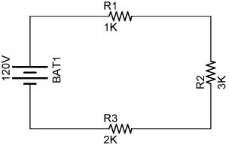

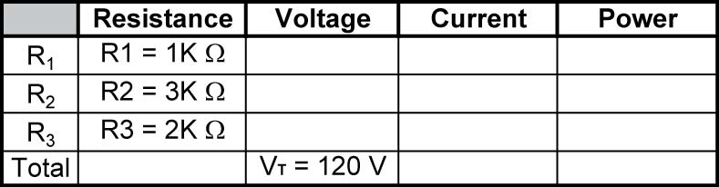

  - Remember:

R_{T} = R₁ + R₂ + R₃ + … + R_{N}
V_{T} = V₁ + V₂ + V₃ + …+ V_{N}
I_{T} = I₁ = I₂ = I₃ =…I_{N}
V = I R

  - Example Problem 2:
    - Solve for all of the unknowns in the following circuit. Fill in each unknown in the table below the circuit.

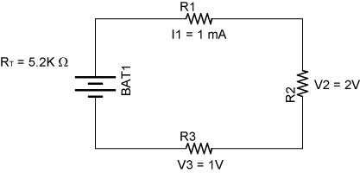

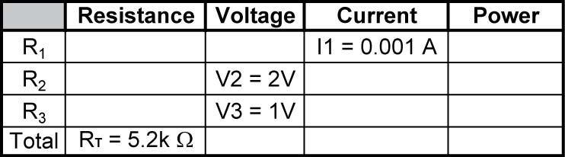
  - Example Problem 3:
    - Solve for all of the unknowns in the following circuit. Fill in each unknown in the table below the circuit.

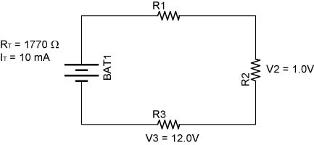

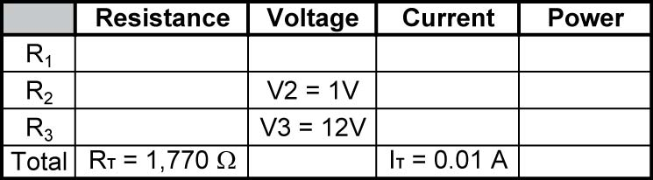

  - Remember:

R_{T} = R₁ + R₂ + R₃ + … + R_{N}
V_{T} = V₁ + V₂ + V₃ + …+ V_{N}
I_{T} = I₁ = I₂ = I₃ =…I_{N}
V = I R

  - Example Problem 4:
    - Solve for all of the unknowns in the following circuit. Fill in each unknown in the table below the circuit.

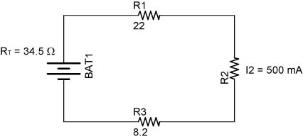

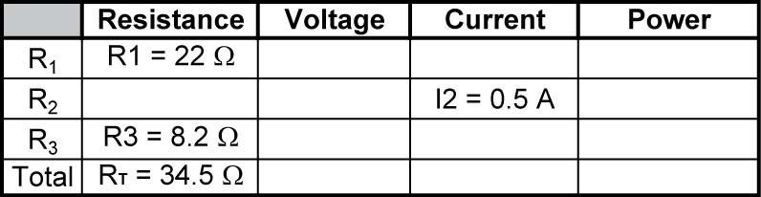
  - Suggested Student Activity Sheets: 6-1 and 6-2
  - Voltage Dividers:
    - Series resistors can be used to divide a voltage into smaller voltages. For example, the following series resistors divide a 12 volt source into 12 volts, 8 volts, and 4 volts using the same value for each resistor. Notice that we are not measuring voltages across each resistor, but voltages from a point, e.g. B (V_{BD}) to the ground point D. The common black voltmeter lead will remain on ground while the red lead will move from point to point as we measure the voltage at a particular point in the circuit. (The voltage drop across each individual resistor is 4V.)

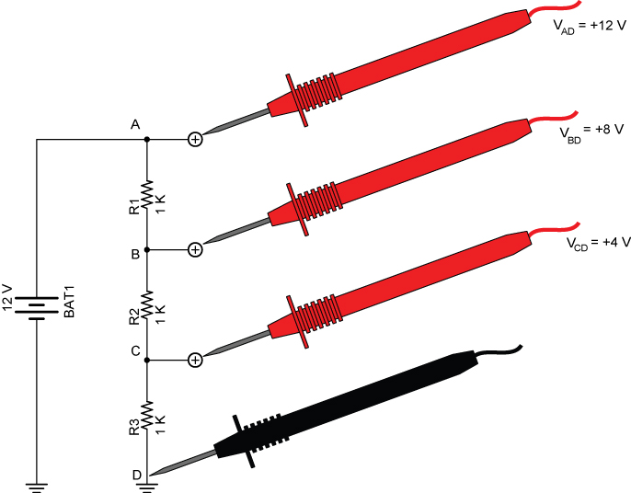

Figure 6 – Series Resistors as a Voltage Divider

    - Two Resistor Voltage Divider Circuit:
      - The resistors in a voltage divider do not have to be of equal value. An input voltage can be divided to any lesser voltage using two resistors. In the circuit below, the higher the resistance of R2, the higher the output voltage.

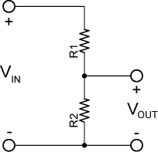

V_{OUT} = V_{IN} * R₂ / (R₁ + R₂) (No load on output)

      - If a load is added to the output terminals, the resistive load must be taken into consideration as a parallel resistor to R2.
    - Examples of Two Resistor Voltage Divider:

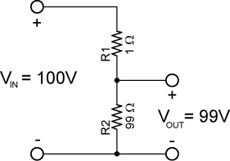

Example 1

V_{OUT} = V_{IN} * R₂ / (R₁ + R₂)
V_{OUT} = 100V * 99 Ω / (1 Ω + 99 Ω)
V_{OUT} = 100V * 99 Ω / 100 Ω
V_{OUT} = 99V

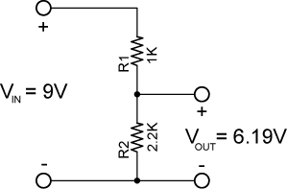

Example 2

V_{OUT} = V_{IN} * R₂ / (R₁ + R₂)
V_{OUT} = 9V * 2200 Ω / (1000 Ω + 2200 Ω)
V_{OUT} = 9V * 2200 Ω / 3200 Ω
V_{OUT} = 6.19V

    - Perform Series Circuits Lab 5 – Voltage Dividers
    - See applets:
      - http://www.falstad.com/circuit/e-voltdivide.html
      - http://www.raltron.com/cust/tools/voltage_divider.asp
      - http://hyperphysics.phy-astr.gsu.edu/hbase/electric/voldiv.html
  - Related web sites:
    - http://openbookproject.net//electricCircuits/DC/DC_5.html
- Fundamental equations for electrical circuits according to Darren Ashby, Electrical Engineering 101:
  - Ohm’s Law
  - Voltage divider rule
  - Capacitors impede changes in voltage
  - Inductors impede changes in current
  - Series and parallel resistors
  - Thevenin’s theorem
Electronics Technology and Robotics I Week 13
Series Circuits Lab 1 – Series Resistors

- Purpose: The purpose of this lab is to verify, by experiment, the formula for total resistance for resistors in series.

- Apparatus and Materials:

  - 1 – Solderless Breadboard with 9 V Supply
  - 1 – Digital Multimeter
  - 1 – 220 Ohm Resistor
  - 1 – 330 Ohm Resistor
  - 1 – 470 Ohm Resistor
  - 1 – 1 K Ohm Resistor
  - 1 – 2.2 K Ohm Resistor

- Procedure:
  - Total Resistance of Series Resistors Using Ohm Meter:
    - Measure the resistance of each resistor and record.
    - Wire the series resistor network in Figure 1.
    - Add the individual resistances to determine the total resistance of the network.
    - Now measure the total resistance of the resistor network and record.

Figure 1

  - Total Resistance of Series Resistors Using Ohm’s Law:
    - Connect a 9 V battery to the resistor network as shown in Figure 2.

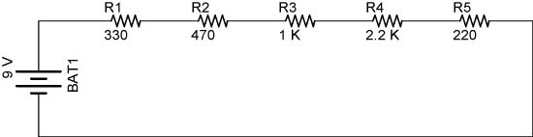

Figure 2

    - Measure the source voltage V_{T} and the current I_{T} through the series resistor network.
    - Knowing V_{T} and I_{T}, calculate the total resistance R_{T} using Ohm’s Law.
- Results:

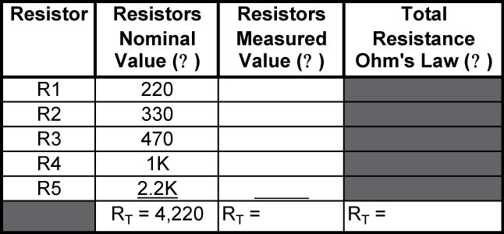

- Conclusions:
  - Do the four values of R_{T} equal one another? Explain any discrepancies.

  - If a 1 M Ohm resistor is in series with a 100 Ohm resistor, which resistor affects the total resistance more?

Electronics Technology and Robotics I Week 13
Series Circuits Lab 2 – Kirchhoff’s Voltage Law

- Purpose: The purpose of this lab is to experimentally verify Kirchhoff’s Voltage Law for a series resistor circuit.

- Apparatus and Materials:

  - 1 – Solderless Breadboard with 9 V Power Supply
  - 1 – Digital Multimeter
  - 1 – 100 Ohm Resistor
  - 1 – 220 Ohm Resistor
  - 1 – 330 Ohm Resistor

- Procedure:
  - Wire the following series circuit and measure the voltage drop across each resistor.
  - Compare the sum of the voltage drops with the voltage source:

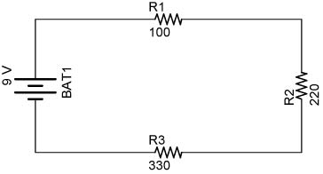

- Results:
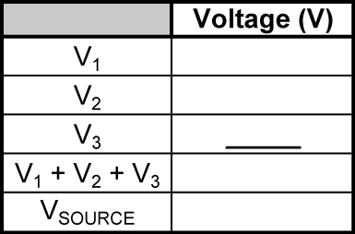

- Conclusions:
  - Does V_{SOURCE} = V₁+V₂+V₃?

  - Or put another way, does V_{SOURCE} - V₁ - V₂ - V₃ = 0? Explain any discrepancies.

Electronics Technology and Robotics I Week 13
Series Circuits Lab 3 – Current in Series Circuits

- Purpose: The purpose of this lab is to verify, by experiment, the formula for total current for resistors in series.

- Apparatus and Materials:

  - 1 – Solderless Breadboard with 9 V Power Supply
  - 1 – Digital Multimeter
  - 1 – 100 Ohm Resistor
  - 1 – 220 Ohm Resistor
  - 1 – 330 Ohm Resistor

- Procedure:
  - Using the same circuit from Lab 2, measure and record the current at each Point A - D.

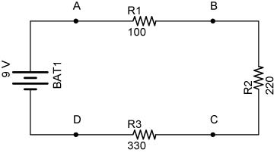

- Results:

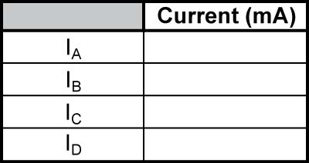

- Conclusions:
  - How do the 4 current readings relate to one another?

Electronics Technology and Robotics I Week 13
Series Circuits Lab 4 – Power in Series Circuits

- Purpose: The purpose of this lab is to verify, by experiment, that the total power consumed in series circuit is equal to the sum of the power consumed by each resistor.

- Apparatus and Materials:

  - 1 – Solderless Breadboard with 9 V Power Supply
  - 1 – Digital Multimeter
  - 1 – 100 Ohm Resistor
  - 1 – 220 Ohm Resistor
  - 1 – 330 Ohm Resistor

- Procedure:
  - Copy the voltages from Lab 2 and currents from Lab 3 into the Result table.
  - Calculate the power for each resistor and then the total power consumed for the following circuit:

- Results:

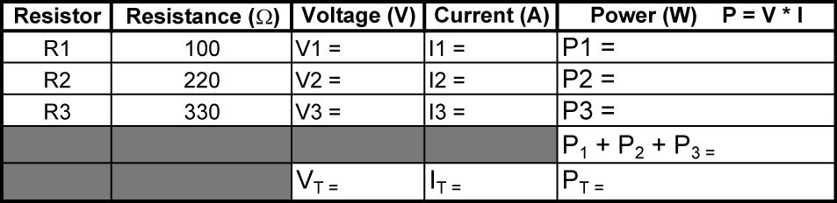

- Conclusions: Does P_{T} = P₁ + P₂ + P₃?

Electronics Technology and Robotics I Week 13
Series Circuits Lab 5 – Voltage Dividers

- Purpose: The purpose of this lab is to verify, by experiment, that t

- Apparatus and Materials:

  - 1 – Solderless Breadboard with 10 V Power Supply
  - 2 – Digital Multimeters
  - 1 – 5 K Ohm Potentiometer
  - Several 1 K Ohm Resistors

- Procedure:
  - Using 1 k resistors, design and build a voltage divider on your breadboard that will divide the +10V source voltage into +10 V, +7.5 V, +5 V, and +2.5 V. Show the instructor your readings on the DMM.
  - Potentiometers can be used as voltage dividers. Wire the circuit below then measure and record the voltmeter readings _{VAB} and _{VBC} as you adjust the potentiometer. Take 3 readings.

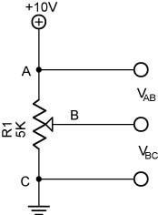

- Results:
  - Potentiometer as a Voltage Divider:

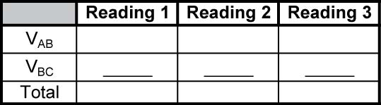

- Conclusions: See the next page.
- Conclusions:

  - In the potentiometer experiment, are the sums of V_{AB} + V_{BC} nearly consistent?

  - In the potentiometer experiment, do the sums of V_{AB} + V_{BC} nearly equal the source voltage (10 V). Explain any discrepancies.

