Morse Code Practice Oscillator
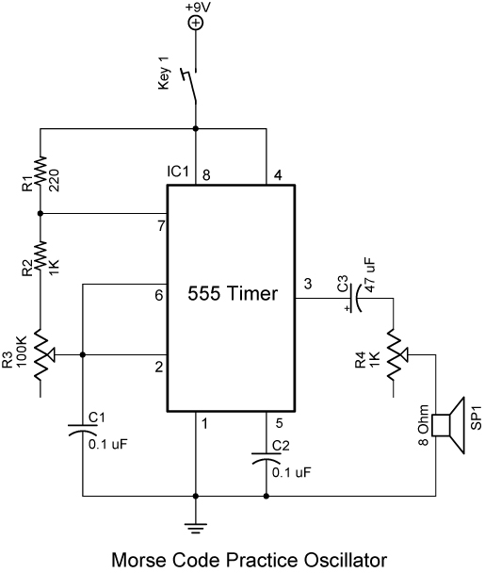
Explanation: Tones are generated by using a 555 timer in astable operation. See the lesson on 555 timer astable operation at: http://cornerstonerobotics.org/curriculum/lessons_year2/erii5_555_timer_astable_operation.pdf. The potentiometer R3 controls the frequency of the tone and potentiometer R4 controls the volume. Two oscillators may be linked together with a cable as shown in the schematic on the second page. Be certain that the polarity of the two oscillators match, that is, the +9V of the first oscillator circuit connects to +9V of the second oscillator circuit and ground connects to ground.

Reference Web Site: http://home.alphalink.com.au/~parkerp/gateway/noapr98.htm

